ALASKA WORKERS' COMPENSATION BOARD
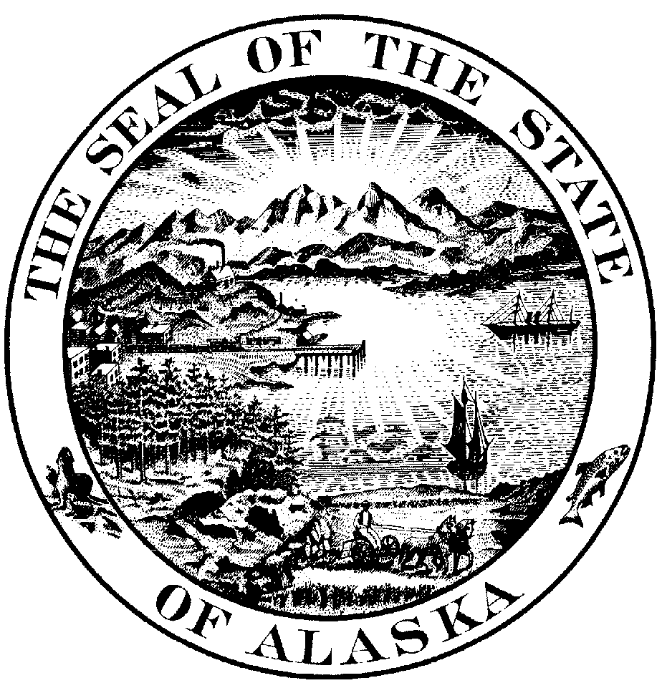

P.O. Box 25512 Juneau, Alaska 99802-5512

JAMES SIDNEY, )
)
Employee, ) DECISION AND ORDER
Respondent, )
) AWCB Case No. 9311924
v. )
) AWCB Decision No. 94-0327
UNIVERSITY OF ALASKA SOUTHEAST, )
(Self-Insured) ) Filed with AWCB Juneau
) December 27, 1994
Employer, )
Petitioner. )
)

We met in special session in Juneau on 22 November 1994 to consider Petitioners' appeal of a decision of the Reemployment Benefits Administrator (RBA) . Employee is represented by attorney Michael J. Jensen. Petitioner is represented by attorney Shelby L. Nuenke-Davison. We closed the record and concluded our deliberations on 22 November 1994.

ISSUES
1) Did the RBA abuse his discretion by not relying on the Unites States Department Of Labor's "Selected Characteristics of occupations Defined in the Dictionary of Occupational Titles" (SCODDOT) when determining, for the purpose of AS 23.30.041(e), the physical demands of Employee's job at the time of injury?
2) Is Petitioner responsible for the payment of Employee's attorney's fees.

SUMMARY OF THE EVIDENCE AND PROCEEDINGS
The facts in this case are not disputed. Employee is a highly-skilled, 43-year-old, Building Maintenance Supervisor. He has worked for Employer since March 1981, and has been the Building Maintenance Supervisor for the Physical Plant Department since April 1983.
On 27 June 1994, Rehabilitation Specialist B. Sue Roth, M.Ed., CRC, prepared a Reemployment Benefits Eligibility Evaluation, in which she determined Employee was eligible for reemployment benefits.
In the evaluation, the Rehab Specialist concluded that the title in the U.S. Department of Labor Dictionary of Occupational Titles (DOT) which most closely described Employee's position was "Building Maintenance Supervisor." This position is classified as light-duty work in the SCODDOT. (Eligibility Evaluation at 4.) The Rehab Specialist concluded that the job description in the DOT was not entirely accurate, however, because Employee was a working supervisor, and was expected to be able to do the work of those he supervised. She reported Employee was expected to do the work of a Maintenance Repairer (heavy-duty work); a Plumber (heavy-duty work); an Electrician, maintenance (medium-duty work); and a Heavy Equipment Operator (medium-duty work). Therefore, she concluded that Employee's job at the time of injury was mostly medium-duty work with intermittent heavy-duty work.
Based on the above analysis, the Rehab specialist concluded Employee "has physical capacities that are less than the physical demands of Mr. Sidney's job at the time of injury as described in the U.S. Department of Labor's Dictionary of Occupational Titles." (Eligibility Evaluation, at 6-7.)
On 2 August 1994 the RBA determined Employee was eligible for reemployment benefits. In reaching the determination, the RBA
relied on the Rehab Specialist’s report, which included the finding that Employee's permanent physical capacities are less than the physical demands of his job at the time of injury.
Petitioners appeal the RBA's decision on the grounds that the Rehab Specialist and RBA failed to correctly apply the United States Department of Labor's "Selected characteristic of Occupations Defined in the Dictionary of Occupational titles" (SCODDOT). Petitioners also assert the Rehab Specialist and RBA incorrectly applied the specific vocational preparation (SVP) codes from the SCODDOT, and incorrectly applied the concept of "remunerative employment" in reaching their decision.

FINDINGS OF FACT AND CONCLUSIONS OF LAW
As 23.30.041(d) provides in pertinent part:
Within 30 days after the referral by the administrator, the rehabilitation specialist shall perform the eligibility evaluation and issue a report of findings. within 14 days after receipt of the report from the rehabilitation specialist, the administrator shall notify the parties of the employee's eligibility for reemployment preparation benefits. Within 10 days after the decision, either party may seek review of the decision by requesting a hearing under AS 23.30.110. The hearing shall be held within 30 days after it is requested. The board shall uphold the decision of the administrator except for abuse of discretion on the administrator's part.

(Emphasis added.)
For the purpose of appeals of decisions of the RBA, we have consistently defined abuse of discretion as- "Issuing a decision which is arbitrary, capricious, manifestly unreasonable, or which stems from an improper: motive. " Tobeluk v. Lind, 589 P. 2d 873, 878 (Alaska 1979). We have also held that misapplication of the law is an abuse of discretion. Binder v. Fairbanks Historical Preservation Foundation, AWCB Decision No, 91-0392 (11 December 1991).

AS 23.30.041(e) provides:

An employee shall be eligible for benefits under this section upon the employee's written request and by having a physician predict that the employee will have permanent physical capacities that are less than the physical demands of the employee’s job as described in the United States Department of Labor's "Selected Characteristics of Occupations Defined in the Dictionary of Occupational Titles" for
(1) the employee's job at the time of injury; or
(2) other jobs that exist in the labor market that the employee has held or received training for within 10 years before the injury or that the employee has held following the injury for a period long enough to obtain the skills to compete in the labor market, according to specific vocational preparation codes as described in the Unites States Department of Labor's "Selected Characteristics of Occupations Defined in the Dictionary of Occupational Titles."

(Emphasis added.)

We find that the meaning of AS 23.30.041(e) is clear; when determining how an employee's physical capacities compare to the requirements of the employee's job at the time of injury, the theoretical description of the physical requirements of the job as described in SCODDOT must be used, not the actual duties the employee was required to perform in the job. This is consistent with our decision in Konecky v. Camco Wireline, Inc., AWCB Decision No. 93-0148 (17 June 1993), aff1d, 3AN-92-9126 CIV, (Alaska Super. Ct., May 20, 1994).
This is a case in which the actual physical requirements of the job vary from the description of the job in the SCODDOT. Tt is not disputed that Employee is capable of performing medium-duty work, and we so find. We find that the Building maintenance Supervisor position is categorized as light-duty work in SCODDOT. (Eligibility Evaluation at 4; Tony Reiter letter of 9 November 1994.)
We find the Rehab Specialist and the RBA relied on Employee's actual job duties in reaching the determination that Employee was eligible for reemployment benefits. We find this was a mistake, and a misapplication of the law. We find Employee's job at the time of injury, as described in SCODDOT, required light-duty work, and that Employee is able to perform. medium-duty work. Therefore, we find Employee does not have permanent physical capacities that are less than the physical demands of the job as described in SCODDOT.
In view of the above findings, we find the RBA abused his discretion in finding Employee eligible for reemployment benefits. We reverse his determination and find Employee is not eligible for reemployment benefits.
Because we have determined the RBA abused his discretion and Employee is not eligible for reemployment benefits, it is unnecessary to address the other grounds cited by Petitioners for reversing the RBA's decision.
We recognize that Employee is no longer physically able to perform all the duties of his job at the University of Alaska Southeast, and we recognize that our ruling is harsh and appears to be unfair. Nevertheless, we are bound to enforce the statute as enacted.
As we have found Employee is not entitled to reemployment benefits, we find Employee did not prevail on his claim. Accordingly, we find Petitioner is not responsible for the payment of Employee's attorney's fees.

ORDER
1. The Reemployment Benefits Administrator's determination finding Employee eligible for reemployment benefits is reversed.
2. Employee's claim for payment of his attorney's fees is denied and dismissed.
Dated at Juneau, Alaska this 27th day of December, 1994.

ALASKA WORKERS' COMPENSATION BOARD

/s/ L.N. Lair
Lawson N. Lair,
Designated Chairman

/s/ Paula J. Wilson
Paula J. Wilson, Member

If compensation is payable under terms of this decision, it is due on the date of issue and penalty of 25 percent will accrue if not paid within 14 days of the due date unless an interlocutory order staying payment is obtained in Superior Court.

APPEAL PROCEDURES
A compensation order ma@, be appealed through proceedings in Superior Court brought by a party in interest against the Board and all other parties to the proceedings before the Board, as provided in the Rules of Appellate Procedure of the State of Alaska.
A compensation order becomes effective when filed in the office of the Board, and unless proceedings to appeal it are instituted, it becomes final on the 31st day after it is filed.

CERTIFICATION
I hereby certify that the foregoing is a full, true and correct copy of the Decision and order in the matter of James Sidney, employee / respondent v. University of Alaska Southeast, (Self-insured) employer / petitioner; Case No. 9311925; dated and filed in the office of the Alaska Workers’ Compensation Board in Juneau, Alaska, this 27th day of December, 1994.

Bruce Dalrymple
SNO

?Absent some indication to the contrary, we assume Mr. Jensen seeks our order requiring Petitioner to pay his attorney's fees.
?Employee holds a Journeyman Electrician license, a Journeyman Plumber license, an Electrician Lineman license, a Stationary Steam Boiler license, and an Electrical Administrator certificate.

