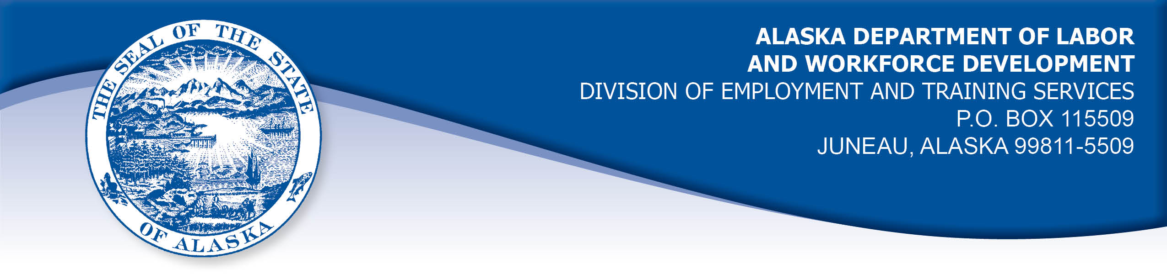

APPEAL TRIBUNAL DECISION

Docket Number: P20 196 Hearing Date: January 13, 2021

CLAIMANT:

RABIUL ISLAM

CLAIMANT APPEARANCES: DETS APPEARANCES:

Rabiul Islam Richard Doogan

CASE HISTORY

The claimant timely appealed a September 18, 2020 determination which denied Pandemic Unemployment Assistance (PUA) benefits under the CARES Act, Public Law 116-136. The issue before the Appeal Tribunal is whether the claimant meets the eligibility requirements of the Act.

FINDINGS OF FACT

The claimant has been self-employed as a taxi driver for the past twenty years. The claimant ceased to work in March due to his fears of COVID 19. The claimant has three children at home. His mother-in-law resides with the claimant. She was born in 1955. He was afraid that he would get the virus from a client and bring it home to his family.

The claimant was not advised by a doctor that he should self quarantine for his health or the health of his family. The claimant returned to work on or about June 22, 2020, temporarily. He found work to be slow as there were few customers. He returned full time on July 11, 2020.

STATUTORY PROVISIONS

AS 23.20.080 Federal-state cooperation

(a) In the administration of this chapter, the department shall cooperate, to the extent consistent with this chapter, with the Secretary of Labor, and shall take action through the adoption of regulations, administration methods, and standards that is necessary to obtain for this state and its citizens all advantages available under 26 U.S.C. 3303 and 3304 (Internal Revenue Code) and the Wagner-Peyser Act, as amended. The department shall comply with the regulations of the Secretary of Labor relating to the receipt or expenditure by this state of money granted under these federal laws and shall make reports in the form and containing the information which the Secretary of Labor requires. The department shall comply with the provisions which the Secretary of Labor may from time to time find necessary to assure the correctness and verification of the reports. The department may cooperate with every agency of the United States charged with the administration of an unemployment insurance law.

The CARES Act of 2020, Public Law 116-136, Title II, Sec. 2102 Pandemic Unemployment Assistance

(3) COVERED INDIVIDUAL.—The term “covered individual”—
(A) means an individual who—
(i) is not eligible for regular compensation or extended benefits under State or Federal law or pandemic emergency unemployment compensation under section 2107, including an individual who has exhausted all rights to regular unemployment or extended benefits under State or Federal law or pandemic emergency unemployment compensation under section 2107; and
(ii) provides self-certification that the individual—
(I) is otherwise able to work and available for work within the meaning of applicable State law, except the individual is unemployed, partially unemployed, or unable or unavailable to work because—
(aa) the individual has been diagnosed with COVID–19 or is experiencing symptoms of COVID–19 and seeking a medical diagnosis;
(bb) a member of the individual's household has been diagnosed with COVID–19;
(cc) the individual is providing care for a family member or a member of the individual's household who has been diagnosed with COVID–19;

(dd) a child or other person in the household for which the individual has primary caregiving responsibility is unable to attend school or another facility that is closed as a direct result of the COVID–19 public health emergency and such school or facility care is required for the individual to work;
(ee) the individual is unable to reach the place of employment because of a quarantine imposed as a direct result of the COVID–19 public health emergency;
(ff) the individual is unable to reach the place of employment because the individual has been advised by a health care provider to self-quarantine due to concerns related to COVID–19;
(gg) the individual was scheduled to commence employment and does not have a job or is unable to reach the job as a direct result of the COVID–19 public health emergency;
(hh) the individual has become the breadwinner or major support for a household because the head of the household has died as a direct result of COVID–19;
(ii) the individual has to quit his or her job as a direct result of COVID–19;
(jj) the individual's place of employment is closed as a direct result of the COVID–19 public health emergency; or
(kk) the individual meets any additional criteria established by the Secretary for unemployment assistance under this section; or
(II) is self-employed, is seeking part-time employment, does not have sufficient work history, or otherwise would not qualify for regular unemployment or extended benefits under State or Federal law or pandemic emergency unemployment compensation under section 2107 and meets the requirements of subclause (I); and
(B) does not include—
(i) an individual who has the ability to telework with pay; or
(ii) an individual who is receiving paid sick leave or other paid leave benefits, regardless of whether the individual meets a qualification described in items (aa) through (kk) of subparagraph (A)(i)(I).
UIPL 16-20, Change 2 Issued by USDOL July 21, 2020
Clarification on item (kk) of acceptable COVID-19 related reasons. Section 2102(a)(3)(A)(ii)(I)(kk) of the CARES Act provides for the Secretary of Labor to establish any additional criteria under which an individual may self-certify eligibility for PUA benefits. Section C.1.k. of Attachment I to UIPL No. 16-20 provides for coverage of an independent contractor whose ability to continue performing his or her customary work activities is severely limited because of the COVID-19 public health emergency. The example provided includes a driver of a ride sharing service who has been forced to suspend operations because of COVID-19. Question 42 of Attachment I to UIPL No. 16- 20, Change 1, explains that an independent contractor who experiences a “significant diminution of work as a result of COVID-19” may be eligible for PUA. With these examples in UIPL Nos. 16-20 and 16-20, Change 1, the Secretary provides coverage under item (kk) to those self-employed individuals who experienced a significant diminution of services because of the COVID-19 public health emergency, even absent a suspension of services.

CONCLUSION

The claimant was not advised by a doctor to self-quarantine. He found work to be slow when he returned to work in June.

UIPL 16-20 change 1, question 41 specifically states “Without having been advised by a health care provider to self-quarantine, an individual who does not go to work due to general concerns about exposure to COVID 19, and who does not meet any of the other COVID-related criteria for PUA, is not eligible for PUA.”

Under UIPL 16-20 Change 2 Question 14, the Secretary provides that: “Not being able to find work because businesses have closed and/or may not be hiring due to COVID 19 is not an identified reason.”

Therefore the claimant cannot be held to be a covered individual for this reason.

DECISION

The determination issued on September 18, 2020 is AFFIRMED. The claimant is not eligible for benefits from the Pandemic Unemployment Assistance (PUA) program.

APPEAL RIGHTS

This decision is final unless an appeal is filed in writing to the Commissioner of Labor and Workforce Development within 30 days after the decision is mailed to each party. The appeal period may be extended only if the appeal is delayed for circumstances beyond the party’s control. A statement of rights and procedures is enclosed.

Dated and mailed on January 25, 2021.

Tom Mize
Appeals Officer

