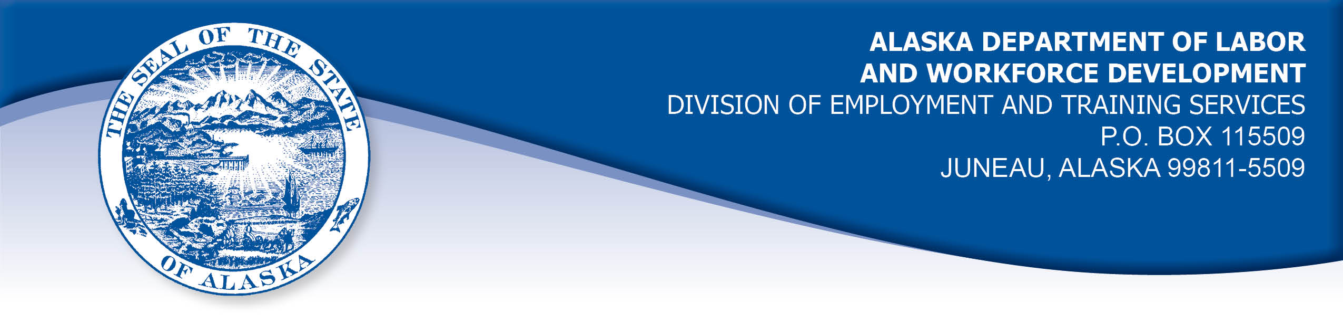

APPEAL TRIBUNAL DECISION

Docket number: 21 0285 Hearing date: May 28, 2021

CLAIMANT:

CATHIA DEMMERT

CLAIMANT APPEARANCES: DETS APPEARANCES:

Cathia Demmert None

CASE HISTORY

The claimant timely appealed a February 11, 2021 determination which denied benefits under Alaska Statute 23.20.378. The issue before the Appeal Tribunal is whether the claimant was able to work and available for suitable work.
FINDINGS OF FACT

The claimant established a claim for unemployment insurance benefits effective March 29, 2020.
The claimant last worked on December 4, 2020. She started a planned maternity leave after that date because it was getting too difficult for her to lean over and prepare food because of her pregnancy. She had been limited to lifting no more than ten pounds and being on her feet for the entire shift was getting difficult. Then claimant’s baby was born on December 20, 2020. The claimant was advised by her doctor to remain off work for six weeks, then another six weeks. The claimant was released to return to work about March 19, 2020. The claimant did not return to work at that point because she did not have childcare for her infant. The claimant had contacted multiple childcare agencies, but found many were not accepting new infants. At the time of the hearing, the claimant was still looking for childcare and was working on applying for childcare assistance funding.
The claimant remained in contact with the employer. The employer contacted the claimant in May 2021 and requested the claimant return her keys.

PROVISIONS OF LAW

AS 23.20.378 provides:

(a) An insured worker is entitled to receive waiting-week credit or benefits for a week of unemployment if for that week the insured worker is able to work and available for suitable work. An insured worker is not considered available for work unless registered for work in accordance with regulations adopted by the department. An insured worker may not be disqualified for failure to comply with this subsection if

(1) the insured worker is not available for work because the insured worker

(A) is ill or disabled;
(B) is traveling to obtain medical services that are not available in the area in which the insured worker resides, or, if a physician determines it is necessary, the insured worker is accompanying a spouse or dependent who is traveling to obtain medical services;
(C) resides in the state and is non-commercially hunting or fishing for personal survival or the survival of dependents;
(D) is serving as a prospective or impaneled juror in a court; or
(E) is attending the funeral of an immediate family member for a period of no longer than seven days; and

(2) a condition described in (1) of this subsection occurs during an uninterrupted period of unemployment immediately following a week for which the insured worker has filed a compensable claim, and work has not been offered that would have been suitable for the insured worker before the illness, disability, hunting, fishing, medical travel, jury service, or funeral attendance.

(b) A waiver of disqualification for an illness or disability under (a)(1) of this section may not exceed six consecutive weeks.

8 AAC 85.350:

(a) A claimant is considered able to work if the claimant is physically and mentally capable of performing work under the usual conditions of employment in the claimant's principal occupation or other occupations for which the claimant is reasonably fitted by training and experience.

(b) A claimant is considered available for suitable work for a week if the claimant

(1) registers for work as required under 8 AAC 85.351;
(2) makes independent efforts to find work as directed under 8 AAC 85.352 and 8 AAC 85.355;
(3) meets the requirements of 8 AAC 85.353 during periods of travel;
(4) meets the requirements of 8 AAC 85.356 while in training;
(5) is willing to accept and perform suitable work which the claimant does not have good cause to refuse;
(6) is available, for at least five working days in the week, to respond promptly to an offer of suitable work; and
(7) is available for a substantial amount of full-time employment.

HB 308 UNEMPLOYMENT INSURANCE: BENEFIT QUALIFICATION AND WAITING WEEK DURING NOVEL CORONAVIRUS DISEASE OUTBREAK.
(a) To the extent consistent with federal law, an insured worker who is otherwise qualified to receive a benefit under AS 23.20 (Alaska Employment Security Act) may not be disqualified for failure to comply with AS 23.20.378(a) because of conduct by the insured worker or the employer of the insured worker related to an outbreak of novel coronavirus disease (COVID-19), including conduct involving:
(1) providing care, including medical care, to one or more persons
(2) preventing or limiting the spread of COVID-19; or
(3) preventing or limiting economic loss or harm.
(b) The protection of an insured worker under (a) of this section applies for a period of 120 days beginning on the effective date of this section or the date the insured worker applies for a benefit under AS 23.20, whichever is later.

CONCLUSION

In Arndt v. State, DOL, 583 P2d 799, Alaska, September 22, 1978, the Alaska Supreme Court adopted a two-fold test for determining a claimant's availability for work. The court held:

The test requires (1) that an individual claimant be willing to accept suitable work which he has no good cause for refusing, and (2) that the claimant thereby make himself available to a substantial field of employment.

This decision has been codified in 8 AAC 85.350. The burden is on the claimant to establish the first part of the test. The burden is on the Alaska Division of Employment and Training Services (DETS) to establish there is not a substantial field of employment remaining if it intends to deny benefits.

The claimant was initially unable to accept suitable work because of her advanced pregnancy and the extended recovery advised by her doctor afterward. The claimant has not established that she would accept suitable work after her medical release because she does not have childcare available. The Tribunal finds the claimant remains unavailable for work.

DECISION

The determination issued on February 11, 2021 is AFFIRMED. Benefits are DENIED beginning with the week ending December 5, 2020 and continuing until such a time as the claimant’s circumstances change and she is able and available to accept work. The claimant is advised to contact the Division to report any change in her availability for work.

APPEAL RIGHTS

This decision is final unless an appeal is filed in writing to the Commissioner of Labor and Workforce Development within 30 days after the decision is mailed to each party. The appeal period may be extended only if the appeal is delayed for circumstances beyond the party’s control. A statement of rights and procedures is enclosed.

Dated and mailed on June 3, 2021

Rhonda Buness, Appeals Officer

