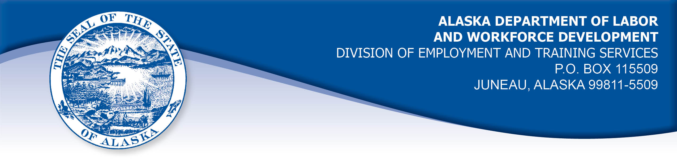

APPEAL TRIBUNAL DECISION

Docket number: 22 0609 Hearing date: July 28, 2022

CLAIMANT:

ANTHONY LEONDAKOS

CLAIMANT APPEARANCES: DETS APPEARANCES:

Anthony Leondakos None

CASE HISTORY

The claimant timely appealed a June 14, 2022 determination which denied benefits under AS 23.20.378 and 8 AAC 85.350-351. The issue is whether the claimant met the registration requirements to be considered available for full-time work.

FINDINGS OF FACT

On May 30, 2022, the claimant established a claim for unemployment insurance benefits effective May 29, 2022. The claimant was advised of the requirement to post a résumé on the Division’s AlaskaJobs website, within seven days, or benefits would be denied.
The claimant attempts to keep his résumé on line and available even when he is not filing for unemployment benefits. He checks it about 3 or 4 times per year. He did not recall the last time he verified that it was online and available.
On or about June 14, 2022, a representative of the Division contacted the claimant to advise that his résumé was not online and available. He entered the system and posted it online that date. He later learned that something had not performed correctly and his résumé was not online. He contacted the help desk to get it corrected.

PROVISIONS OF LAW

AS 23.20.378 provides, in part:

(a) An insured worker is entitled to receive waiting-week credit or benefits for a week of unemployment if for that week the insured worker is able to work and available for suitable work....

8 AAC 85.350 provides, in part:

(b) A claimant is considered available for suitable work for a week if the claimant
(1) registers for work as required under 8 AAC 85.351;
(2) makes independent efforts to find work as directed under 8 AAC 85.352 and 8 AAC 85.355;
(3) meets the requirements of 8 AAC 85.353 during periods of travel;
(4) meets the requirements of 8 AAC 85.356 while in training;
(5) is willing to accept and perform suitable work which the claimant does not have good cause to refuse;
(6) is available, for at least five working days in the week to respond promptly to an offer of suitable work; and
(7) is available for a substantial amount of full-time employment.

8 AAC 85.351 provides:

(a) a claimant who files a claim for benefits in a state that acts as agent in taking claims for benefits held by this state shall register for work in accordance with the statutes, regulations, and procedures of the state in which the claim is filed.
(b) a claimant who files for benefits in this state shall register for work as required by AS 23.20 and this section. A claimant shall register for work
(1) repealed 3/4/2006;
(2) in person or by mail at the employment service office of the division that is nearest the claimant’s residence;
(3) by telephone, if permitted by the director; or
(4) at the department’s website by electronic means, if available from the division.
(c) The director shall find that a claimant is not available for work for any week ending before completion of a placement registration for work. To be considered available for work from the date of the initial claim, a claimant must complete a placement registration within seven days after filing the initial claim. If the placement registration is not completed within seven days, the claimant is considered available for work the week the placement registration is completed.
(g) The director may defer registration for work for a claimant who is
(1) temporarily unemployed with a definite date to return to full-time work within 45 days after the date the claimant files the initial claim;
(2) unemployed due to a labor dispute;
(3) traveling immediately following the filing of the initial claim, for the purpose of relocating outside of this state; upon arrival in the new area of residence, the claimant shall register for work as required in (a) of this section;
(5) normally hired through a trade union, if the union furnishes information when requested by the director to verify the claimant's current membership and eligibility for dispatch;
(8) under an approved waiver of availability under AS 23.20.378 or AS 23.20.382.
(i) If the director does not require the claimant to have a placement registration, the director shall inform the claimant that the placement registration requirement has been deferred and advise the claimant of available employment services.

CONCLUSION

Alaska Statute 23.20.378 requires that a claimant be able to work and available for work in a week in order to be eligible for benefits for a week of unemployment. Regulation 8 AAC 85.351 provides that to be considered available for work, a claimant must register and post a résumé on the Division’s AlaskaJobs website that can be matched with available jobs. If the résumé is not posted online within seven days, the claimant is considered available for work the week the résumé is posted online.
The claimant in this case was aware of the requirement to post a résumé online within seven days of the date the initial claim application date. The claimant posted a résumé online on June 14, 2022.
Neither the Appeal Tribunal nor I have any jurisdiction to hold contrary to the clear wordage of the law. Scott, Com. Dec. 87H-EB-162, June 18, 1987.
The circumstances do not establish that the reason for the delay was out of the claimant’s control. Therefore the claimant cannot be considered available for work in the period under review in accordance with Regulation 8 AAC 85.351, above.
The claimant’s testimony was straightforward and credible. The claimant believed the proper form and procedure was followed to complete a résumé on the Division’s website on June 14, 2022.

In Ward Com. Dec. No. 06 1433, September 27, 2006:
The Commissioner held a credible claimant complied with ALEXsys registration requirements and was allowed benefits where "The claimant could not recall if, when he created his first résumé, the program advised him that the résumé had been saved to ALEXsys. His testimony during the hearing was straightforward and confident. We believe that he did in fact prepare his résumé as instructed and for some unknown reason it was not saved properly to ALEXsys."
The Appeal Tribunal holds the claimant in this case met registration requirements effective June 14, 2022. The claimant may be found to be available for work effective that week under Regulation 8 AAC 85.351, above.

DECISION

The determination issued on June 14, 2022 is AFFIRMED. Benefits are denied for the weeks ending June 4, 2022 through June 11, 2022. Benefits are allowed after June 12, 2022, in the claimant is otherwise eligible.

APPEAL RIGHTS

This decision is final unless an appeal is filed in writing to the Commissioner of Labor and Workforce Development within 30 days after the decision is mailed to each party. The appeal period may be extended only if the appeal is delayed for circumstances beyond the party’s control. A statement of rights and procedures is enclosed.

Dated and mailed on July 28, 2022.

Tom Mize

Tom Mize
Appeals Officer

