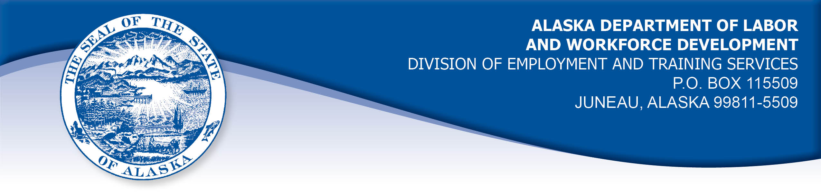

APPEAL TRIBUNAL DECISION

Docket number: 22 0651 Hearing date: August 22, 2022

CLAIMANT:

THERESA CHRISTMAN

CLAIMANT APPEARANCES: DETS APPEARANCES:

Theresa Christman None

CASE HISTORY

The claimant timely appealed a June 30, 2022 determination which denied benefits under Alaska Statute 23.20.378. The issue before the Appeal Tribunal is whether the claimant was able to work and available for suitable work.
FINDINGS OF FACT

The claimant established a claim for unemployment insurance benefits effective June 19, 2022. The claimant’s last work had ended May 27, 2022. The claimant was recovered from surgery and her employer had no more light duty available for the claimant.
The claimant was restricted by her doctor to lifting less than 15 pounds and no extended walking or standing. The claimant’s last work had required her handle parts that weighed more than 15 pounds and required extended walking and standing. The claimant was able to perform some of her duties from home, including phone calls, emails and billing related to fleet management accounts.
The claimant searched for work in the administrative field, where she could use her skills in account management and procurement. The claimant searched for work she could perform from home or a hybrid schedule of home and office. The claimant held she could work 7-8 hours per day, five days a week and she would have no problem getting to and from an office if required. The claimant applied for several positions that met her medical requirements. The claimant stopping filing certifications to claim benefits after the week ending July 23, 2022 because she did not believe she would receive benefits.

PROVISIONS OF LAW

AS 23.20.378 provides:

(a) An insured worker is entitled to receive waiting-week credit or benefits for a week of unemployment if for that week the insured worker is able to work and available for suitable work. An insured worker is not considered available for work unless registered for work in accordance with regulations adopted by the department. An insured worker may not be disqualified for failure to comply with this subsection if
(1) the insured worker is not available for work because the insured worker
(A) is ill or disabled;
(B) is traveling to obtain medical services that are not available in the area in which the insured worker resides, or, if a physician determines it is necessary, the insured worker is accompanying a spouse or dependent who is traveling to obtain medical services;
(C) resides in the state and is non-commercially hunting or fishing for personal survival or the survival of dependents;
(D) is serving as a prospective or impaneled juror in a court; or
(E) is attending the funeral of an immediate family member for a period of no longer than seven days; and
(2) a condition described in (1) of this subsection occurs during an uninterrupted period of unemployment immediately following a week for which the insured worker has filed a compensable claim, and work has not been offered that would have been suitable for the insured worker before the illness, disability, hunting, fishing, medical travel, jury service, or funeral attendance.
(b) A waiver of disqualification for an illness or disability under (a)(1) of this section may not exceed six consecutive weeks.

8 AAC 85.350:

(a) A claimant is considered able to work if the claimant is physically and mentally capable of performing work under the usual conditions of employment in the claimant's principal occupation or other occupations for which the claimant is reasonably fitted by training and experience.
(b) A claimant is considered available for suitable work for a week if the claimant
(1) registers for work as required under 8 AAC 85.351;
(2) makes independent efforts to find work as directed under 8 AAC 85.352 and 8 AAC 85.355;
(3) meets the requirements of 8 AAC 85.353 during periods of travel;
(4) meets the requirements of 8 AAC 85.356 while in training;
(5) is willing to accept and perform suitable work which the claimant does not have good cause to refuse;
(6) is available, for at least five working days in the week, to respond promptly to an offer of suitable work; and
(7) is available for a substantial amount of full-time employment.

CONCLUSION

In Arndt v. State, DOL, 583 P2d 799, Alaska, September 22, 1978, the Alaska Supreme Court adopted a two-fold test for determining a claimant's availability for work. The court held:

The test requires (1) that an individual claimant be willing to accept suitable work which he has no good cause for refusing, and (2) that the claimant thereby make himself available to a substantial field of employment.

This decision has been codified in 8 AAC 85.350. The burden is on the claimant to establish the first part of the test. The burden is on the Alaska Division of Employment and Training Services (DETS) to establish there is not a substantial field of employment remaining if it intends to deny benefits. The claimant in this case established that she was available to work full-time withing her medical restrictions and she was actively looking for work during the period under review.

DECISION

The determination issued on June 30, 2022 is REVERSED. Benefits are ALLOWED for the weeks ending June 18, 2022 through July 23, 2022, if the claimant is otherwise eligible.

APPEAL RIGHTS

This decision is final unless an appeal is filed in writing to the Commissioner of Labor and Workforce Development within 30 days after the decision is mailed
to each party. The appeal period may be extended only if the appeal is delayed for circumstances beyond the party’s control. A statement of rights and procedures is enclosed.

Dated and mailed on August 26, 2022.

Rhonda Buness, Appeals Officer

