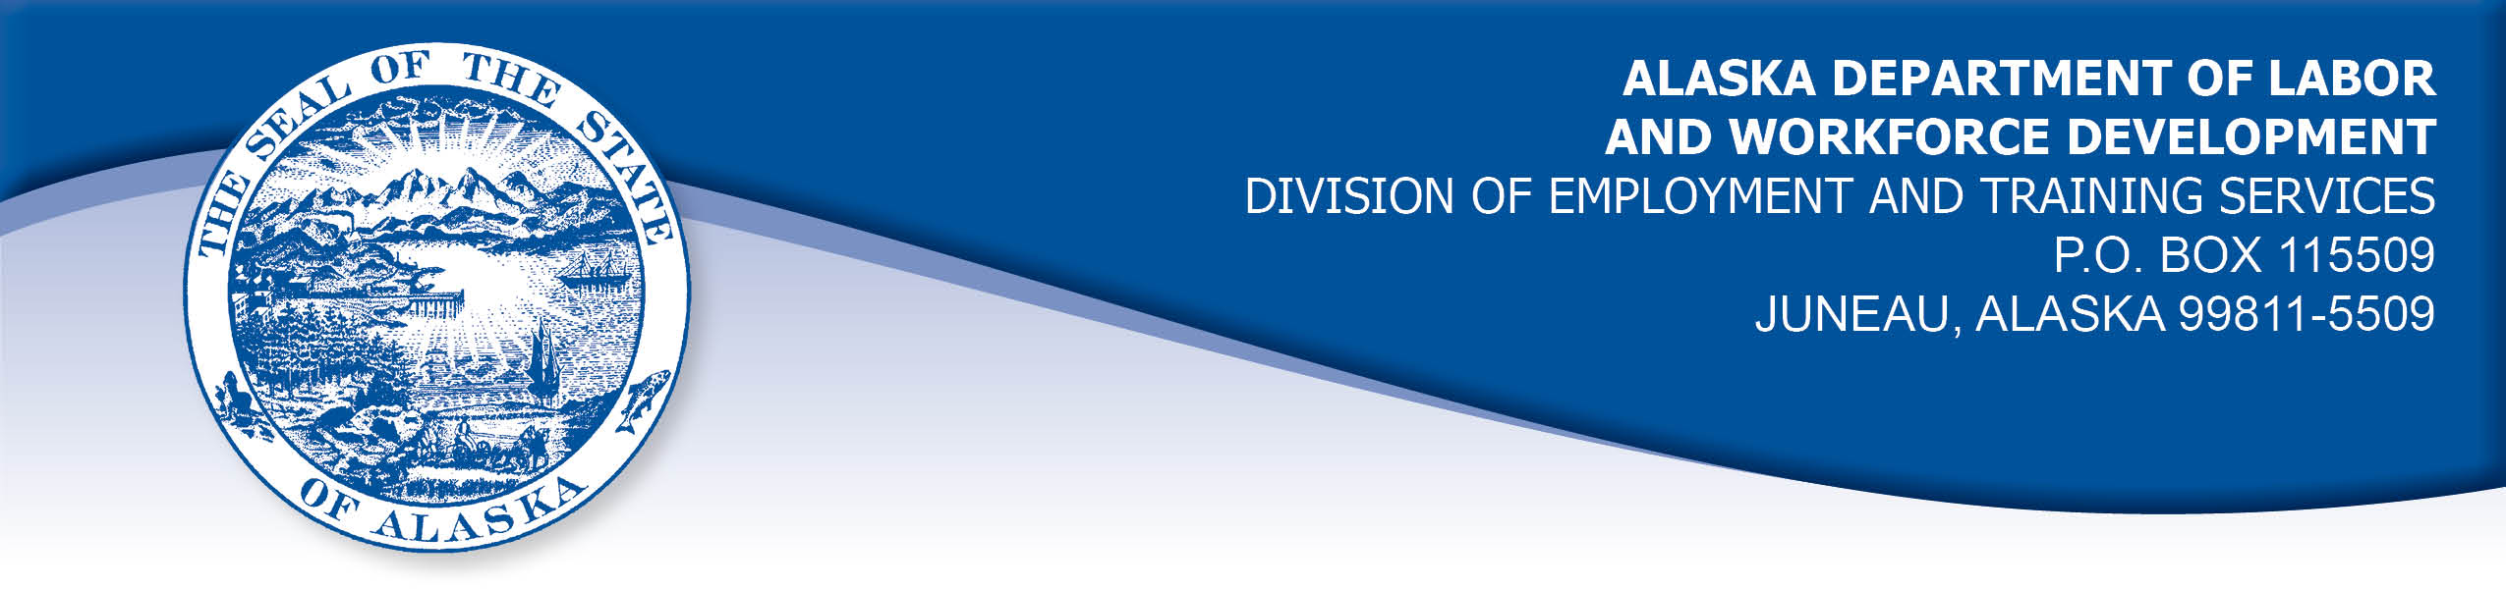

APPEAL TRIBUNAL DECISION

Docket number: 23 0151 Hearing date: March 17, 2023

CLAIMANT: EMPLOYER:

KIM WEVER HOST INTERNATIONAL - ANCHORAGE
INTERNATIONAL AIRPORT SNACKBAR

CLAIMANT APPEARANCES: EMPLOYER APPEARANCES:

Kim Wever None

CASE HISTORY

The claimant timely appealed a February 3, 2023 determination which denied benefits under Alaska Statute 23.20.379. The issue before the Appeal Tribunal is whether the claimant voluntarily quit suitable work without good cause.

FINDINGS OF FACT

The claimant began work for the employer in June 2022. She last worked on December 8, 2022. At that time, she worked full-time as a general manager.
When the claimant started work, she was responsible for the hiring process for staff in the three airport restaurants she managed. After a change in process, the claimant was only to interview potential workers, and a specific human resources staff member would complete the hiring process. The claimant found the staff member did not follow through with the process, staff was not hired timely and the claimant became very short-staffed. The responsible staff member worked only part-time and it was difficult for the claimant to reach her. When the claimant did speak to the staff member, she made excuses to claimant for her lack of follow through on hiring.
Because she was so short on workers, the claimant was required to work up to 75 hours a week to keep the restaurants open, although she was only scheduled to work up to 50 hours per week. The claimant was not paid for overtime work, but she did earn a quarterly bonus for meeting sales goorals. The claimant was given the goal of implementing a code that could be scanned by a customer at the table to place their order directly, and a portion of the claimant’s bonus was linked to achieving a certain level of use of that system in December. The claimant had set up such a system at a previous workplace. She asked the manager in charge for the information to start setting up the system, but the manager told the claimant that the manager would set it up when she could get to it.
The claimant brought the issues to her supervisor in September and asked if she could return to completing the hiring process herself so she could get some staff on board. The claimant’s request was refused, the hiring process improved very briefly and then went back to no action. The claimant again brought the issues to her supervisor in October, but he was getting ready to transfer to another position, so he was unable to help. In late October, the claimant called a corporate hotline and reported that the human resources person’s actions were creating a hostile workplace. The claimant had a video meeting with the head of the human resources department who said she would look into the matter. The claimant did not hear back from human resources office for the entire month of November.
The claimant continued to work up to 75 hours per week throughout November and she was not given the information to implement the table ordering system, so she could not meet the requirement to receive a full quarterly bonus. On December 1, 2022, the claimant gave the employer two weeks notice that she was quitting. On December 8, 2022, the claimant’s airport badge and keys were taken and she was walked out of the airport, however she was paid through her intended last day.

PROVISIONS OF LAW

AS 23.20.379 provides in part:

(a) An insured worker is disqualified for waiting-week credit or benefits for the first week in which the insured worker is unemployed and for the next five weeks of unemployment following that week if the insured worker...
- left the insured worker's last suitable work voluntarily without good cause....

8 AAC 85.095 provides in part:

(c) To determine the existence of good cause under AS 23.20.379(a)(1) for voluntarily leaving work determined to be suitable under
AS 23.20.385, the department will consider only the following factors:
(1) leaving work due to a disability or illness of the claimant that makes it impossible for the claimant to perform the duties required by the work, if the claimant has no other reasonable alternative but to leave work;
(2) leaving work to care for an immediate family member who has a disability or illness;
(3) leaving work due to safety or other working conditions or an employment agreement related directly to the work, if the claimant has no other reasonable alternative but to leave work;
(4) leaving work to accompany or join a spouse at a change of location, if commuting from the new location to the claimant’s work is impractical; for purposes of this paragraph, the change of location must be as a result of the spouse’s
(A) discharge from military service; or
(B) employment;
(5) leaving unskilled work to attend a vocational training or retraining course approved by the director under AS 23.20.382, only if the claimant enters the course immediately upon separating from work;
(6) leaving work in order to protect the claimant or the claimant’s immediate family members from harassment or violence;
(7) leaving work to accept a bonafide offer of work that offers better wages, benefits, hours, or other working conditions; if the new work does not materialize, the reasons for the work not materializing must not be due to the fault of the worker;
(8) other factors listed in AS 23.20.385(b).

AS 23.20.385(b) provides, in part:

(b) In determining whether work is suitable for a claimant and in determining the existence of good cause for leaving or refusing work, the department shall, in addition to determining the existence of any of the conditions specified in (a) of this section, consider the degree of risk to the claimant's health, safety, and morals, the claimant's physical fitness for the work, the claimant's prior training, experience, and earnings, the length of the claimant's unemployment, the prospects for obtaining work at the claimant's highest skill, the distance of the available work from the claimant's residence, the prospects for obtaining local work, and
other factors that influence a reasonably prudent person in the claimant's circumstances.

CONCLUSION

The claimant in this case voluntarily quit because she was required to work far beyond her agreed upon hours of work for a long period of time. In addition, she was denied the means to meet her sales goal and earn her full quarterly bonus. The claimant brought both issues to her supervisor and to the corporate human resources office, but no solutions were provided and the employer denied the solutions the claimant proposed.

Regulation 8 AAC 85.095(c) provides seven reasons that the Department will consider when determining good cause for voluntarily leaving work, including leaving work due to safety or other working conditions or an employment agreement related directly to the work, if the claimant has no other reasonable alternative but to leave work.

In Missall, Com. Dec. 8924740, April 17, 1990, the Commissioner of Labor summarized Department policy regarding what constitutes good cause for voluntarily leaving work. The Commissioner held, in part:

The basic definition of good cause is 'circumstances so compelling in nature as to leave the individual no reasonable alternative.' (Cite omitted.) A compelling circumstance is one 'such that the reasonable and prudent person would be justified in quitting his job under similar circumstances.' (Cite omitted). Therefore, the definition of good cause contains two elements; the reason for the quit must be compelling, and the worker must exhaust all reasonable alternatives before quitting.

The claimant was being required to work more hours than agreed upon at hire without increased compensation, and she was being denied the ability to earn her full quarterly bonus, both of which the Tribunal finds to be compelling circumstances, as compensation for work performed is a major component of the employment agreement. The claimant brought her concerns to the employer and even proposed what seemed to her be reasonable solutions, but the employer rejected her solutions and her circumstances did not change over several months. The Tribunal finds the claimant had no other reasonable alternative but to leave the work.

The Tribunal concludes the claimant had good cause to voluntarily leave work at the time she did. The penalties of AS 23.20.379 are not appropriate.

DECISION

The determination issued on February 10, 2023 is REVERSED. Benefits are ALLOWED for the weeks ending January 28, 2023 through March 4, 2023, if otherwise eligible. The three weeks are restored to the claimant’s maximum benefits. The determination will not interfere with the claimant’s eligibility for extended benefits under AS 23.20.406-409.

APPEAL RIGHTS

This decision is final unless an appeal is filed in writing to the Commissioner of Labor and Workforce Development within 30 days after the decision is mailed to each party. The appeal period may be extended only if the appeal is delayed for circumstances beyond the party’s control. A statement of rights and procedures is enclosed.

Dated and mailed on March 22, 2023.

Rhonda Buness, Appeals Officer

