ALASKA WORKERS' COMPENSATION BOARD
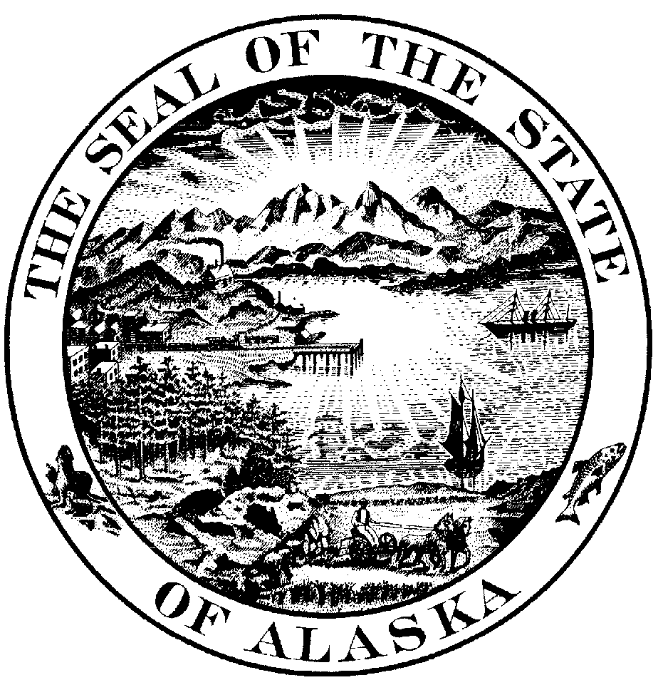

P.O. Box 115512 Juneau, Alaska 99811-5512

MARILYN M. CHAMBERS,  Employee,  Applicant,  v.  STATE OF ALASKA,  Employer,  and  ALASKA, STATE OF,  Insurer,  Defendants. | )  )  )  )  )  )  )  )  )  )  )  )  )  )  )  )  ) | CORRECTED ERRATA SHEET  DECISION AND ORDER  AWCB Case Nos. 200423099, 200408718  AWCB Decision No. 09-0153 ERT  Filed with AWCB Anchorage, Alaska  on January 19, 2010

On September 15, 2009, a Final Decision and Order (D & O) issued in this case, AWCB Decision No. 09-0153. Upon further reviewing the D & O, it was thought the D & O contained clerical errors. Consequently, on January 15, 2010, an Errata Sheet Decision and Order issued to correct these suspected errors. However, upon further reviewing the process and procedure followed in this case, it was discovered the document did not contain clerical errors. Therefore, the Errata Sheet Decision and Order, AWCB Decision No. 09-0153 ERT (January 15, 2010) was incorrectly issued and is hereby withdrawn.

In all respects, the original September 15, 2009 Decision No. 09-0153 remains in full force and effect as issued.

Dated at Anchorage, Alaska this 19 day of January 2010.

ALASKA WORKERS' COMPENSATION BOARD

Janel Wright,
Designated Chairman

CERTIFICATION

I hereby certify that the foregoing is a full, true and correct copy of the Corrected Errata in the matter of MARILYN M. CHAMBERS employee / applicant; v. STATE OF ALASKA, employer(s) ALASKA, STATE OF, insurer(s) / defendants; Case No(s). 200423099, 200408718; dated and filed in the office of the Alaska Workers' Compensation Board in Anchorage, Alaska, this 19 day of January, 2010.

Jean Sullivan, Clerk

