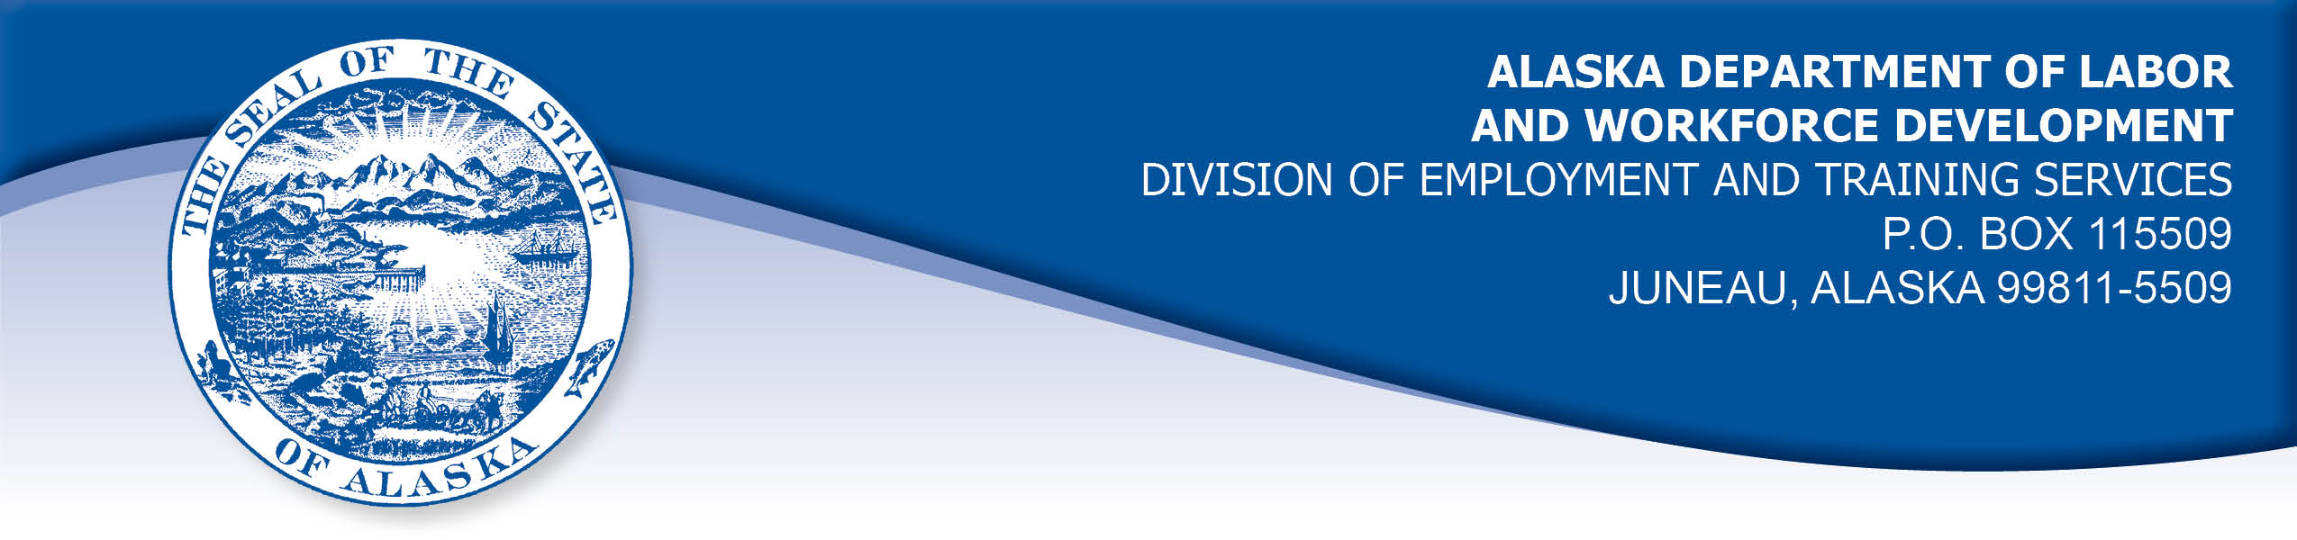

APPEAL TRIBUNAL DECISION

Docket number: 19 0632 Hearing date: July 30, 2019

CLAIMANT: EMPLOYER

TRACY CRAIG KODIAK ISLAND HOUSING AUTHORITY

CLAIMANT APPEARANCES: EMPLOYER APPEARANCES:

Tracy Craig Robert Staufer
Mindy Pruitt

CASE HISTORY

The claimant timely appealed a June 27, 2019 determination which denied benefits under Alaska Statute 23.20.379. The issue before the Appeal Tribunal is whether the claimant was discharged for misconduct connected with the work.
FINDINGS OF FACT

The claimant began work for the employer on September 8, 2016. She last worked on June 20, 2019. At that time, she worked full time as a housing advisor.
On June 12, 2019, the claimant left a binder behind in a client/family area at a worksite of the employer. The claimant used her daughter’s old school binder to organize her documents for a volunteer group she participated in outside work hours. The claimant called a co-worker and asked her to get the binder and hold onto it for her. The back of the binder displayed pictures from a charity calendar featuring fireman without shirts. The pictures were seen by other employees who felt they were inappropriate and the pictures could have been seen by clients and children.
The employer has a policy against harassing behavior which includes displaying nude pictures. The claimant denied that the photos were nude, and she believed similar pictures could be found in magazine advertisements in the same area where she left her binder.

The claimant had been placed on a corrective action plan to correct some performance issues related to calculating rent and her knowledge of the financial and housing systems. The claimant had satisfactorily completed the corrective action plan in March, but the employer felt some of the performance problems were being noted again and the employer was reviewing the next steps to address the performance issues at the time of the binder incident.

The employer discharged the claimant on June 20, 2019 for showing poor judgement by bringing the pictures into the workplace and for her ongoing performance issues.

PROVISIONS OF LAW

AS 23.20.379 provides in part:

(a) An insured worker is disqualified for waiting-week credit or benefits for the first week in which the insured worker is unemployed and for the next five weeks of unemployment following that week if the insured worker...

(2) was discharged for misconduct connected with the insured worker's last work.

8 AAC 85.095 provides in part:

(d) "Misconduct connected with the insured worker's work" as used in
AS 23.20.379(a)(2) means

(1) a claimant's conduct on the job, if the conduct shows a willful and wanton disregard of the employer's interest, as a claimant might show, for example, through gross or repeated negligence, willful violation of reasonable work rules, or deliberate violation or disregard of standards of behavior that the employer has the right to expect of an employee; willful and wanton disregard of the employer's interest does not arise solely from inefficiency, unsatisfactory performance as the result of inability or incapacity, inadvertence, ordinary negligence in isolated instances, or good faith errors in judgment or discretion....

CONCLUSION

The claimant in this case was discharged because she brought a binder to work that displayed pictures of partially clothed men.

Misconduct cannot be established on the basis of unproven allegations. Cole, Com. Dec. 85HUI006, January 22, 1985.

When a worker has been discharged, the burden of persuasion rests upon the employer to establish that the worker was discharged for misconduct in connection with the work. In order to bear out that burden, it is necessary that the employer bring forth evidence of a sufficient quantity and quality to establish that misconduct was involved. Rednal, Com. Dec. 86H-UI-213, August 25, 1986.

The decision in this matter turns on the weight of the evidence. In Weaver, Com. Dec. 96 2687, February 13, 1997. The commissioner has held in part:

Uncorroborated hearsay evidence must normally be given less weight than that of the sworn testimony of eyewitnesses to an event. Only if first-hand testimony is clearly not credible, should hearsay statements be considered more reliable.

The employer witnesses testified as to what they had been told about the pictures, they had not seen them. The claimant argued that the pictures on the binder were not nude and similar pictures could be found in advertising. While the pictures may not have been workplace-appropriate, the employer did not establish that bringing such pictures into the workplace rose to the level of a willful disregard of the employer’s interests. The Tribunal concludes that the claimant’s actions were a one-time incident of poor judgement.

The Tribunal does not question an employer’s right to discharge a claimant that does not meet its standards, but such a discharge is not always for misconduct. The Tribunal finds the claimant in this case was discharged for reasons other than misconduct and thus the penalties of AS 23.20.379 are not appropriate.

DECISION

The determination issued on June 27, 2019 is REVERSED. Benefits are ALLOWED for the weeks ending June 29, 2019 through August 3, 2019, if otherwise eligible. The three weeks are restored to the claimant’s maximum benefits. The determination will not interfere with the claimant’s eligibility for extended benefits under AS 23.20.406-409.

APPEAL RIGHTS

This decision is final unless an appeal is filed in writing to the Commissioner of Labor and Workforce Development within 30 days after the decision is mailed to each party. The appeal period may be extended only if the appeal is delayed for circumstances beyond the party’s control. A statement of rights and procedures is enclosed.

Dated and mailed on August 5, 2019.

Rhonda Buness, Appeals Officer

