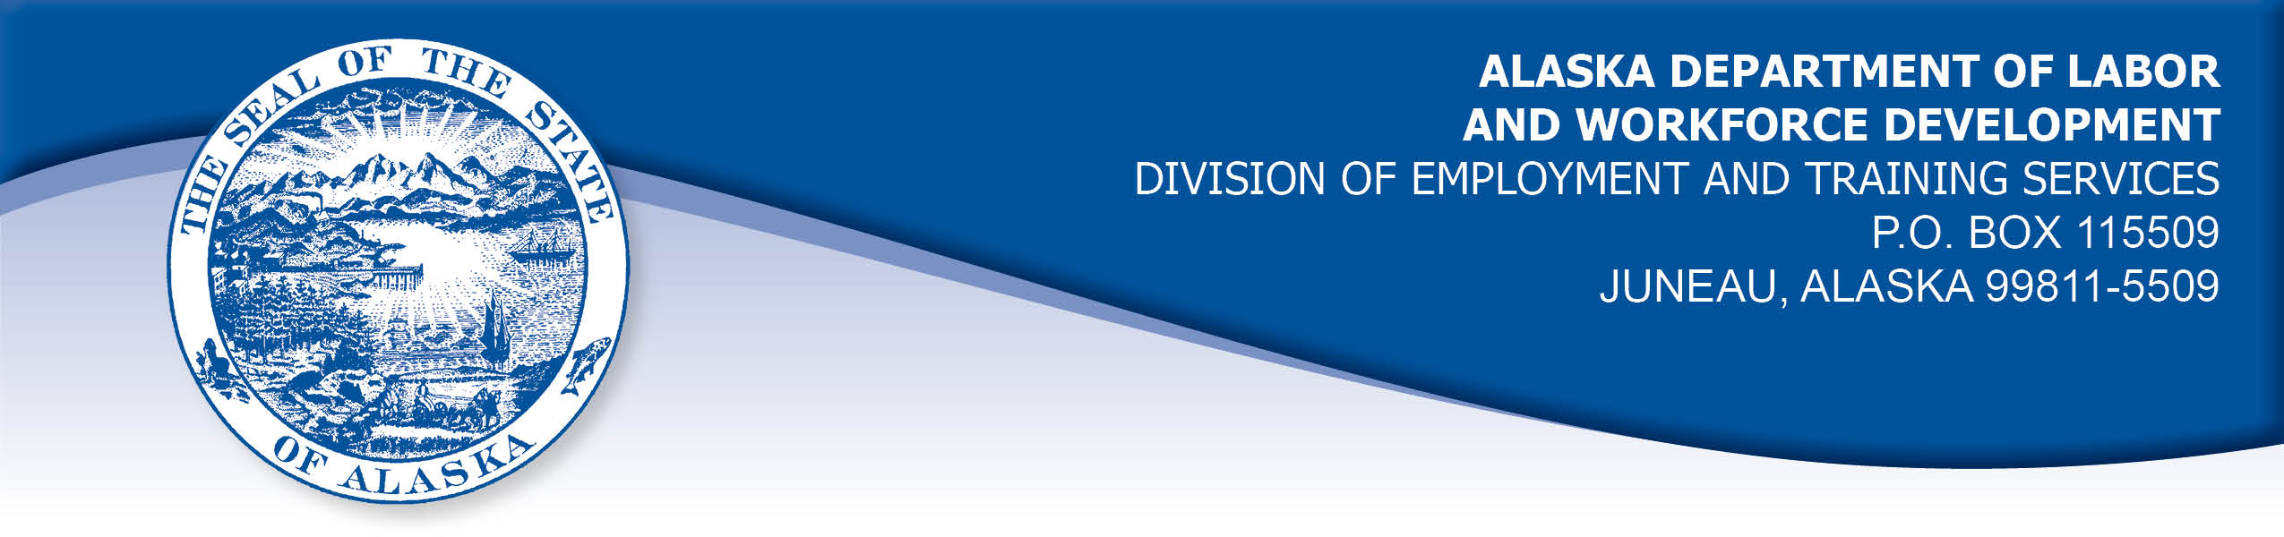

APPEAL TRIBUNAL DECISION

Docket number: 19 0671 Hearing date: 19 0671

CLAIMANT: EMPLOYER:

TRENT PILAND SENIOR CARE SPECIALIST

CLAIMANT APPEARANCES: EMPLOYER APPEARANCES:

Trent Piland None

CASE HISTORY

The claimant timely appealed a July 2, 2019 determination which denied benefits under Alaska Statute 23.20.379. The issue before the Appeal Tribunal is whether the claimant was discharged for misconduct connected with the work.
FINDINGS OF FACT

The claimant began work for the employer in February 2019. He last worked on June 14, 2019. At that time, he worked full time as a human resources director.
The employer had expressed to the claimant a concern that new hires were not being brought on staff quickly enough. The claimant told his supervisor that the procedure was slowed by the state’s background check process, over which the claimant had no control.
The claimant often dropped his daughter off for school at 8:00 and arrived at work at 8:15. The claimant believed his supervisor had agreed that the claimant could make up that time at lunch or by staying late. The claimant sometimes needed extra time to get to work because of a medical issue that flared up in the morning. The claimant always let his supervisor know if he would be late and the claimant believed the employer understood his situation.
The claimant was scheduled to take an hour lunch, but he often took a shorter break. On his last day, the claimant took a lunch break from 12:09 to 12:40 pm. The claimant then returned to the office and immediately checked out to take some documents to a contractor. He expected to be gone for 45 minutes. The claimant stayed longer at the contractor talking to a representative about an issue the employer was having. The claimant returned to the office at 1:49 pm.
The claimant’s supervisor advised him that day that he was being discharged. The claimant explained that he had not been at lunch for almost two hours. The supervisor said the claimant was being discharged because work wasn’t getting done and the claimant was not communicating to his supervisor of what was needed.

PROVISIONS OF LAW

AS 23.20.379 provides in part:

(a) An insured worker is disqualified for waiting-week credit or benefits for the first week in which the insured worker is unemployed and for the next five weeks of unemployment following that week if the insured worker...
(2) was discharged for misconduct connected with the insured worker's last work.

8 AAC 85.095 provides in part:

(d) "Misconduct connected with the insured worker's work" as used in
AS 23.20.379(a)(2) means
(1) a claimant's conduct on the job, if the conduct shows a willful and wanton disregard of the employer's interest, as a claimant might show, for example, through gross or repeated negligence, willful violation of reasonable work rules, or deliberate violation or disregard of standards of behavior that the employer has the right to expect of an employee; willful and wanton disregard of the employer's interest does not arise solely from inefficiency, unsatisfactory performance as the result of inability or incapacity, inadvertence, ordinary negligence in isolated instances, or good faith errors in judgment or discretion....

CONCLUSION

The claimant in this case was discharged because the employer believed he had taken a long lunch and the claimant was not happy with the claimant’s work performance.

Misconduct cannot be established on the basis of unproven allegations. Cole, Com. Dec. 85HUI006, January 22, 1985.

When a worker has been discharged, the burden of persuasion rests upon the employer to establish that the worker was discharged for misconduct in connection with the work. In order to bear out that burden, it is necessary that the employer bring forth evidence of a sufficient quantity and quality to establish that misconduct was involved. Rednal, Com. Dec. 86H-UI-213, August 25, 1986.

In Douglas, Com. Dec. 85H-UI-069, April 26, 1985, paraphrasing AS 44.62.460(d), the commissioner held in part:

“Hearsay evidence may be used to supplement or explain direct evidence but is, by itself, insufficient to support a finding unless that evidence would be admissible over objection in a civil action”.

The employer did not appear at the hearing to offer sworn testimony. The claimant provided credible sworn testimony that he did not take a long lunch, and that his performance failures were due to circumstances not within his control. The employer’s hearsay evidence did not establish that the claimant’s actions rose to the level of misconduct’/.

The Tribunal does not question an employer’s right to discharge a claimant that does not meet its standards, but such a discharge is not always for misconduct. The Tribunal finds the claimant in this case was discharged for reasons other than misconduct and thus the penalties of AS 23.20.379 are not appropriate.

DECISION

The determination issued on July 2, 2019 is REVERSED. Benefits are ALLOWED for the weeks ending June 22, 2019 through July 27, 2019, if otherwise eligible. The three weeks are restored to the claimant’s maximum benefits. The determination will not interfere with the claimant’s eligibility for extended benefits under AS 23.20.406-409.

APPEAL RIGHTS

This decision is final unless an appeal is filed in writing to the Commissioner of Labor and Workforce Development within 30 days after the decision is mailed to each party. The appeal period may be extended only if the appeal is delayed for circumstances beyond the party’s control. A statement of rights and procedures is enclosed.

Dated and mailed on August 7, 2019.

Rhonda Buness, Appeals Officer

