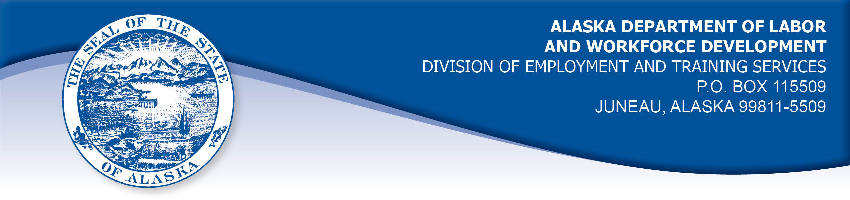

APPEAL TRIBUNAL DECISION

Docket number: 19 0769 Hearing date: August 28, 2019

CLAIMANT: EMPLOYER:

AMY DITTBRENNER AK AIRLINES INC

CLAIMANT APPEARANCES: EMPLOYER APPEARANCES:

Amy Dittbrenner None

CASE HISTORY

The claimant timely appealed a July 25, 2019 determination which denied benefits under Alaska Statute 23.20.379. The issue before the Appeal Tribunal is whether the claimant was discharged for misconduct connected with the work.
FINDINGS OF FACT

The claimant began work for the employer on February 25, 2008. She last worked on July 10, 2019. At that time, she worked full time as a station supervisor.
On June 12, 2019, the claimant was called out to a plane on the tarmac because a cleaning crew had found a hazardous item. The claimant was the senior manager on site shortly after midnight. The claimant walked onto the plane, which had about 8-10 employees on board but no passengers. The claimant was handed an item that had been unwrapped and contained items that appeared to be parts of an explosive device, based on training the claimant had received from the Transportation Security Administration (TSA).
The claimant had been trained that when any hazardous or suspicious item is found, it should not be touched and the area should be vacated and the authorities called. The claimant’s training had not covered what the claimant should do when handed what appeared to be an explosive device. The claimant decided the safest option was for her to leave the plane, to get the device away from the staff on the plane. She feared setting the device down on the plane might be more dangerous than taking it away.
As the claimant reached the tarmac, a TSA representative known to the claimant told her the device was his and this had been a training exercise. The representative asked the claimant what she was doing and she told him that she was planning to remove the device she had been handed to an area away from people and then calling the authorities. The representative told the claimant she had passed the test.
In the week before the June 12, 2019 incident, the employer noted three times it was believed the claimant violated the employer’s rules. In one instance, the claimant helped an elderly disabled passenger into an aisle push chair because the man was trying to get in the chair himself and the passenger’s companion told the claimant the man urgently needed to use the bathroom. The claimant assisted the passenger into the chair and up the aisle a short way before a ramp agent took over. The claimant was advised she should have waited for the ramp agent because it was not her job to assist the passenger off the plane.
In another instance, the claimant asked both flight staff and ramp agents if a tag had been brought to the plane’s cabin to demonstrate to a passenger that their pet was loaded on board the plane. Both assured the claimant the tag had been removed, but it could not be located. The claimant went to the cargo area to take a picture of the pet to show the owner it was on board. The claimant saw the tag was still on the pet’s kennel and she took it up to the flight crew. The claimant was advised she should have asked the ramp agents if she could take the tag because it was not her job to remove the tag.
Immediately following an accident on the tarmac, the claimant asked a ramp supervisor to review security camera video of the accident with her to see if the claimant could tell if a plane had been hit. The claimant does not have computer access to review security video. The claimant could not tell from the video if the plane had been hit. The claimant was advised she should not have asked the supervisor to view the video because he was her peer. The employer then removed the access of ramp supervisors to the security video.
The claimant had not been warned that her job was in jeopardy for any reason and she was frequently sent out by the employer to train station supervisors in other airports.
On July 10, 2019, the claimant was told she was being discharged because she did not follow the proper procedures in the TSA test on June 12, 2019 and because of the three incidents earlier in the week.

PROVISIONS OF LAW

AS 23.20.379 provides in part:

- An insured worker is disqualified for waiting-week credit or benefits for the first week in which the insured worker is unemployed and for

the next five weeks of unemployment following that week if the insured worker...

(2) was discharged for misconduct connected with the insured worker's last work.

8 AAC 85.095 provides in part:

(d) "Misconduct connected with the insured worker's work" as used in
AS 23.20.379(a)(2) means

(1) a claimant's conduct on the job, if the conduct shows a willful and wanton disregard of the employer's interest, as a claimant might show, for example, through gross or repeated negligence, willful violation of reasonable work rules, or deliberate violation or disregard of standards of behavior that the employer has the right to expect of an employee; willful and wanton disregard of the employer's interest does not arise solely from inefficiency, unsatisfactory performance as the result of inability or incapacity, inadvertence, ordinary negligence in isolated instances, or good faith errors in judgment or discretion....

CONCLUSION

The claimant in this case was discharged because she was alleged to have failed to follow the proper procedures during a TSA test and because she had violated employer rules three times in the week before the final incident.

When a worker has been discharged, the burden of persuasion rests upon the employer to establish that the worker was discharged for misconduct in connection with the work. In order to bear out that burden, it is necessary that the employer bring forth evidence of a sufficient quantity and quality to establish that misconduct was involved. Rednal, Com. Dec. 86H-UI-213, August 25, 1986.

The claimant provided credible sworn testimony that each time she was held to have violated the employer’s rules, she was doing her best to provide safety and service to the employer’s passengers and employees. The record does not establish what harm to the employer’s interests was caused or could potentially have been caused by the claimant’s actions.

The meaning of the term misconduct is limited to conduct evincing such willful disregard of an employer's interests as is found in deliberate violations or disregard of standards of behavior which the employer has a right to expect of his employee, or in carelessness or negligence of such degree or recurrence as to manifest equal culpability, wrongful intent or evil design, or to show an intentional and substantial disregard of the employer's interests or of the employee's duties and obligations to his employer. On the other hand mere inefficiency, unsatisfactory conduct, failure in good performance as the result of inability or incapacity, inadvertencies or ordinary negligence in isolated instances, or good faith errors in judgment or discretion are not to be deemed "misconduct" within the meaning of the statute. Boynton Cab Co. v. Neubeck, 237 Wis. 249, 296 N.W. 636 (1041) from Lynch, Com. Rev. No. 82H-UI-051, March 31, 1982.

The employer did not establish that the claimant’s actions were a willful disregard of the employer’s interests. Therefore, the Tribunal must conclude the claimant was discharged for reasons other than misconduct connected with the work and the penalties of AS 23.20.379 are not appropriate.

DECISION

The determination issued on July 25, 2019 is REVERSED. Benefits are ALLOWED for the weeks ending July 20, 2019 through August 24, 2019, if otherwise eligible. The three weeks are restored to the claimant’s maximum benefits. The determination will not interfere with the claimant’s eligibility for extended benefits under AS 23.20.406-409.

APPEAL RIGHTS

This decision is final unless an appeal is filed in writing to the Commissioner of Labor and Workforce Development within 30 days after the decision is mailed to each party. The appeal period may be extended only if the appeal is delayed for circumstances beyond the party’s control. A statement of rights and procedures is enclosed.

Dated and mailed on August 30, 2019.

Rhonda Buness, Appeals Officer

