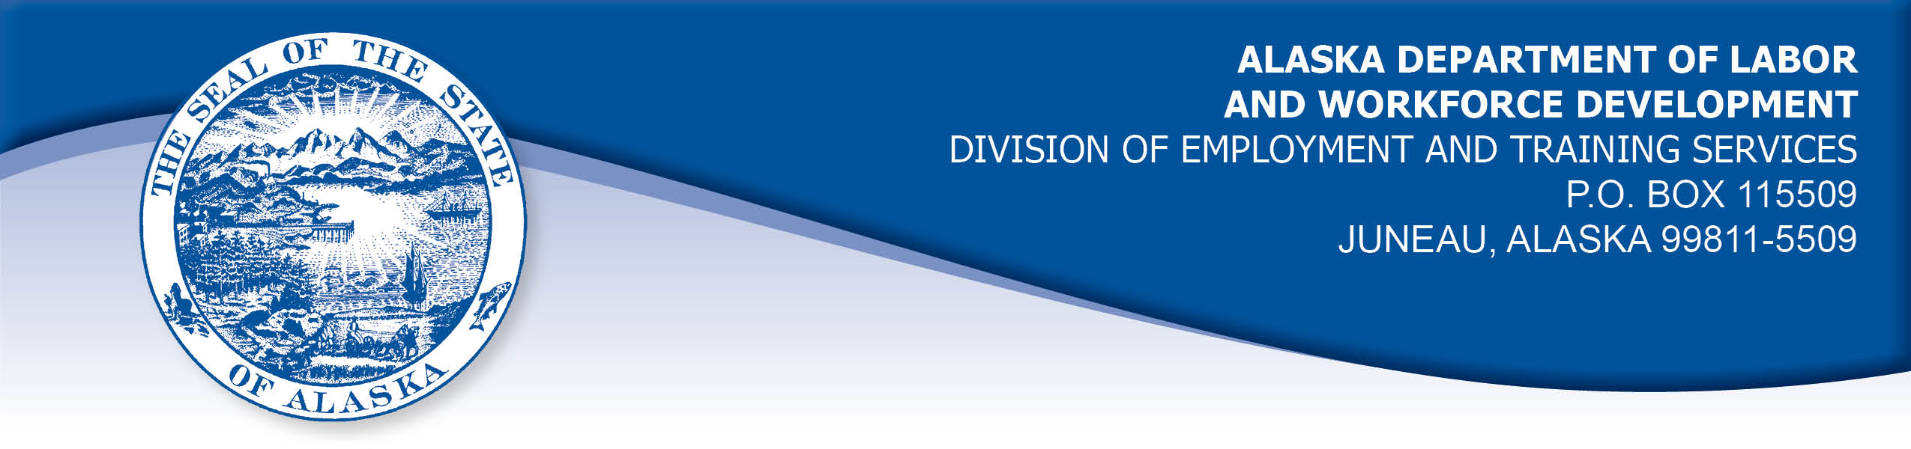

APPEAL TRIBUNAL DECISION

Docket number: 19 0877 Hearing date: October 3, 2019

CLAIMANT: EMPLOYER:

JONATHAN STRYDOM CATC ALASKA TOURISM CORPORATION

CLAIMANT APPEARANCES: EMPLOYER APPEARANCES:

Jonathan Strydom Done

CASE HISTORY

The claimant timely appealed a September 5, 2019 determination which denied benefits under Alaska Statute 23.20.379. The issue before the Appeal Tribunal is whether the claimant was discharged for misconduct connected with the work.

FINDINGS OF FACT

The claimant began work for the employer in April 2018. He last worked on July 16, 2019. At that time, he worked full time as a tour vessel captain.
The claimant was suspended from work for a few days in July 2019. One incident leading to the discipline involved the claimant noting a plugged toilet in the vessel’s log for the third day in a row. The claimant was deeply frustrated by the employer’s failure to correct the problem because it resulted in the claimant and other crew members personally dealing with human waste. The claimant added characters to represent profanity in the vessel’s log to represent his frustration. The employer told the claimant this was unacceptable in the official log of the vessel. The claimant acknowledged that using the characters to represent profanity had been a poor choice made out of frustration. The claimant was given a written warning on July 9, 2019 that the employer expected him to communicate in a professional manner or his job was in jeopardy.
Shortly after he returned from suspension, on about July 14, 2019, the claimant presented the employer with a statement explaining that, aside from the log book entry, each of the employer’s concerns which lead to the claimant’s suspension were the result of the claimant’s crew failing to communicate with the claimant and those failures should not have been held to be the claimant’s fault.
On July 14, 2019, the claimant was loading the employer’s vessel at a boat launch ramp. The vessel had a bow landing ramp, and the standard procedure for loading goods was to have the van driver back down the launch ramp until the van’s tires touched the water. Then crewmembers could step directly from the van to the landing ramp without stepping on the wet, slippery launch ramp. The claimant was on a tight schedule and the van’s location was a safety matter for the crew. The claimant directed the van driver to back down to the water about twelve times, but he refused. The next time, the claimant spoke very sternly and included a profanity in his instruction, which got the driver’s attention and prompted him to comply and back down to the water. The claimant’s profanity was observed by employees, but no passengers or members of the public were present. The claimant acknowledged that he should not have used profanity and likely could have secured the driver’s attention without profanity, however he was frustrated by the driver’s refusal to follow his instruction.
Before the claimant started his next shift, he was called in to a meeting with his supervisor and asked to explain what had happened at the ramp. Following his explanation, the claimant was advised that he was discharged.

PROVISIONS OF LAW

AS 23.20.379 provides in part:

(a) An insured worker is disqualified for waiting-week credit or benefits for the first week in which the insured worker is unemployed and for the next five weeks of unemployment following that week if the insured worker...

(2) was discharged for misconduct connected with the insured worker's last work.

8 AAC 85.095 provides in part:

(d) "Misconduct connected with the insured worker's work" as used in
AS 23.20.379(a)(2) means

(1) a claimant's conduct on the job, if the conduct shows a willful and wanton disregard of the employer's interest, as a claimant might show, for example, through gross or repeated negligence, willful violation of reasonable work rules, or deliberate violation or disregard of standards of behavior that the employer has the right to expect of an employee; willful and wanton disregard of the employer's interest does not arise solely from inefficiency, unsatisfactory performance as the result of inability or incapacity, inadvertence, ordinary negligence in isolated instances, or good faith errors in judgment or discretion....

CONCLUSION

The claimant in this case was discharged after he used profanity directed at an employee, shortly after being disciplined for using characters to represent profanity in the vessel’s logbook.

The employer does have the right to set the parameters of the work. Furthermore, insubordination - that is, refusal to obey a reasonable request of the employer - does constitute misconduct. On the other hand, if just cause can be shown for refusing the request, then misconduct may be converted to a nondisqualifying separation. In Vaara, Com. Dec. 85H-UI-184, September 9, 1985.

In a question of whether insubordination constitutes misconduct in connection with a claimant's work, "it is only necessary to show that he [the claimant] acted willfully against the best interests of his employer in order to establish that." Risen, Com. Dec. 86H-UI-214, September 15, 1986. In Risen, the Commissioner also held that when a claimant refuses an employer's instructions, "Such refusal, absent a showing that the employer's request was unreasonable or detrimental to the individual, is misconduct in connection with the work."

The employer warned the claimant that his log entry with characters representing profanity was not acceptable and warned that further unprofessional communication could result in termination. The claimant argued that his use of profanity toward the van driver was a technique to get the driver’s attention and therefor his unprofessional communication was warranted. The Tribunal does not agree. While the driver’s failure to comply with the claimant’s instruction could have created a safety issue, there was not an immediate safety issue at the time the claimant used profanity. The claimant has demonstrated a pattern of communicating unprofessionally when frustrated.

The Tribunal finds the claimant’s actions were a willful disregard of the employer’s interests. The claimant was discharged due to misconduct as described in regulation 8 AAC 85.095(d). The penalties of AS 23.20.379 are appropriate.

DECISION

The determination issued on September 5, 2019 is AFFIRMED. Benefits remain DENIED for the weeks ending July 20, 2019 through August 24, 2019. The three

weeks remain reduced from the claimant’s maximum benefits. The claimant may not be eligible for extended benefits under AS 23.20.406-409.

APPEAL RIGHTS

This decision is final unless an appeal is filed in writing to the Commissioner of Labor and Workforce Development within 30 days after the decision is mailed to each party. The appeal period may be extended only if the appeal is delayed for circumstances beyond the party’s control. A statement of rights and procedures is enclosed.

Dated and mailed on October 7, 2019.

Rhonda Buness, Appeals Officer

