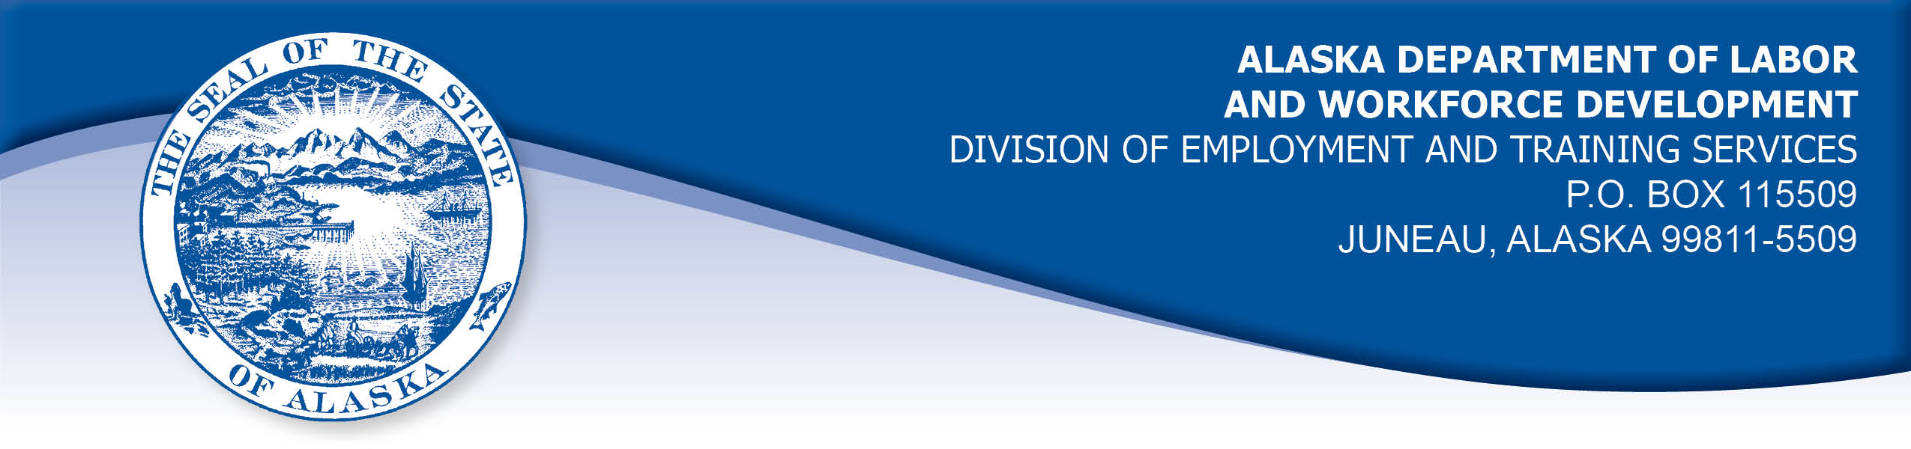

APPEAL TRIBUNAL DECISION

Docket number: 19 1111 Hearing date: December 3, 2019

CLAIMANT: EMPLOYER:

ERIN ROBERTSON-HERBERT DR BRAD WOODRING DMD LLC

CLAIMANT APPEARANCES: EMPLOYER APPEARANCES:

Erin Robertson-Herbert None

CASE HISTORY

The claimant timely appealed a November 1, 2019 determination which denied benefits under Alaska Statute 23.20.379. The issue before the Appeal Tribunal is whether the claimant was discharged for misconduct connected with the work.
FINDINGS OF FACT

The claimant began work for the employer in July 2018. She last worked on October 4, 2019. At that time, she worked full time as an office manager.
At the end of September the claimant was served a subpoena that required her to appear in court on October 7, 2019 for up to five days. The employer was notified of the claimant’s requirement to appear in court.
The claimant called the employer on the afternoon of October 10, 2019 to tell them her court appearance was over. She asked if she should report to work that afternoon or the next morning. The claimant’s supervisor told the her that it had been decided in her absence that her services were no longer required, as her duties had been covered in her absence.
The claimant had not been warned her job was in jeopardy for any reason. The claimant’s supervisor had recently questioned the claimant about a large number of patient credits on the books and the claimant had explained the process she was taught that resulted in the credits. The claimant’s supervisor told her he would clarify the process with a consultant and get back to her. The claimant had received a raise in September which was based on her performance.

PROVISIONS OF LAW

AS 23.20.379 provides in part:

(a) An insured worker is disqualified for waiting-week credit or benefits for the first week in which the insured worker is unemployed and for the next five weeks of unemployment following that week if the insured worker...

(2) was discharged for misconduct connected with the insured worker's last work.

8 AAC 85.095 provides in part:

(d) "Misconduct connected with the insured worker's work" as used in
AS 23.20.379(a)(2) means

(1) a claimant's conduct on the job, if the conduct shows a willful and wanton disregard of the employer's interest, as a claimant might show, for example, through gross or repeated negligence, willful violation of reasonable work rules, or deliberate violation or disregard of standards of behavior that the employer has the right to expect of an employee; willful and wanton disregard of the employer's interest does not arise solely from inefficiency, unsatisfactory performance as the result of inability or incapacity, inadvertence, ordinary negligence in isolated instances, or good faith errors in judgment or discretion....

CONCLUSION

The claimant in this case was discharged after an approved absence.

When a worker has been discharged, the burden of persuasion rests upon the employer to establish that the worker was discharged for misconduct in connection with the work. In order to bear out that burden, it is necessary that the employer bring forth evidence of a sufficient quantity and quality to establish that misconduct was involved. Rednal, Com. Dec. 86H-UI-213, August 25, 1986.

The employer did not participate in the hearing. The claimant provided credible testimony that she was let go after an approved absence and with no warning that her performance was not satisfactory. The employer’s hearsay documents do not establish that the claimant’s actions were a willful disregard of the employer’s interests.

The Tribunal finds the claimant in this case was discharged for reasons other than misconduct and the penalties of AS 23.20.379 are not appropriate.

DECISION

The determination issued on November 1, 2019 is REVERSED. Benefits are ALLOWED for the weeks ending October 12, 2019 through November 16, 2019, if otherwise eligible. The three weeks are restored to the claimant’s maximum benefits. The determination will not interfere with the claimant’s eligibility for extended benefits under AS 23.20.406-409.

APPEAL RIGHTS

This decision is final unless an appeal is filed in writing to the Commissioner of Labor and Workforce Development within 30 days after the decision is mailed to each party. The appeal period may be extended only if the appeal is delayed for circumstances beyond the party’s control. A statement of rights and procedures is enclosed.

Dated and mailed on December 5, 2019.

Rhonda Buness, Appeals Officer

