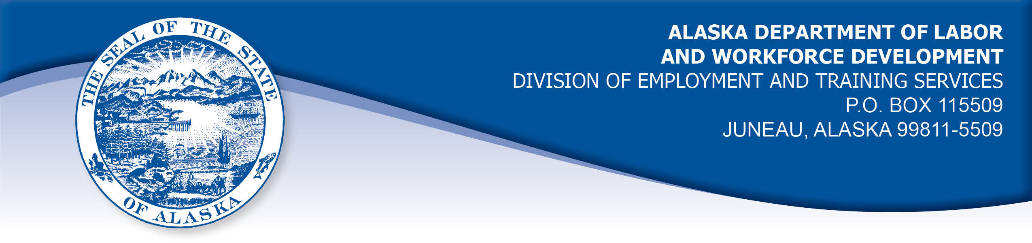

APPEAL TRIBUNAL DECISION

Docket number: 20 0051 Hearing date: February 6, 2020

CLAIMANT: EMPLOYER:

CHRISTIEN BRUNQUIST MAC FEDERAL CREDIT UNION

CLAIMANT APPEARANCES: EMPLOYER APPEARANCES:

Christien Brunquist Marie Rocheleau

CASE HISTORY

The claimant timely appealed a January 2, 2020 determination which denied benefits under Alaska Statute 23.20.379. The issue before the Appeal Tribunal is whether the claimant was discharged for misconduct connected with the work.
FINDINGS OF FACT

The claimant began work for the employer on October 12, 2016. He last worked on November 29, 2019. At that time, he worked full time as an IT manager.
On October 15, 2019, the claimant was counseled regarding his job performance. The employer was disappointed with claimant’s lack of presence in the office and with the status of several projects the claimant was in charge of.
The claimant had been counseled by his supervisor before the Thanksgiving holiday for having a negative attitude at work. The claimant thought about this, and decided his alcohol consumption was affecting his attitude at work so he decided to stop drinking. On Sunday, December 1, 2019, the claimant logged into his work laptop computer, and accessed the employer’s computer system to send an email to his supervisor stating that he would be out December 2, 2019 due to the physical effects of detoxifying from alcohol. The claimant also requested assistance getting his new work cell phone operational.
On December 2, 2019, the employer received an email from the claimant’s work email account. The body of the message identified it as being sent by the claimant’s girlfriend, who detailed the claimant’s medical condition, said he could not type, was having memory problems and advised that she was taking the claimant to see a doctor that day. The claimant’s girlfriend provided her phone number to call with questions. The claimant recalled that he had logged on to the laptop and opened an email message for his girlfriend to type, then closed the laptop when she was finished.
The employer had instructed the claimant not to use his Virtual Private Network (VPN) to access the employer’s computer system from home. The claimant at times needed to access the employer’s computer system from home on an emergency basis to take care of work issues. A co-worker told the claimant he could get around the employer’s policy by using one of two VPNs that were designated for workers to use when out at a field location performing work. The claimant used one of those VPNs to access the employer’s computer system to send his email and for his girlfriend to send an email.
The claimant did not send a text message to his supervisor because his work cell phone was not operational. He believes that his girlfriend’s phone broke at some point during that time. He could have used his personal computer top send a message without violating the employer’s policies, but he didn’t think of that because mental side effects of his medical condition.
The claimant had received a written warning in December 2018 because his work cell phone was accessed by his ex-wife.
The employer’s policy holds that users may not establish connections that would allow non-credit union users to gain access to the employer’s systems and information. Such a violation is grounds for disciplinary action including termination. The employer decided to discharge the claimant because of his violation of the policies and the potential risks to the employer’s security, after previous warning.

PROVISIONS OF LAW

AS 23.20.379 provides in part:

(a) An insured worker is disqualified for waiting-week credit or benefits for the first week in which the insured worker is unemployed and for the next five weeks of unemployment following that week if the insured worker...
(2) was discharged for misconduct connected with the insured worker's last work.

8 AAC 85.095 provides in part:

(d) "Misconduct connected with the insured worker's work" as used in
AS 23.20.379(a)(2) means

(1) a claimant's conduct on the job, if the conduct shows a willful and wanton disregard of the employer's interest, as a claimant might show, for example, through gross or repeated negligence, willful violation of reasonable work rules, or deliberate violation or disregard of standards of behavior that the employer has the right to expect of an employee; willful and wanton disregard of the employer's interest does not arise solely from inefficiency, unsatisfactory performance as the result of inability or incapacity, inadvertence, ordinary negligence in isolated instances, or good faith errors in judgment or discretion....

CONCLUSION

The claimant in this case was discharged because he violated a policy of the employer regarding the employer’s computer security.

The employer does have the right to set the parameters of the work. Furthermore, insubordination - that is, refusal to obey a reasonable request of the employer - does constitute misconduct. On the other hand, if just cause can be shown for refusing the request, then misconduct may be converted to a nondisqualifying separation. In Vaara, Com. Dec. 85H-UI-184, September 9, 1985.

In a question of whether insubordination constitutes misconduct in connection with a claimant's work, "it is only necessary to show that he [the claimant] acted willfully against the best interests of his employer in order to establish that." Risen, Com. Dec. 86H-UI-214, September 15, 1986. In Risen, the Commissioner also held that when a claimant refuses an employer's instructions, "Such refusal, absent a showing that the employer's request was unreasonable or detrimental to the individual, is misconduct in connection with the work."

The claimant in this case understood the employer’s policies and knowingly broke them when he used a VPN to access the employer’s computer system from home, and when he let his girlfriend type emails on his laptop. The claimant had other options to notify the employer. He had been warned for his part in a security issue one year before. The employer has established that the claimant’s actions rose to the level of a willful disregard for the employer’s interests.

The Tribunal finds the claimant was discharged for work related misconduct. The penalties of AS 23.20.379 are appropriate in this case.

DECISION

The determination issued on January 2, 2020 is AFFIRMED. Benefits remain DENIED for the weeks ending December 14, 2019 through January 18, 2020. The three weeks remain reduced from the claimant’s maximum benefits. The claimant may not be eligible for extended benefits under AS 23.20.406-409.

APPEAL RIGHTS

This decision is final unless an appeal is filed in writing to the Commissioner of Labor and Workforce Development within 30 days after the decision is mailed to each party. The appeal period may be extended only if the appeal is delayed for circumstances beyond the party’s control. A statement of rights and procedures is enclosed.

Dated and mailed on February 11, 2020.

Rhonda Buness, Appeals Officer

