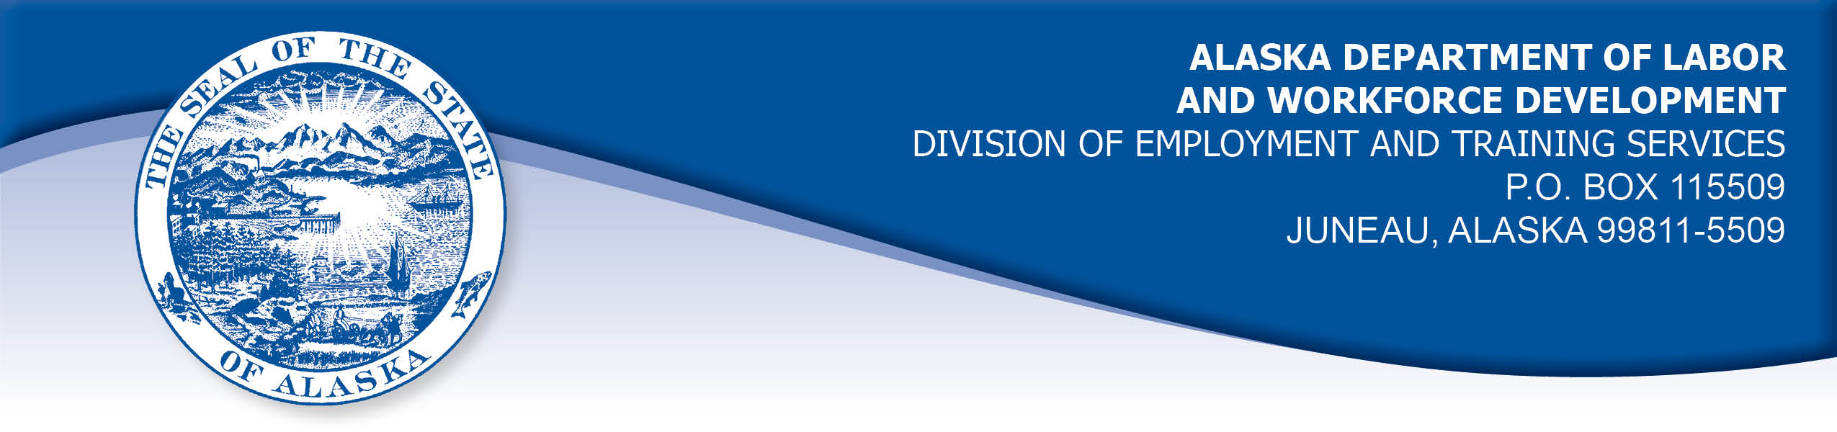

APPEAL TRIBUNAL DECISION

Docket number: 20 0371 Hearing date: May 5, 2020

CLAIMANT:

BRIAN TAYLOR

CLAIMANT APPEARANCES: DETS APPEARANCES:

Brian Taylor None

CASE HISTORY

The claimant timely appealed an April 16, 2020 determination which denied benefits under AS 23.20.378. The issue before the Appeal Tribunal is whether the claimant was able to work and available for suitable work during a period of travel.

FINDINGS OF FACT

The claimant established a claim for unemployment insurance benefits effective March 22, 2020. At that time, he was travelling by car from Utah to Gustavus, Alaska to relocate for work that was scheduled to begin April 12, 2020. The claimant arrived in Juneau on March 27, 2020. He had made arrangements for himself, his travel partner and his vehicle to be transported to Gustavus on March 29, 2020. The transport company cancelled the sailing because it was no longer economically viable after cancellations the business attributed directly to the COVID-19 pandemic. The claimant had to make other arrangements to get his vehicle and himself to Gustavus. The claimant arrived in Gustavus on April 1, 2020.
PROVISIONS OF LAW

AS 23.20.378 provides:

(a) An insured worker is entitled to receive waiting-week credit or benefits for a week of unemployment if for that week the insured worker is able to work and available for suitable work….

8 AAC 85.350:

(a) A claimant is considered able to work if the claimant is physically and mentally capable of performing work under the usual conditions of employment in the claimant's principal occupation or other occupations for which the claimant is reasonably fitted by training and experience.

(b) A claimant is considered available for suitable work for a week if the claimant

(1) registers for work as required under 8 AAC 85.351;
(2) makes independent efforts to find work as directed under 8 AAC 85.352 and 8 AAC 85.355;
(3) meets the requirements of 8 AAC 85.353 during periods of travel;
(4) meets the requirements of 8 AAC 85.356 while in training;
(5) is willing to accept and perform suitable work which the claimant does not have good cause to refuse;
(6) is available, for at least five working days in the week, to respond promptly to an offer of suitable work; and
(7) is available for a substantial amount of full-time employment.

HB 308 UNEMPLOYMENT INSURANCE: BENEFIT QUALIFICATION AND WAITING WEEK DURING NOVEL CORONAVIRUS DISEASE OUTBREAK.
(a) To the extent consistent with federal law, an insured worker who is otherwise qualified to receive a benefit under AS 23.20 (Alaska Employment Security Act) may not be disqualified for failure to comply with AS 23.20.378(a) because of conduct by the insured worker or the employer of the insured worker related to an outbreak of novel coronavirus disease (COVID-19), including conduct involving:
(1) providing care, including medical care, to one or more persons
(2) preventing or limiting the spread of COVID-19; or
(3) preventing or limiting economic loss or harm.
(b) The protection of an insured worker under (a) of this section applies for a period of 120 days beginning on the effective date of this section or the date the insured worker applies for a benefit under AS 23.20, whichever is later.
8 AAC 85.353 provides:

(a) The requirements of this section apply to any period during which a claimant travels outside the customary commutable area in which the claimant resides, unless the claimant travels while exempted from availability requirements under AS 23.20.378(a) or in connection with training approved under AS 23.20.382. For purposes of this section, a customary commutable area means an area where a claimant customarily commutes to and from work each day.
(b) A claimant is available for work each week while traveling only if the claimant is traveling to
(1) search for work and is legally eligible to accept work in the area of travel;
(2) accept an offer of work that begins no later than 14 days after the claimant's departure; or
(3) establish or return to a residence immediately following the claimant's discharge from the armed forces.
(c) A claimant who travels in search of work must be legally eligible to accept work and make reasonable efforts to find work each week in the area of the claimant's travel, by
(1) contacting in person an employment office;
(2) making at least two in-person employer contacts;
(3) registering in person with the local chapter of the claimant's union that has jurisdiction over the area of the claimant's travel; a claimant who has previously registered with the local union that has jurisdiction over the area of the travel is available for work if the claimant makes contacts as required by the union to be eligible for dispatch in the area of the travel; or
(4) attending in person a pre-arranged job interview.
(d) A claimant is not available for work after the claimant travels for more than four consecutive calendar weeks to search for work. A claimant is not available for work after the claimant travels for more than seven days if traveling to
(1) accept an offer or work that begins 14 days after the claimant’s departure; or
(2) establish or return to a residence immediately following the claimant’s discharge from the armed forces.

CONCLUSION

8 AAC 85.353(a) provides that the requirements of this section apply to any period during which a claimant travels outside the area in which the claimant resides. The claimant was in Juneau for the first three days of the week ending April 4, 2020, so the travel provisions apply to him.
8 AAC 85.353(b) provides that a claimant who travels away from their area of residence during their customary workweek is considered available for work only if they travel for one of the three allowable reasons stated in section (c). While the claimant was traveling to accept work, that work was more than 14 days from the date his travel commenced. The claimant did not travel for an allowable reason. Under 8 AAC 85.350, a claimant must be available for work at least five working days of their customary workweek. The claimant was not available for work in Gustavus for five days in the week ending April 4, 2020.
House Bill 308 passed by the Alaska Legislature and made retroactive to March 1, 2020, provides for the waiver of the requirement to be available for work under AS 23.20.378(a) under certain conditions during the COVID-19 pandemic. It provides that to the extent consistent with federal law, an insured worker who is otherwise qualified to receive a benefit under the Alaska Employment Security Act may not be disqualified for failure to comply with AS 23.20.378(a) because of conduct by the insured worker or the employer of the insured worker related to an outbreak of COVID-19, including conduct involving providing care including medical care, and actions limiting economic loss.

The claimant argued that because his delay in Juneau was caused by the actions of the transportation company, in its efforts to prevent economic loss, and therefore his unavailability was a direct result of the COVID-19 pandemic.

The Tribunal agrees. The claimant’s unavailability for work in the week ending April 4, 2020 was directly related to the COVID-19 pandemic and was outside his control. If not for the pandemic, the claimant would have been in Gustavus and available to accept work for five days in the week ending April 4, 2020. The Tribunal finds the claimant can be waived from the requirement to be available for work as allowed in HB 308.

DECISION

The determination issued on April 16, 2020 is REVERSED. Benefits are ALLOWED for the week ending April 4, 2020, if the claimant is otherwise eligible.

APPEAL RIGHTS

This decision is final unless an appeal is filed in writing to the Commissioner of Labor and Workforce Development within 30 days after the decision is mailed to each party. The appeal period may be extended only if the appeal is delayed for circumstances beyond the party’s control. A statement of rights and procedures is enclosed.

Dated and mailed on May 5, 2020

Rhonda Buness, Appeals Office

