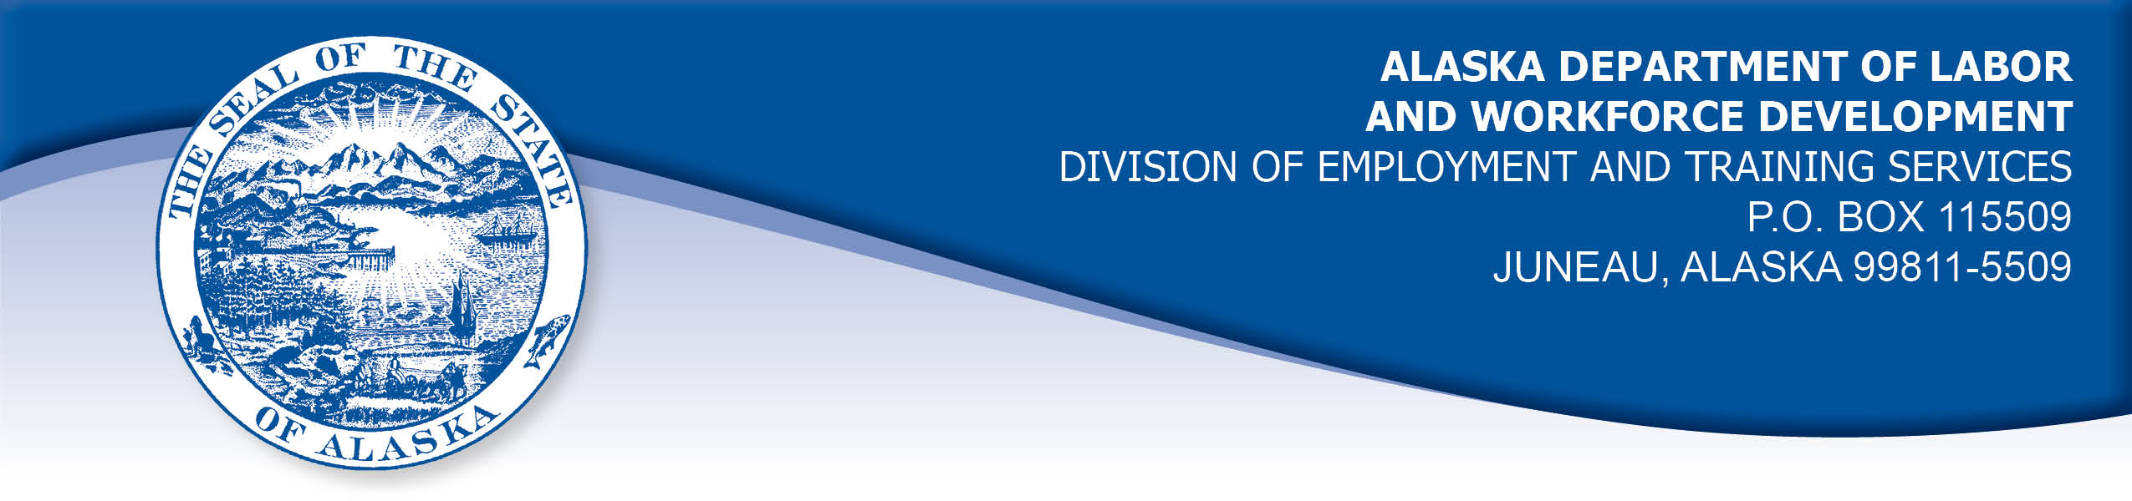

APPEAL TRIBUNAL DECISION

Docket number: 20 0470 Hearing date: June 3, 2020

CLAIMANT: EMPLOYER:

KAREN DESALERNOS MT VIEW RED APPLE MKT

CLAIMANT APPEARANCES: EMPLOYER APPEARANCES:

Karen DeSalernos Ron Peterson

CASE HISTORY

The claimant timely appealed an April 28, 2020 determination which denied benefits under Alaska Statute 23.20.379. The issue before the Appeal Tribunal is whether the claimant was discharged for misconduct connected with the work.
FINDINGS OF FACT

The claimant began work for the employer in May 2005. She had worked at that location for a previous owner since June 2004. She last worked on March 17, 2020. At that time, she worked full time as a cashier.
On January 13, 2020, the claimant was checking out a customer and she failed to complete the customer’s payment transaction. The customer took her purchase and left. The claimant began checking out the second customer, who had been talking and had distracted her from completing the previous sale. She inadvertently added his purchases to the first customer’s unpaid total and charged him for both purchases. Office staff had to fix the second customer’s transaction and refund him for the incorrect amount. The employer later approached the first customer in the store and explained the situation and the customer paid for her previous purchase. The claimant was warned by the general manager that another such error would lead to her termination.
Following this, a customer wrote a check to purchase a pack of cigarettes and his check was not honored. The customer then left with the cigarettes anyway. The claimant paid for the cigarettes herself, because she did not want to get in trouble for the loss. Another customer attempted to purchase a gift card and his payment was declined. The claimant paid for the customer’s gift card because he was known to her and she felt sorry for him.
On March 17, 2020, the claimant was waiting for someone to relieve her at the register so she could take a break. She rang up a customer but did not complete the customer’s payment transaction because she was distracted by her need to use the bathroom and to eat. The customer refused a receipt and left. The customer then returned and asked for a receipt. The claimant had already begun checking out another customer. While attempting to provide a receipt, the claimant pushed a button on the register and both purchases were combined and charged to one customer. Office staff had to help re-ring both purchases and properly reimburse and charge the customers.
The general manager considered that the claimant had made a second similar error after her warning in January. The errors caused inconvenience to the customers and may have caused the incorrect purchase amounts to be unavailable in the customer’s bank accounts for several days until the charges were corrected. Customers experiencing the errors could become dissatisfied with the employer and choose to shop elsewhere. Considerable staff time was required to fix the errors and correct the employer’s records. Immediately after the second incident, the claimant was asked to meet with the general manager in his office. She requested permission to use the bathroom and eat something and then met with the general manager, who advised the claimant that she was discharged for a second cash register error after warning.

PROVISIONS OF LAW

AS 23.20.379 provides in part:

(a) An insured worker is disqualified for waiting-week credit or benefits for the first week in which the insured worker is unemployed and for the next five weeks of unemployment following that week if the insured worker...

(2) was discharged for misconduct connected with the insured worker's last work.

8 AAC 85.095 provides in part:

(d) "Misconduct connected with the insured worker's work" as used in
AS 23.20.379(a)(2) means

(1) a claimant's conduct on the job, if the conduct shows a willful and wanton disregard of the employer's interest, as a claimant might show, for example, through gross or repeated negligence, willful violation of reasonable work rules, or deliberate violation or disregard of standards of behavior that the employer has the right to expect of an employee; willful and wanton disregard of the employer's interest does not arise solely from inefficiency, unsatisfactory performance as the result of inability or incapacity, inadvertence, ordinary negligence in isolated instances, or good faith errors in judgment or discretion....

CONCLUSION

The claimant was discharged for making a second error in completing a customer’s payment transaction after a purchase, resulting in customers being charged incorrectly.

The meaning of the term misconduct is limited to conduct evincing such willful disregard of an employer's interests as is found in deliberate violations or disregard of standards of behavior which the employer has a right to expect of his employee, or in carelessness or negligence of such degree or recurrence as to manifest equal culpability, wrongful intent or evil design, or to show an intentional and substantial disregard of the employer's interests or of the employee's duties and obligations to his employer. On the other hand mere inefficiency, unsatisfactory conduct, failure in good performance as the result of inability or incapacity, inadvertencies or ordinary negligence in isolated instances, or good faith errors in judgment or discretion are not to be deemed "misconduct" within the meaning of the statute. Boynton Cab Co. v. Neubeck, 237 Wis. 249, 296 N.W. 636 (1041) from Lynch, Com. Rev. No. 82H-UI-051, March 31, 1982.

The claimant made two errors that caused harm to the employer’s interests in terms of customer satisfaction and lost work time. Her final error occurred when she was distracted by her bodily needs. The claimant was aware that her job was in jeopardy and she was trying to limit harm to the employer, including paying for cigarettes taken by a customer so she would not be blamed for the loss.

The Tribunal does not dispute an employer’s right to discharge a worker who fails to meet its standards. However, not all performance failures constitute misconduct. The claimant’s errors did not show an intentional and substantial disregard of the employer’s interests, therefore, her discharge was for reasons other than misconduct connected with the work and the penalties of AS 23.20.379 are not appropriate.

DECISION

The determination issued on April 28, 2020 is REVERSED. Benefits are ALLOWED for the weeks ending March 21, 2020 through April 25, 2020. The three weeks are not reduced from the claimant’s maximum benefits. The determination does not exclude the claimant from eligibility for extended benefits under AS 23.20.406-409.

APPEAL RIGHTS

This decision is final unless an appeal is filed in writing to the Commissioner of Labor and Workforce Development within 30 days after the decision is mailed to each party. The appeal period may be extended only if the appeal is delayed for circumstances beyond the party’s control. A statement of rights and procedures is enclosed.

Dated and mailed on June 3, 2020.

Rhonda Buness, Appeals Officer

