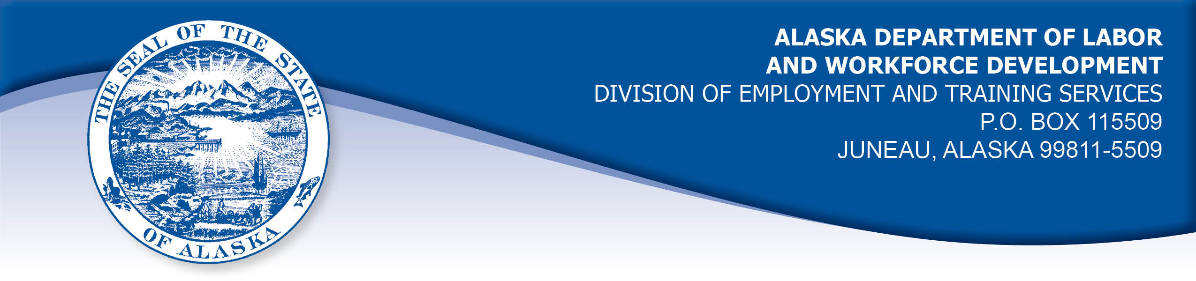

APPEAL TRIBUNAL DECISION

Docket number: 20 0893 Hearing date: August 11, 2020

CLAIMANT:

LEORETA SHAZIMANI

CLAIMANT APPEARANCES: DETS APPEARANCES:

Leoreta Shazimani None

CASE HISTORY

The claimant timely appealed a June 19, 2020 determination which denied benefits under Alaska Statute 23.20.379. The issue before the Appeal Tribunal is whether the claimant refused suitable work.

FINDINGS OF FACT

The claimant established a claim for unemployment insurance benefits effective March 15, 2020. She last worked on March 20, 2020, then the salon where she worked as a stylist was temporarily closed due to mandates related to the COVID-19 pandemic.

After the mandate was lifted, the claimant was contacted by the employer on May 8, 2020 asking her when she would return to work. The claimant told the employer she was concerned about returning at that time, due to concerns about the COVID-19 virus and her son’s health. The claimant’s son has had previous breathing problems and has had a past lung surgery. The claimant was concerned about exposing her son to the virus because his health condition could make him susceptible to complications of the virus. The claimant also believes her husband’s risk of complication is elevated because he is a heavy smoker. The claimant did not seek advice from a medical provider, but relied on public announcements and the continued rise of cases of the virus in her area.

The claimant was aware that the employer had a sanitizing plan and was requiring staff and customers to wear masks. However, the claimant would have to touch customers and their hair would get in her face, even with a mask on. The claimant believed it was too soon to return to close contact with people, so she told the employer she would not return at that time.

PROVISIONS OF LAW

AS 23.20.379. Voluntary quit, discharge for misconduct, and refusal of work.

- An insured worker is disqualified for waiting-week credit or benefits for a week and the next five weeks of unemployment following that week if, for that week, the insured worker fails without good cause

- to apply for available suitable work to which the insured worker was referred by the employment office; or
- to accept suitable work when offered to the insured worker.

AS 23.20.385. Suitable work.

(a) Work may not be considered suitable and benefits may not be denied under a provision of this chapter to an otherwise eligible individual for refusing to accept new work under any of the following conditions:
(1) if the position offered is vacant due directly to a strike, lockout, or other labor dispute;
(2) if the wages, hours, or other conditions of the work offered are substantially less favorable to the individual than those prevailing for similar work in the locality;
(3) if, as a condition of being employed, the individual would be required to join a company union or to resign from or refrain from joining a bona fide labor organization.
(b) In determining whether work is suitable for a claimant and in determining the existence of good cause for leaving or refusing work, the department shall, in addition to determining the existence of any of the conditions specified in (a) of this section, consider the degree of risk to the claimant’s health, safety, and morals, the claimant’s physical fitness for the work, the claimant’s prior training, experience, and earnings, the length of the claimant’s unemployment, the prospects for obtaining work at the claimant’s highest skill, the distance of the available work from the claimant’s residence, the prospects for obtaining local work, and other factors that influence a reasonably prudent person in the claimant’s circumstances.

8 AAC 85.410. Suitable work.

(a) The director shall determine that work is suitable for a claimant if the work is in the claimant's customary occupation, or is work for which the claimant has training and experience.
(b) To determine if the wages, hours, or other conditions of work offered to a claimant are substantially less favorable to him than those prevailing for similar work in the locality, the following standards apply:
(1) similar work is work which is similar in the operations performed, the skill, ability and knowledge required, and the responsibilities involved. A judgment of similar work will not be based on job title, hours of work, wages, permanency of the work, unionization, employee benefits, or other conditions of work;
(2) the locality of the work offered to a claimant is the area surrounding the offered work and is comprised of those establishments which normally use the same labor supply for work similar to the offered work;
(3) the prevailing wages, hours, or other conditions of work are those under which the greatest number of workers are employed in similar work in the locality; however, if the greatest number of workers employed at the same rate is not at least one-third of the total employed, then the prevailing rate will be expressed as the weighted average of the total number of rates;
(4) a condition of work offered to a claimant is not substantially less favorable than that prevailing for similar work in the locality if the difference between the condition of the offered work and the prevailing condition is minor or technical, or would have no adverse effect on the claimant. Wages for work offered to a claimant are substantially less favorable than those prevailing if the offered rate is less than 90 percent of the prevailing rate.

8 AAC 85.420. Refusal of suitable work.

- A claimant will be disqualified under AS 23.20.379(b) for refusing suitable work without good cause, or for a failure to apply for suitable work to which he was referred by the employment office, if the offer of work or referral to work was properly made. An offer of work or referral to work is properly made if

(1) a job opening exists at the time the offer is made or the referral given;
(2) the claimant understands that he is receiving an offer or referral, unless an offer of work is not made by the employer because of claimant actions which cause the employer to withhold an offer of employment;
(3) the claimant is given sufficient information concerning the conditions of the job, including duties, location of the work, hours of work, wages, working conditions, equipment needed, and union requirements, if any, to determine the suitability of the offer or referral; and
(4) the claimant, upon accepting a referral, is given adequate information concerning where and how he should apply.

(c) Refusal of an offer of work includes
(1) refusal of a job offer from an employer or from an agent of the employer having authority to hire;
(2) action by the claimant which causes the employer to withhold a job offer; or
(3) after acceptance of a job offer, a failure to report to work on the first scheduled day of work.

CONCLUSION

The claimant in this case refused an offer to return to work on May 8, 2020. She declined to return to her job because she was concerned about potentially being exposed to the COVID-19 virus despite the employer’s plan for preventing viral spread. The claimant was concerned her son may be susceptible to complications of the COVID-19 virus because of his health issues.

The Division’s Benefit Policy Manual, at VL 5-2 holds:

C. Suitable Work

There is no disqualification if a worker leaves unsuitable work. A worker needs good cause only to quit suitable work.

Suitable work is defined as work in the worker's usual occupation or an occupation for which the worker is reasonably fitted by training, experience, and physical condition.

If the worker has accepted the conditions of employment, by remaining on the job a significant period of time, and not attempting to change the objectionable circumstance, the work is suitable. However, in cases where the work is detrimental to the claimant’s health, even though the claimant is capable of performing a particular job, the work may be deemed unsuitable.

The claimant in this case refused an offer of work not because of a possible detriment to her own health, but that of her young child. The claimant’s decision not to return to work was reasonable in light of her son’s lung issues and the requirement that the claimant touch customers. The Tribunal concludes the work was not suitable for the claimant at the time she refused to return. The penalties of AS 23.20.379 are not appropriate. The potential disqualification period is adjusted to reflect that the claimant refused the offer of work on May 8, 2020.

DECISION

The determination issued on June 19, 2020 is REVERSED and MODIFIED. Benefits are ALLOWED for the weeks ending May 9, 2020 through June 13, 2020, if the claimant is otherwise eligible.

APPEAL RIGHTS

This decision is final unless an appeal is filed in writing to the Commissioner of Labor and Workforce Development within 30 days after the decision is mailed to each party. The appeal period may be extended only if the appeal is delayed for circumstances beyond the party’s control. A statement of rights and procedures is enclosed.

Dated and mailed on September 10, 2020.

Rhonda Buness, Appeals Officer

