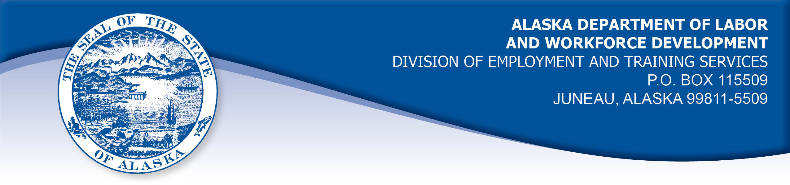

APPEAL TRIBUNAL DECISION

Docket number: 20 1428 Hearing date: October 6, 2019

CLAIMANT: EMPLOYER:

WILLIAM H BELLINGER CHAZ LIMITED

CLAIMANT APPEARANCES: EMPLOYER APPEARANCES:

William Bellinger None

CASE HISTORY

The claimant timely appealed an August 11, 2020 determination which denied benefits under Alaska Statute 23.20.379. The issue before the Appeal Tribunal is whether the claimant was discharged for misconduct connected with the work.
FINDINGS OF FACT

The claimant began work for the employer on in March 2018. He worked as an automobile painter.
At first, he was the lead painter. His supervisor was Mike Hill. At some point a painter, Jonathan, transferred from the Fairbanks, Alaska shop to the shop in Wasilla, Alaska. The claimant was slowly dispossessed of his lead painter position. The painters were all paid the same hourly wages. On the other hand, the body mechanics were paid a commission on their work which resulted in more pay. The claimant was unhappy about this differential treatment but nothing was ever done about it. He attempted to get along with Jonathan, helping when he could, however, he did not feel this was reciprocated. Instead he found him messy and unproductive. The employer did not agree.
After complaints about the shop work environment and the claimant’s angry attitude, in March 2020, management gave the claimant a warning about his behavior.
On about April 22, 2020, the employer received another complaint about the claimant’s behavior, that he was throwing things across the room and speaking angrily to coworkers. It was the last incident.
Ex. 1 page 17 is part of the claimant’s exit interview. He writes, “…My attitude was bad sometimes because of no help from others….I did have my doctor give me med to help. Some attitude was from trying to quit smoking.”
At his hearing, the claimant denied throwing things around, pointing to the fact that he used his own tools and they were expensive. He further denied cursing, yelling, threatening or calling anyone names.
Aside from his behavior, the employer found the claimant a good painter. Nevertheless, the claimant was discharged.

PROVISIONS OF LAW

AS 23.20.379 provides in part:

(a) An insured worker is disqualified for waiting-week credit or benefits for the first week in which the insured worker is unemployed and for the next five weeks of unemployment following that week if the insured worker...

(2) was discharged for misconduct connected with the insured worker's last work.

8 AAC 85.095 provides in part:

(d) "Misconduct connected with the insured worker's work" as used in
AS 23.20.379(a)(2) means

(1) a claimant's conduct on the job, if the conduct shows a willful and wanton disregard of the employer's interest, as a claimant might show, for example, through gross or repeated negligence, willful violation of reasonable work rules, or deliberate violation or disregard of standards of behavior that the employer has the right to expect of an employee; willful and wanton disregard of the employer's interest does not arise solely from inefficiency, unsatisfactory performance as the result of inability or incapacity, inadvertence, ordinary negligence in isolated instances, or good faith errors in judgment or discretion....

CONCLUSION

The claimant in this case was discharged.

The employer did not appear at the hearing to give testimony. Naturally, the claimant disagreed with the employer about the last incident leading to his discharge. Since the claimant’s testimony was given under oath it must be given a little more weigh. Thus, Tribunal hold the claimant’s actions were not willfully against the employer’s interest. as described in Regulation 8 AAC 85.095(d), above.

The Tribunal does not question an employer’s right to discharge a claimant that does not meet its standards, but such a discharge is not always for misconduct. Penalties found under AS 23.20.379 are not appropriate.

DECISION

The determination issued on August 11, 2020 is REVERSED. Benefits are ALLOWED for the weeks ending May 2, 2020 through June 6, 2020, if otherwise eligible. The three weeks are restored to the claimant’s maximum benefits. The determination will not interfere with the claimant’s eligibility for extended benefits under AS 23.20.406-409.

APPEAL RIGHTS

This decision is final unless an appeal is filed in writing to the Commissioner of Labor and Workforce Development within 30 days after the decision is mailed to each party. The appeal period may be extended only if the appeal is delayed for circumstances beyond the party’s control. A statement of rights and procedures is enclosed.

Dated and mailed on October 7, 2020

Michael Swanson, Appeals Officer

