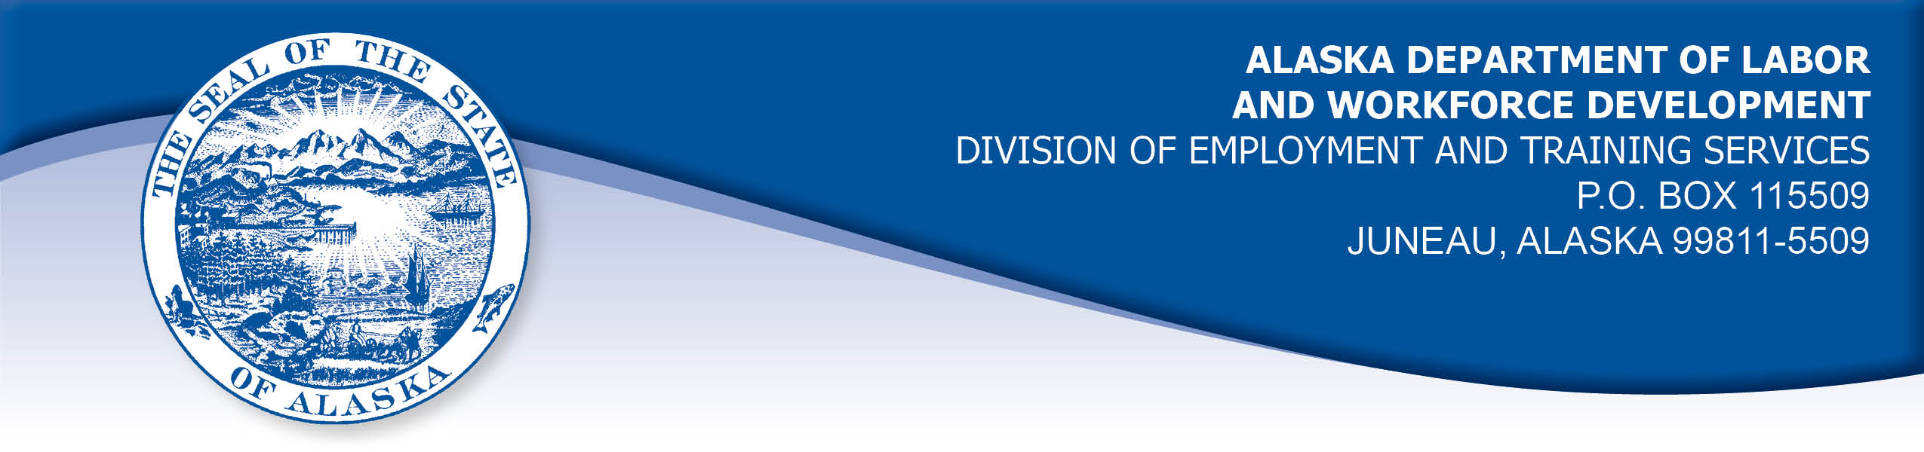

APPEAL TRIBUNAL DECISION

Docket number: 20 1796 Hearing date: December 7, 2020

CLAIMANT:

PATRICK CAMPBELL

CLAIMANT APPEARANCES: DETS APPEARANCES:

Patrick Campbell None

CASE HISTORY

The claimant timely appealed a September 24, 2020 determination which denied benefits under AS 23.20.375. The issue before the Appeal Tribunal is whether the claimant met the filing requirements.

FINDINGS OF FACT

The claimant was laid off on March 22, 2020 when his employer closed due to effects of the COVID-19 pandemic. The claimant’s employer directed him to contact Nevada’s unemployment office and apply for benefits. That week, the claimant contacted the Nevada unemployment office and established a claim for Pandemic Unemployment Assistance (PUA) benefits effective March 22, 2020.

The claimant filed weekly certifications to claim benefits for one or two weeks, then the Nevada UI website would not allow him to file further certifications and advised him to contact the office by phone. The claimant contacted the Nevada unemployment office, and was referred to the PUA office. The PUA office referred the claimant back to the unemployment office. Both offices were overwhelmed with phone calls and the claimant had great difficulty reaching a person or getting a callback from either office. Finally, on June 9, 2020, the claimant’s girlfriend reached a Nevada unemployment representative who told her that she had an open claim for benefits in Alaska and she was required to call Alaska unemployment and re-open that claim. The claimant realized that might be his situation as well, although he had been unaware he still had an active claim in Alaska.

The claimant called the Division on June 9, 2020 and his claim, which had been established in September 2019, was re-opened effective June 7, 2020. The claimant requested that his re-opened claim be back dated to March 22, 2020 and that he be allowed to file for the weeks he had been attempting to claim through Nevada. The claimant’s request was denied.

PROVISIONS OF LAW

AS 23.20.375. Filing requirements
(a) An insured worker is entitled to receive waiting-week credit or benefits for a week of unemployment for which the insured worker has not been disqualified under, 23.20.362, 23.20.378 - 23.20.387, or 23.20.505 if, in accordance with regulations adopted by the department, the insured worker has
(1) made an initial claim for benefits; and
(2) for that week, certified for waiting-week credit or made a claim for benefits.

8 AAC 85.100 Intrastate claim filing: initial claims
(a) Intrastate initial claims, including new claims, transitional claims, additional claims, and reopened claims, as defined in this chapter, must be filed in accordance with the standards set out in this section. A claimant is not eligible for waiting week credit or benefits for any week before the week in which the initial claim is effective under this section.
(b) A claimant shall file an initial claim with an unemployment insurance claim center of the division by
(1) electronic means using an Internet application for benefits, which is the division's preferred and primary method for filing an initial claim;
(2) telephone; or
(3) mail, with the prior approval of the director.

(c) An initial claim is effective Sunday of the week in which the claimant
(1) files the claim; or
(2) requests to file a claim during regular business hours of the division, if the claim cannot be immediately accepted and the claimant files the claim within five business days after the date of that request, or if filed by mail, within 14 calendar days after the date of that request.

(d) An initial claim filed by mail is effective on Sunday of the week of the postmark date of the mailing of the completed claim form.
(e) Repealed 3/25/2007.
(f) A claimant who is in continued claim status at the end of a benefit year must file a new claim to begin a new benefit year. An extended benefit claimant who is in continued claim status at the end of the benefit year, or at the end of any quarter following the benefit year, must file a new claim to determine eligibility for regular benefits in a new benefit year. The director will send a notice of the requirement to file a new claim to the claimant at least two weeks before the end of the benefit year or the end of the applicable calendar quarter.
(g) A transitional claim, or any new claim filed during a series of continued claims after the end of a benefit year, is effective on Sunday of the week immediately following the end of the benefit year or the applicable calendar quarter, if the claim is filed no later than seven calendar days after the end of the benefit year or applicable calendar quarter. The director shall extend the time allowed for filing the claim if the failure to file the claim earlier was caused by an oversight or error of the division.
(h) A claimant shall file an additional claim to begin a new series of continued claims in a benefit year if the claimant had intervening work and
(1) stopped filing continued claims; or
(2) earned wages for a week greater than one and one-third times the weekly benefit amount plus $50.

(i) An claimant filing an additional claim shall provide
(1) the name and address of the claimant's last employer;
(2) the dates of employment; and
(3) the reason for separation from that employer.

(j) A claimant who stopped filing continued claims for a reason other than work shall file a reopened claim to begin a new series of continued claims in the same benefit year. A claimant filing a reopened claim shall provide the reason why the claimant stopped filing continued claims.

Sec. 23.20.095. Exchange of services, facilities, and information.
(a)The administration of this chapter and of other state and federal unemployment compensation and public employment service laws will be promoted by cooperation between this state and those states and the appropriate federal agencies exchanging services and making facilities and information available.
(b)The department may make investigations, secure and transmit information, make available services and facilities, and exercise other powers provided in this chapter with respect to the administration of this chapter which the department considers necessary or appropriate to facilitate the administration of the unemployment compensation or public employment service law of another state or the federal government…

CONCLUSION

The claimant in this case filed a claim for benefits promptly upon becoming unemployed. He lived in Nevada and had most recently worked in Nevada, so his employer’s instruction to contact Nevada’s unemployment office was reasonable to him. He was allowed to establish a claim in Nevada and filed certifications to claim benefits for one or two weeks before he was directed to contact the office. He immediately attempted to do that, but contact was delayed by the flood of calls to that office due to the COVID-19 pandemic. When the claimant did make contact, he was directed to call another office and then referred back to the same office. He eventually realized that he might have to call Alaska only because his girlfriend was directed to do so and their claim situations were similar.

The claimant’s actions in attempting to open a claim in Nevada resulted in a considerable delay in contacting the Division to re-open his claim in Alaska. It can be reasonably assumed that the State of Nevada had access to nationwide unemployment claim information and therefore had an obligation to direct the claimant to contact Alaska to re-open his claim within a reasonable time of his attempt to establish a claim in Nevada.

Because the delayed processing of his claim was through no fault of his own, the Tribunal holds his claim should be backdated to reflect his first attempt to file the necessary initial claim, and continuing claims for benefits filed in a timely fashion.

DECISION

The determination issued on September 24, 2020 is REVERSED. Benefits are ALLOWED beginning with the week ending March 28, 2020, if the claimant is otherwise eligible.

The matter is REMANDED to the Division to change the effective date of the claimant’s re-opened claim to March 22, 2020 and to take certifications for weeks ending March 28, 2020 through June 6, 2020 and enter as timely filed.

APPEAL RIGHTS

This decision is final unless an appeal is filed in writing to the Commissioner of Labor and Workforce Development within 30 days after the decision is

mailed to each party. The appeal period may be extended only if the appeal is delayed for circumstances beyond the party’s control. A statement of rights and procedures is enclosed.

Dated and mailed on December 10, 2020.

Rhonda Buness, Appeals Officer

