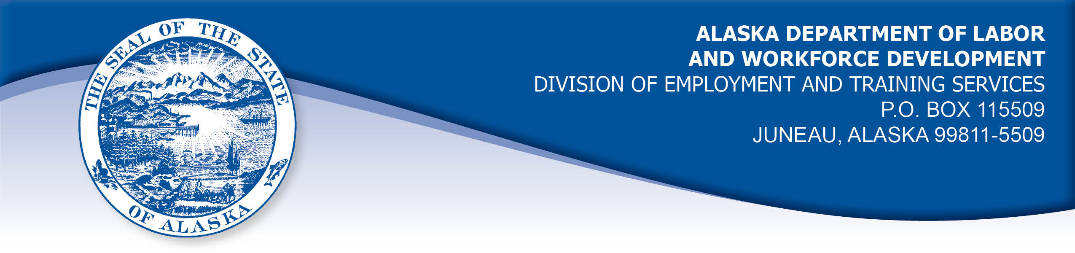

APPEAL TRIBUNAL DECISION

Docket number: 20 1830 Hearing date: December 16, 2020

CLAIMANT: EMPLOYER:

GRACE HARRIS TVI INC

CLAIMANT APPEARANCES: EMPLOYER APPEARANCES:

Grace Harris Jennifer Schmalle

CASE HISTORY

The claimant timely appealed an October 1, 2020 determination which denied benefits under Alaska Statute 23.20.379. The issue before the Appeal Tribunal is whether the claimant voluntarily quit suitable work without good cause.

FINDINGS OF FACT

The claimant began work for the employer in January 2018. She last worked on August 4, 2020. At that time, she worked full time as a production worker.
The claimant returned to work June 22, 2020 after a layoff due to the COVID-19 pandemic. The claimant became concerned because she did not believe the store was being cleaned as required by the store’s policies to prevent the spread of the COVID-19 virus. She observed that the employee restroom appeared not to have been cleaned and she had problems finding cleaning supplies to clean racks used to move clothing, which were supposed to be cleaned each time they were returned from the sales floor. The claimant was told by a supervisor to go borrow cleaning supplies from another area of the store. The store manager agreed that cleaning supplies were in short supply and some were kept in the store office to prevent them from being taken. The manager made supplies available at each employee’s work station about a week after the claimant left employment.
The claimant noted that employees did not always wear required masks properly. The claimant brought her concerns to management several times and she was told the matters would be addressed. A supervisor took her mask off and approached the claimant to talk to her. The manager agreed that some employees needed to be reminded to wear masks properly at first, but she felt that had improved.
The claimant brought her concerns to the production supervisor and an assistant manager and noted no improvements although she was told by the production manager that her concerns would be addressed. The assistant manager told the claimant she wasn’t sure what she could do because she was new to the position. About a week before the claimant left the work, the store manager heard the claimant’s complaints to the production supervisor and she took some actions to improve the cleaning supply situation.
In the claimant’s last week, an employee was visibly sick and laid on the floor during the morning meeting and the employee was not sent home. The employer had a checklist on the employee website advising employees not to come to work with certain symptoms. On August 3, 2020, the claimant learned that the employee had tested positive for COVID-19. The claimant reported to work on August 4, 2020 and was excused to get a COVID-19 test and quarantine at home until she got the results.
On August 5, 2020, the claimant called the manager and told her she was not returning to work because she believed the work environment was unsafe. The manager told her that the store would be enforcing protocols more strictly. The claimant did not accept that assurance because she had been told things would improve before and they had not improved.
The claimant did not contact the employer’s human resources department because she did not want to be seen to be causing problems. She did not request a leave of absence because she did not know it was possible.

PROVISIONS OF LAW

AS 23.20.379 provides in part:

(a) An insured worker is disqualified for waiting-week credit or benefits for the first week in which the insured worker is unemployed and for the next five weeks of unemployment following that week if the insured worker...

- left the insured worker's last suitable work voluntarily without good cause....

8 AAC 85.095 provides in part:

(c) To determine the existence of good cause under AS 23.20.379(a)(1) for voluntarily leaving work determined to be suitable under
AS 23.20.385, the department will consider only the following factors:

(1) leaving work due to a disability or illness of the claimant that makes it impossible for the claimant to perform the duties required by the work, if the claimant has no other reasonable alternative but to leave work;
(2) leaving work to care for an immediate family member who has a disability or illness;
(3) leaving work due to safety or other working conditions or an employment agreement related directly to the work, if the claimant has no other reasonable alternative but to leave work;
(4) leaving work to accompany or join a spouse at a change of location, if commuting from the new location to the claimant’s work is impractical; for purposes of this paragraph, the change of location must be as a result of the spouse’s
(A) discharge from military service; or
(B) employment;
(5) leaving unskilled work to attend a vocational training or retraining course approved by the director under AS 23.20.382, only if the claimant enters the course immediately upon separating from work;
(6) leaving work in order to protect the claimant or the claimant’s immediate family members from harassment or violence;
(7) leaving work to accept a bonafide offer of work that offers better wages, benefits, hours, or other working conditions; if the new work does not materialize, the reasons for the work not materializing must not be due to the fault of the worker;
(8) other factors listed in AS 23.20.385(b).

AS 23.20.385(b) provides, in part:

(b) In determining whether work is suitable for a claimant and in determining the existence of good cause for leaving or refusing work, the department shall, in addition to determining the existence of any of the conditions specified in (a) of this section, consider the degree of risk to the claimant's health, safety, and morals, the claimant's physical fitness for the work, the claimant's prior training, experience, and earnings, the length of the claimant's unemployment, the prospects for obtaining work at the claimant's highest skill, the distance of the available work from the claimant's residence, the prospects for obtaining local work, and
other factors that influence a reasonably prudent person in the claimant's circumstances.

CONCLUSION

Alaska Statute 23.20.385(b) holds that when considering if a claimant had good cause to leave work, the Department will consider if work is suitable to the claimant including the degree of risk to a claimant’s health.

The claimant had brought her concerns with lack of proper cleaning and other COVID-19 protocols to the management’s attention several times between June 22, 2020 and August 4, 2020, including a discussion with the store manager a week before she left the work. The store manager made efforts to improve the adherence to the store cleaning protocols, but had not been able to distribute sufficient cleaning supplies to each work station before the claimant left the work. Although the store had a policy about employees staying home when sick, a sick employee was allowed to stay at work even though she was so ill she laid on the floor during the morning staff meeting. That employee later tested positive for COVID-19, which prompted the claimant to decide to leave the work.

The claimant has established that the employer did not provide sufficient cleaning supplies for employees to comply with the employer’s protocols for cleaning the clothing racks and that an employee was allowed to remain at work despite being clearly ill. These circumstances risked the claimant’s health.

The Tribunal finds the work was not suitable for the claimant at the time she decided to leave the work. Under AS 23.20.379, a claimant does not have to show good cause for voluntarily leaving unsuitable work. The penalties of AS 23.20.379 are not appropriate.

DECISION

The determination issued on October 1, 2020 is REVERSED. Benefits are ALLOWED for the weeks ending August 8, 29020 through September 12, 2020, if otherwise eligible. The three weeks are restored to the claimant’s maximum benefits. The determination will not interfere with the claimant’s eligibility for extended benefits under AS 23.20.406-409.

APPEAL RIGHTS

This decision is final unless an appeal is filed in writing to the Commissioner of Labor and Workforce Development within 30 days after the decision is mailed to each party. The appeal period may be extended only if the appeal is delayed for circumstances beyond the party’s control. A statement of rights and procedures is enclosed.

Dated and mailed on December 18, 2020.

Rhonda Buness, Appeals Officer

