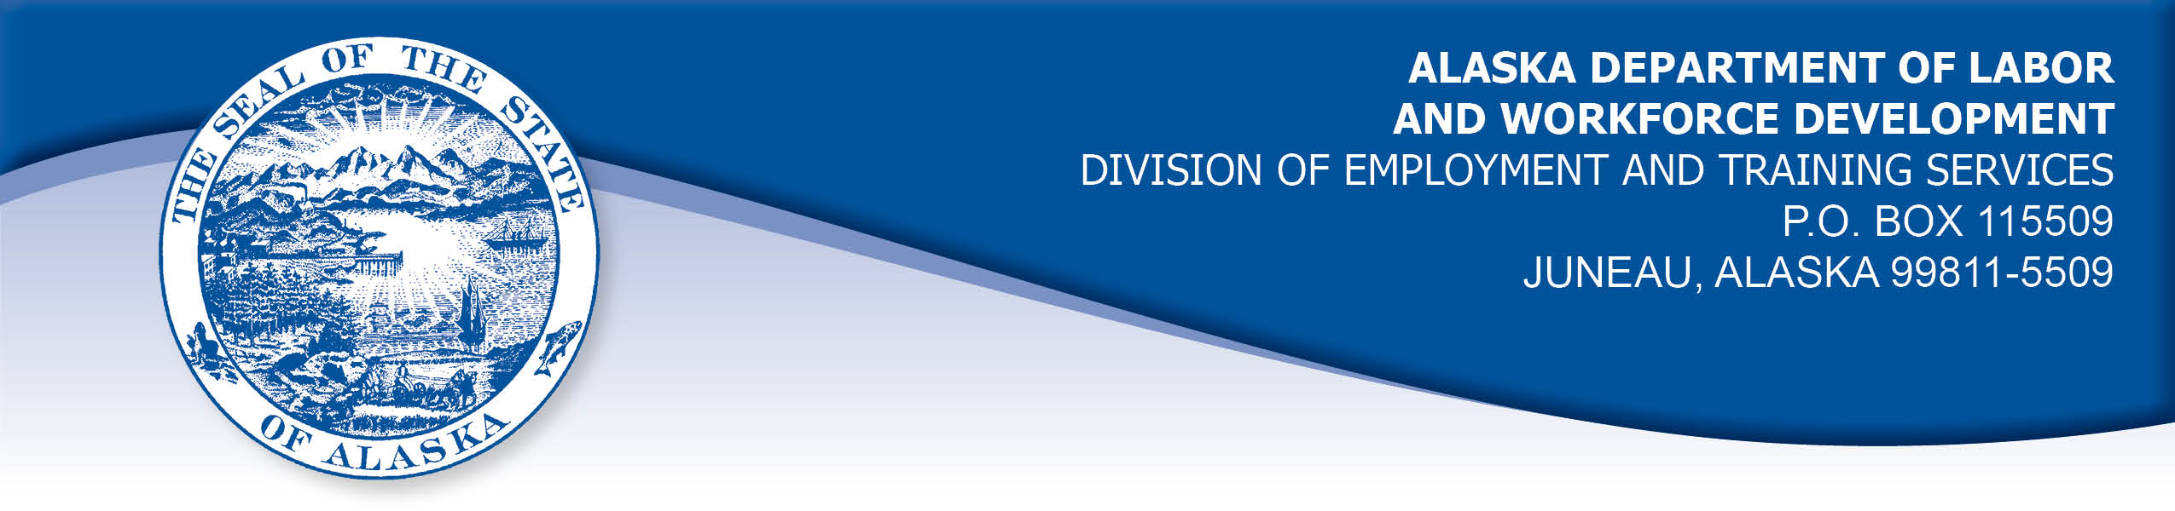

APPEAL TRIBUNAL DECISION

Docket number: 20 1892 Hearing date: January 8, 2021

CLAIMANT: EMPLOYER:

JAMES ELISOFF SILVER BOW CONSTRUCTION CO INC

CLAIMANT APPEARANCES: EMPLOYER APPEARANCES:

James Elisoff None

CASE HISTORY

The claimant timely appealed an October 9, 2020 determination which denied benefits under Alaska Statute 23.20.379. The issue before the Appeal Tribunal is whether the claimant voluntarily quit suitable work without good cause or was discharged for misconduct connected with the work.

FINDINGS OF FACT

The claimant began work for the employer in the first week of March 2020. He last worked on July 6, 2020. At that time, he worked full time as a laborer.
The claimant had agreed on hire that he would obtain a driver’s license, as it was required for his employment. The claimant was unable to get his license because the Department of Motor Vehicles was unable to provide driving tests due to the COVID-19 pandemic, starting shortly after the claimant began work.

On July 6, 2020, the employer assigned the claimant to work in the employer’s shop instead of in the field. The claimant was ill with nausea and a fever that day and he asked to go home early. The employer sent another worker to give the claimant a ride home. The next day, the claimant had just pulled into the employer’s parking lot when he received a message from his supervisor that he was to stand down, as there was no work available for him. In the following weeks, the claimant contacted the employer periodically as instructed. On July 17, 2020, the claimant’s supervisor told him that there would not likely be work for him without a driver’s license. The supervisor recommended the claimant file for unemployment benefits.

PROVISIONS OF LAW

AS 23.20.379 provides in part:

(a) An insured worker is disqualified for waiting-week credit or benefits for the first week in which the insured worker is unemployed and for the next five weeks of unemployment following that week if the insured worker...

- left the insured worker's last suitable work voluntarily without good cause....
- was discharged for misconduct connected with the insured
worker's last work.

8 AAC 85.095 provides in part:

(c) To determine the existence of good cause under AS 23.20.379(a)(1) for voluntarily leaving work determined to be suitable under
AS 23.20.385, the department will consider only the following factors:

(1) leaving work due to a disability or illness of the claimant that makes it impossible for the claimant to perform the duties required by the work, if the claimant has no other reasonable alternative but to leave work;
(2) leaving work to care for an immediate family member who has a disability or illness;
(3) leaving work due to safety or other working conditions or an employment agreement related directly to the work, if the claimant has no other reasonable alternative but to leave work;
(4) leaving work to accompany or join a spouse at a change of location, if commuting from the new location to the claimant’s work is impractical; for purposes of this paragraph, the change of location must be as a result of the spouse’s
(A) discharge from military service; or
(B) employment;
(5) leaving unskilled work to attend a vocational training or retraining course approved by the director under AS 23.20.382, only if the claimant enters the course immediately upon separating from work;
(6) leaving work in order to protect the claimant or the claimant’s immediate family members from harassment or violence;
(7) leaving work to accept a bonafide offer of work that offers better wages, benefits, hours, or other working conditions; if the new work does not materialize, the reasons for the work not materializing must not be due to the fault of the worker;
(8) other factors listed in AS 23.20.385(b).

(d) "Misconduct connected with the insured worker's work" as used in
AS 23.20.379(a)(2) means

(1) a claimant's conduct on the job, if the conduct shows a willful and wanton disregard of the employer's interest, as a claimant might show, for example, through gross or repeated negligence, willful violation of reasonable work rules, or deliberate violation or disregard of standards of behavior that the employer has the right to expect of an employee; willful and wanton disregard of the employer's interest does not arise solely from inefficiency, unsatisfactory performance as the result of inability or incapacity, inadvertence, ordinary negligence in isolated instances, or good faith errors in judgment or discretion....

AS 23.20.385(b) provides, in part:

(b) In determining whether work is suitable for a claimant and in determining the existence of good cause for leaving or refusing work, the department shall, in addition to determining the existence of any of the conditions specified in (a) of this section, consider the degree of risk to the claimant's health, safety, and morals, the claimant's physical fitness for the work, the claimant's prior training, experience, and earnings, the length of the claimant's unemployment, the prospects for obtaining work at the claimant's highest skill, the distance of the available work from the claimant's residence, the prospects for obtaining local work, and
other factors that influence a reasonably prudent person in the claimant's circumstances.

CONCLUSION

A discharge is “a separation from work in which the employer takes the action which results in the separation, and the worker does not have the choice of remaining in employment." 8 AAC 85.010(20). Voluntary leaving means a separation from work in which the worker takes the action which results in the separation, and the worker does have the choice of remaining in employment. Swarm, Com. Dec. 87H-UI-265, September 29, 1987. Alden, Com. Dec. 85H-UI-320, January 17, 1986.

The claimant in this case stopped working because there was no work available for him. He continued to contact the employer to see if work was available until July 17, 2020, when the employer told him no work would be available for him. The claimant established a claim for benefits that day.

The claimant has established that he did not intend to quit the work. The employer took the action to end the employment relationship when the supervisor told the claimant to file an unemployment claim because there was not work available for him without a driver’s license. The separation is a discharge, so the Tribunal will consider if the discharge was for misconduct.

The claimant was unable to obtain a driver’s license because the DMV office was closed due to COVID-19, which was a circumstance beyond the claimant’s control. It has not been established that the claimant’s actions were a willful disregard of the employer’s interests and rise to the level of misconduct.

The Tribunal concludes that the claimant was discharged for reasons other than misconduct. The penalties of AS 23.20.379 are not appropriate in this case.

DECISION

The determination issued on October 9, 2020 is REVERSED. Benefits are ALLOWED for the weeks ending July 11, 2020 through August 15, 2020, if otherwise eligible. The three weeks are restored to the claimant’s maximum benefits. The determination will not interfere with the claimant’s eligibility for extended benefits under AS 23.20.406-409.

APPEAL RIGHTS

This decision is final unless an appeal is filed in writing to the Commissioner of Labor and Workforce Development within 30 days after the decision is mailed to each party. The appeal period may be extended only if the appeal is delayed for circumstances beyond the party’s control. A statement of rights and procedures is enclosed.

Dated and mailed on January 11, 2021.

Rhonda Buness, Appeals Officer

