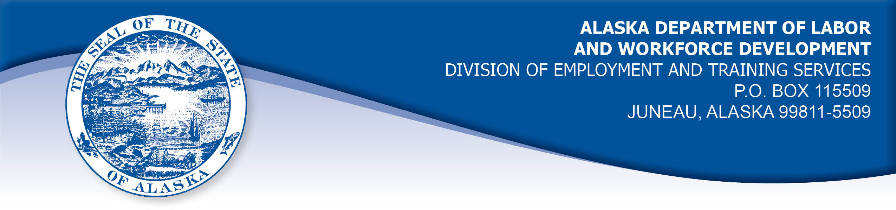

APPEAL TRIBUNAL DECISION

Docket number: 20 1939 Hearing date: January 29, 2021

CLAIMANT:

WHITNEY WOLFE

CLAIMANT APPEARANCES: DETS APPEARANCES:

Whitney Wolfe None

CASE HISTORY

The claimant timely appealed an October 21, 2020 determination which denied benefits under Alaska Statute 23.20.378. The issue before the Appeal Tribunal is whether the claimant was able to work and available for suitable work or whether she was eligible for a waiver of the requirement to be available.
FINDINGS OF FACT

The claimant established a claim for unemployment insurance benefits effective August 23, 2020.
The claimant was sick on October 12, 2020 and called her employer. The claimant’s employer required a negative COVID-19 test before the claimant could return to work. The claimant was tested on October 12, 2020. She did not get her negative test result until October 19, 2020, due to testing backlog. She returned to work for her next scheduled shift after that date.
PROVISIONS OF LAW

AS 23.20.378 provides:

(a) An insured worker is entitled to receive waiting-week credit or benefits for a week of unemployment if for that week the insured worker is able to work and available for suitable work. An insured worker is not considered available for work unless registered for work in accordance with regulations adopted by the department. An insured worker may not be disqualified for failure to comply with this subsection if
(1) the insured worker is not available for work because the insured worker

(A) is ill or disabled;
(B) is traveling to obtain medical services that are not available in the area in which the insured worker resides, or, if a physician determines it is necessary, the insured worker is accompanying a spouse or dependent who is traveling to obtain medical services;
(C) resides in the state and is non-commercially hunting or fishing for personal survival or the survival of dependents;
(D) is serving as a prospective or impaneled juror in a court; or
(E) is attending the funeral of an immediate family member for a period of no longer than seven days; and

(2) a condition described in (1) of this subsection occurs during an uninterrupted period of unemployment immediately following a week for which the insured worker has filed a compensable claim, and work has not been offered that would have been suitable for the insured worker before the illness, disability, hunting, fishing, medical travel, jury service, or funeral attendance.

(b) A waiver of disqualification for an illness or disability under (a)(1) of this section may not exceed six consecutive weeks.

8 AAC 85.350:

(a) A claimant is considered able to work if the claimant is physically and mentally capable of performing work under the usual conditions of employment in the claimant's principal occupation or other occupations for which the claimant is reasonably fitted by training and experience.

(b) A claimant is considered available for suitable work for a week if the claimant

(1) registers for work as required under 8 AAC 85.351;
(2) makes independent efforts to find work as directed under 8 AAC 85.352 and 8 AAC 85.355;
(3) meets the requirements of 8 AAC 85.353 during periods of travel;
(4) meets the requirements of 8 AAC 85.356 while in training;
(5) is willing to accept and perform suitable work which the claimant does not have good cause to refuse;
(6) is available, for at least five working days in the week, to respond promptly to an offer of suitable work; and
(7) is available for a substantial amount of full-time employment.

HB 308 UNEMPLOYMENT INSURANCE: BENEFIT QUALIFICATION AND WAITING WEEK DURING NOVEL CORONAVIRUS DISEASE OUTBREAK.
(a) To the extent consistent with federal law, an insured worker who is otherwise qualified to receive a benefit under AS 23.20 (Alaska Employment Security Act) may not be disqualified for failure to comply with AS 23.20.378(a) because of conduct by the insured worker or the employer of the insured worker related to an outbreak of novel coronavirus disease (COVID-19), including conduct involving:
(1) providing care, including medical care, to one or more persons
(2) preventing or limiting the spread of COVID-19; or
(3) preventing or limiting economic loss or harm.
(b) The protection of an insured worker under (a) of this section applies for a period of 120 days beginning on the effective date of this section or the date the insured worker applies for a benefit under AS 23.20, whichever is later.

CONCLUSION

AS 23.20.378 requires that a claimant be able to work and available for work in order to be eligible for benefits.

HB 308 was signed into law March 26, 2020 in response to the COVID-19 pandemic. It holds that claimants are not to be denied benefits if they are not available for work because of actions of the claimant or their employer that are intended to prevent the spread of the COVID-19 virus. The protection under the law is in effect for 120 days after the claimant established her claim, which was August 23, 2020.

The claimant in this case was not able to work as scheduled in the week ending October 17, 2020 because she was ill and her employer required her to get a COVID-19 test before returning to work. Such a policy is reasonably meant to limit or prevent the spread of the COVID-19 virus.

The Tribunal finds the claimant is waived from the requirement to be able and available in the weeks under review.

DECISION

The determination issued on October 21, 2020 is REVERSED. Benefits are ALLOWED for the weeks ending October 17, 2020 and October 24, 2020, if the claimant is otherwise eligible.

APPEAL RIGHTS

This decision is final unless an appeal is filed in writing to the Commissioner of Labor and Workforce Development within 30 days after the decision is mailed to each party. The appeal period may be extended only if the appeal is delayed for circumstances beyond the party’s control. A statement of rights and procedures is enclosed.

Dated and mailed on February 2, 2021

Rhonda Buness, Appeals Officer

