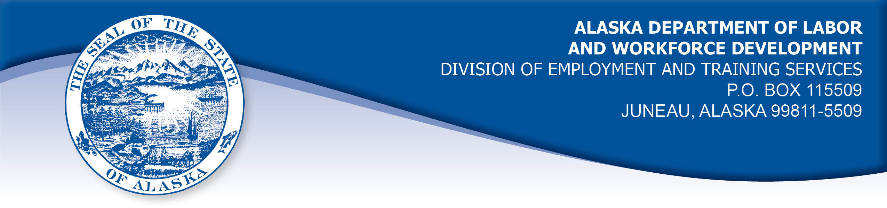

APPEAL TRIBUNAL DECISION

Docket number: 20 2153 Hearing date: March 15, 2021

CLAIMANT: EMPLOYER:

LINDA CARTER TANANA CHIEFS CONFERENCE INC

CLAIMANT APPEARANCES: EMPLOYER APPEARANCES:

Linda Carter Georgianne Kannenberg

CASE HISTORY

The claimant timely appealed a November 11, 2020 determination which denied benefits under Alaska Statute 23.20.379. The issue before the Appeal Tribunal is whether the claimant was discharged for misconduct connected with the work.
FINDINGS OF FACT

The claimant began work for the employer in February 2008. She last worked on July 23, 2020. At that time, she worked full time as a dental assistant.
Shortly before the work ended, the employer asked the claimant to get clearance from her healthcare provider to assist with dental surgical procedures. The claimant’s supervisor was aware of the claimant’s health circumstances, which include issues that could make her more susceptible to complications of the COVID-19 virus. The claimant obtained medical clearance to assist with surgeries.
On the claimant’s last day, she was assigned to work outside administering COVID-19 testing. The claimant was upset about the assignment. The employer had asked for volunteers for that work, and the claimant had not volunteered. The claimant was the oldest assistant on staff and she felt she was being exposed to the virus unnecessarily.
The claimant had a meeting that day with where she was very upset over the assignment to the point she was crying. The claimant felt the supervisor was hovering over her and telling her that the employer had the right to make the assignment. The claimant told the supervisor her doctor would not have cleared her for that work. At one point, the claimant’s supervisor asked the claimant to listen, and the claimant said something to the effect that she was so angry she wanted to pop the supervisor’s head off, or pop the supervisor in the head. Security was called and the claimant was escorted from the workplace. She was advised afterward that she was discharged because of the unprofessional and inappropriate threatening remarks she made on her last day. The employer has a policy regarding the behavior of staff which forbids such threats. The employer considered the claimant’s behavior on her last day egregious enough on its own to merit discharge.

PROVISIONS OF LAW

AS 23.20.379 provides in part:

(a) An insured worker is disqualified for waiting-week credit or benefits for the first week in which the insured worker is unemployed and for the next five weeks of unemployment following that week if the insured worker..
(2) was discharged for misconduct connected with the insured worker's last work.

8 AAC 85.095 provides in part:

(d) "Misconduct connected with the insured worker's work" as used in
AS 23.20.379(a)(2) means
(1) a claimant's conduct on the job, if the conduct shows a willful and wanton disregard of the employer's interest, as a claimant might show, for example, through gross or repeated negligence, willful violation of reasonable work rules, or deliberate violation or disregard of standards of behavior that the employer has the right to expect of an employee; willful and wanton disregard of the employer's interest does not arise solely from inefficiency, unsatisfactory performance as the result of inability or incapacity, inadvertence, ordinary negligence in isolated instances, or good faith errors in judgment or discretion....

CONCLUSION

The claimant in this case was very upset over her assignment to work administering COVID-19 tests and she threatened her supervisor with physical violence. This violated the employer’s policy against workplace threats of violence and the claimant was discharged.

The employer does have the right to set the parameters of the work. Furthermore, insubordination - that is, refusal to obey a reasonable request of the employer - does constitute misconduct. On the other hand, if just cause can be shown for refusing the request, then misconduct may be converted to a nondisqualifying separation. In Vaara, Com. Dec. 85H-UI-184, September 9, 1985.

In a question of whether insubordination constitutes misconduct in connection with a claimant's work, "it is only necessary to show that he [the claimant] acted willfully against the best interests of his employer in order to establish that." Risen, Com. Dec. 86H-UI-214, September 15, 1986. In Risen, the Commissioner also held that when a claimant refuses an employer's instructions, "Such refusal, absent a showing that the employer's request was unreasonable or detrimental to the individual, is misconduct in connection with the work."

The claimant argued that the employer was singling her out and unfairly exposing her to the COVID-19 virus. She argued that her doctor did not clear her for the work the employer assigned her to. The claimant’s arguments do not excuse her violation of the employer’s policy against threats of physical violence. The policy is reasonable and it is not detrimental to the claimant to refrain from violent speech.

It has been shown that the claimant acted willfully against the employer’s interests and her discharge was for work related misconduct. The penalties of AS 23.20.379 are appropriate.

DECISION

The determination issued on November 11, 2020 is AFFIRMED. Benefits remain DENIED for the weeks ending July 25, 2020 through August 29, 2020. The three weeks are reduced from the claimant’s maximum benefits. The claimant may not be eligible for extended benefits under AS 23.20.406-409.

APPEAL RIGHTS

This decision is final unless an appeal is filed in writing to the Commissioner of Labor and Workforce Development within 30 days after the decision is mailed to each party. The appeal period may be extended only if the appeal is delayed for circumstances beyond the party’s control. A statement of rights and procedures is enclosed.

Dated and mailed on March 16, 2021.

Rhonda Buness, Appeals Officer

