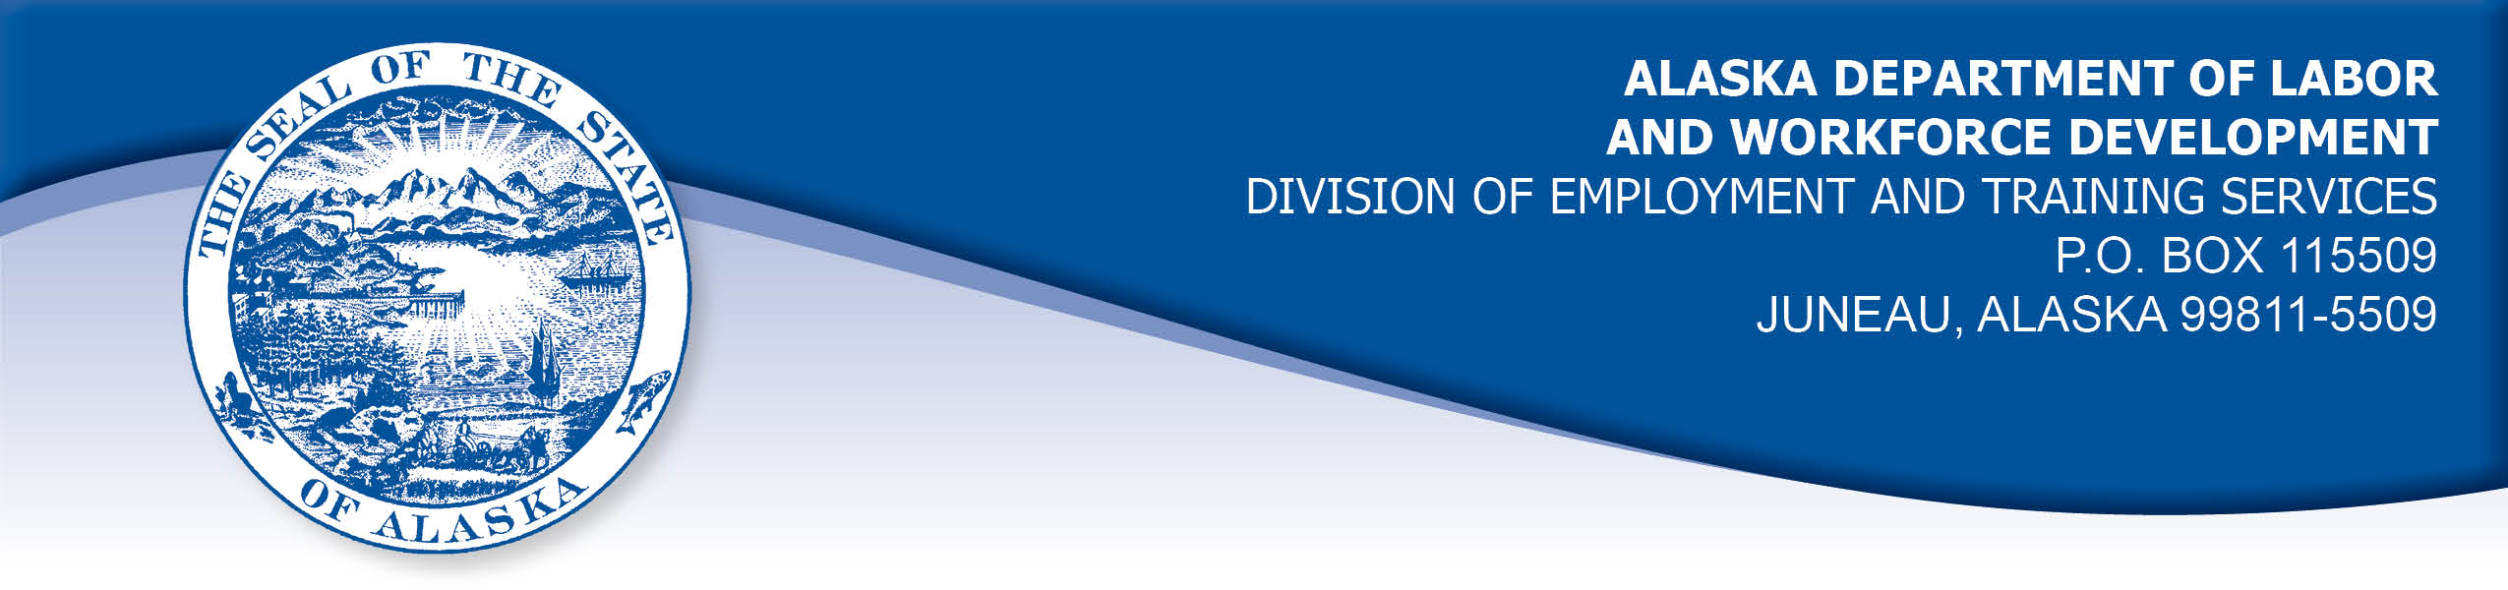

APPEAL TRIBUNAL DECISION

Docket number: 20 2285 Hearing date: April 6, 2021

CLAIMANT: EMPLOYER:

FONY IMAWAN KIKIKTAGRUK INUPIAT CORPORATION

CLAIMANT APPEARANCES: EMPLOYER APPEARANCES:

Font Imwan None
Tim Woodall

CASE HISTORY

The claimant timely appealed a November 18, 2020 determination which denied benefits under Alaska Statute 23.20.379. The issue before the Appeal Tribunal is whether the claimant was discharged for misconduct connected with the work.

FINDINGS OF FACT

The claimant began work for the employer on January 24, 2019. She last worked on August 28, 2020. At that time, she worked full time as a payroll manager.
The claimant injured her foot outside of work on August 4, 2020. She saw a doctor on August 5, 2020 and the doctor put the claimant on crutches and advised her not to drive or climb stairs, and recommended she work from home through August 21, 2020. The claimant provided the note to the employer but the employer denied the claimant’s request to work from home. The claimant had worked from home from March through July of 2020, but the employer had decided the claimant’s work needed to be done at the office.
The claimant had previously scheduled a follow with medical appointment in Arizona on August 20, 2020 and had approved leave. The employer suggested the claimant postpone that trip, since she was using her paid leave because of her foot injury. The claimant responded that she could not postpone her medical appointment, but she offered to come into the office to work, despite her doctor’s advice. The employer said no.
On August 8, 2020, the claimant advised the employer’s human resources office by email that she had moved up her medical appointment and she would go to Arizona while she could not work because of her foot. The claimant’s supervisor had recently resigned and the claimant had not been assigned a supervisor, so she emailed human resources directly. The claimant was able to follow her doctor’s advice during the trip because she did not have to drive in Arizona and she used a wheelchair to get around. The claimant did not receive a response from the human resources office, and she departed to Arizona on August 10, 2020.
A human resources representative emailed the claimant on August 14, 2020 and asked if she would postpone her upcoming trip, and the claimant replied that she had already started her trip. The representative then asked the claimant to confirm her return to work date. The claimant responded that she would return to town August 23, 2020, and would return to work in the office on September 8, 2020, after a required 14 day quarantine. On August 27, 2020, the human resources representative asked the claimant to attend a meeting on August 28, 2020. The claimant asked what the meeting was about, but the representative refused to say. The claimant replied that she believed she would be discharged at the meeting. She told the representative she would rather be discharged in writing. The claimant then received a letter that day advising her that she was terminated for violating the employer’s leave policy, for being insubordinate, and for poor communication with management.
The employer’s leave policy specifies that employees may not take more than two weeks leave at a time without prior approval. The claimant understood that the quarantine time was not counted toward the leave time, since that time was paid from funds the employer set aside for such COVID-19 related leave. The claimant denied that she was insubordinate or that she failed to communicate clearly about her leave time.

PROVISIONS OF LAW

AS 23.20.379 provides in part:

(a) An insured worker is disqualified for waiting-week credit or benefits for the first week in which the insured worker is unemployed and for the next five weeks of unemployment following that week if the insured worker...

(2) was discharged for misconduct connected with the insured worker's last work.

8 AAC 85.095 provides in part:

(d) "Misconduct connected with the insured worker's work" as used in
AS 23.20.379(a)(2) means

(1) a claimant's conduct on the job, if the conduct shows a willful and wanton disregard of the employer's interest, as a claimant might show, for example, through gross or repeated negligence, willful violation of reasonable work rules, or deliberate violation or disregard of standards of behavior that the employer has the right to expect of an employee; willful and wanton disregard of the employer's interest does not arise solely from inefficiency, unsatisfactory performance as the result of inability or incapacity, inadvertence, ordinary negligence in isolated instances, or good faith errors in judgment or discretion....

CONCLUSION

The claimant in this case was discharged for violating the employer’s leave policy, for being insubordinate, and for failing to communicate clearly with management.

When a worker has been discharged, the burden of persuasion rests upon the employer to establish that the worker was discharged for misconduct in connection with the work. In order to bear out that burden, it is necessary that the employer bring forth evidence of a sufficient quantity and quality to establish that misconduct was involved. Rednal, Com. Dec. 86H-UI-213, August 25, 1986.

The employer did not appear at the hearing and stands on the documents in the record. The claimant provided credible testimony that she changed her medical appointment so it could be accomplished while she was unable to work in the office. She notified the employer in advance of her plans to do so. By doing so, she would be able to return to the office sooner than if she had waited for her previously scheduled appointment. The claimant provided emails that demonstrate she communicated with the employer throughout the period under review, and do not demonstrate insubordination. The claimant’s actions do not demonstrate a willful disregard for the employer’s interests.

The Tribunal does not question an employer’s right to discharge an employee who does not meet its standards, but not all such discharges are for misconduct. The employer has not established that the claimant was discharged for work related misconduct. The penalties of AS 23.20.379 are not appropriate.

DECISION

The determination issued on November 18, 2020 is REVERSED. Benefits are ALLOWED for the weeks ending September 5, 2020 through October 10, 2020, if otherwise eligible. The three weeks are restored to the claimant’s maximum benefits. The determination will not interfere with the claimant’s eligibility for extended benefits under AS 23.20.406-409.

APPEAL RIGHTS

This decision is final unless an appeal is filed in writing to the Commissioner of Labor and Workforce Development within 30 days after the decision is mailed to each party. The appeal period may be extended only if the appeal is delayed for circumstances beyond the party’s control. A statement of rights and procedures is enclosed.

Dated and mailed on April 9, 2021.

Rhonda Buness, Appeals Officer

