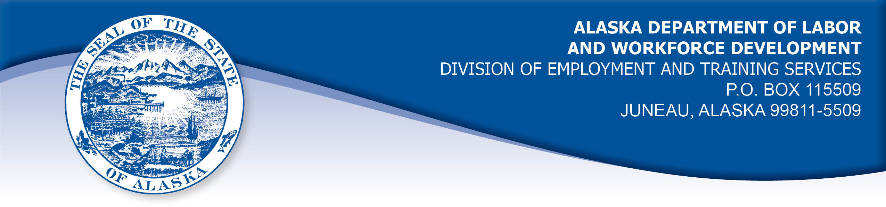

APPEAL TRIBUNAL DECISION

Docket number: 20 2315 Hearing date: April 14, 2021

CLAIMANT: EMPLOYER:

OTONIEL OQUENDO CARLILE ENTERPRISES INC

CLAIMANT APPEARANCES: EMPLOYER APPEARANCES:

Otoniel Oquendo Robyn Bertling

CASE HISTORY

The claimant timely appealed a December 1, 2020 determination which denied benefits under Alaska Statute 23.20.379. The issue before the Appeal Tribunal is whether the claimant was discharged for misconduct connected with the work.

FINDINGS OF FACT

The claimant began work for the employer on June 19, 2018. He last worked on July 12, 2020. At that time, he worked full time as a dockworker.
The claimant had been given a final warning about unplanned absences from work on June 16, 2020. He was warned that his job was in jeopardy because of multiple absences in the last 120 days.
The claimant notified his supervisor that he was unable to work on July 13, 2020 because he had a fever, headache and nausea. The claimant was concerned that his symptoms could be related to the COVID-19 virus.
On July 14, 2020, the claimant’s supervisor asked if the claimant had obtained a doctor’s note for his illness. The claimant replied that had not seen a doctor yet, but planned to see one that day before his 4 pm shift. The claimant’s supervisor told him that he was required to have seen a doctor the previous day and the supervisor told the claimant that the human resources office was “pushing his paperwork,” which the claimant took to mean he was being terminated. The claimant recalled that he contacted the human resources office and it was confirmed that he could not provide a doctor’s note excusing him from work unless he was seen by the doctor on the day he was ill. The human resources representative did not recall that the claimant had called that day. The representative was told by the claimant’s supervisor that he received no messages from the claimant on July 14, 2020. The employer considered that the claimant was absent without notice on July 14, 2020 and decided to discharge him.
On July 15, 2020 the employer sent a termination letter to the claimant by mail, advising him that he was discharged due to excessive absences.

PROVISIONS OF LAW

AS 23.20.379 provides in part:

(a) An insured worker is disqualified for waiting-week credit or benefits for the first week in which the insured worker is unemployed and for the next five weeks of unemployment following that week if the insured worker...

(2) was discharged for misconduct connected with the insured worker's last work.

8 AAC 85.095 provides in part:

(d) "Misconduct connected with the insured worker's work" as used in
AS 23.20.379(a)(2) means

(1) a claimant's conduct on the job, if the conduct shows a willful and wanton disregard of the employer's interest, as a claimant might show, for example, through gross or repeated negligence, willful violation of reasonable work rules, or deliberate violation or disregard of standards of behavior that the employer has the right to expect of an employee; willful and wanton disregard of the employer's interest does not arise solely from inefficiency, unsatisfactory performance as the result of inability or incapacity, inadvertence, ordinary negligence in isolated instances, or good faith errors in judgment or discretion....

CONCLUSION

The claimant in this case was discharged after being warned about his attendance. Work attendance is a commonly understood element of the employment relationship. It need not be defined in a company policy in order to require compliance. And it is so important that a single breach can amount to misconduct connected to the work.

In Tolle, Com. Dec. 9225438, June 18, 1992 the Commission of Labor states, in part:

Unexcused absence or tardiness is considered misconduct in connection with the work unless there is a compelling reason for the absence or tardiness and the worker makes a reasonable attempt to notify the employer.

The claimant in this case had a compelling reason to miss work because of his illness and the similarity of his symptoms to the symptoms of the COVID-19 virus. The employer held that the claimant was a no-show, no-call on July 14, 2020. The claimant held that he talked to his supervisor about the doctor’s note that day and only failed to get a note and show up because he was told in advance that he was being terminated since he did not see the doctor the first day he was sick.

In Douglas, Com. Dec. 85H-UI-069, April 26, 1985, paraphrasing AS 44.62.460(d), the commissioner held in part:

“Hearsay evidence may be used to supplement or explain direct evidence but is, by itself, insufficient to support a finding unless that evidence would be admissible over objection in a civil action”.

The claimant’s supervisor did not appear in the hearing to offer sworn testimony. The claimant’s testimony that he discussed getting a doctor’s note with his supervisor is credible and overcomes the employer’s hearsay evidence that the claimant did not notify the employer of his absence.

The Tribunal concludes the claimant in this case was discharged for reasons other than misconduct connected to the work and the penalties of AS 23.20.379 are not appropriate.

DECISION

The determination issued on December 1, 2020 is REVERSED. Benefits are ALLOWED for the weeks ending July 18, 2020 through August 22, 2020, if otherwise eligible. The three weeks are restored to the claimant’s maximum benefits. The determination will not interfere with the claimant’s eligibility for extended benefits under AS 23.20.406-409.

APPEAL RIGHTS

This decision is final unless an appeal is filed in writing to the Commissioner of Labor and Workforce Development within 30 days after the decision is mailed

to each party. The appeal period may be extended only if the appeal is delayed for circumstances beyond the party’s control. A statement of rights and procedures is enclosed.

Dated and mailed on April 19, 2021.

Rhonda Buness, Appeals Officer

