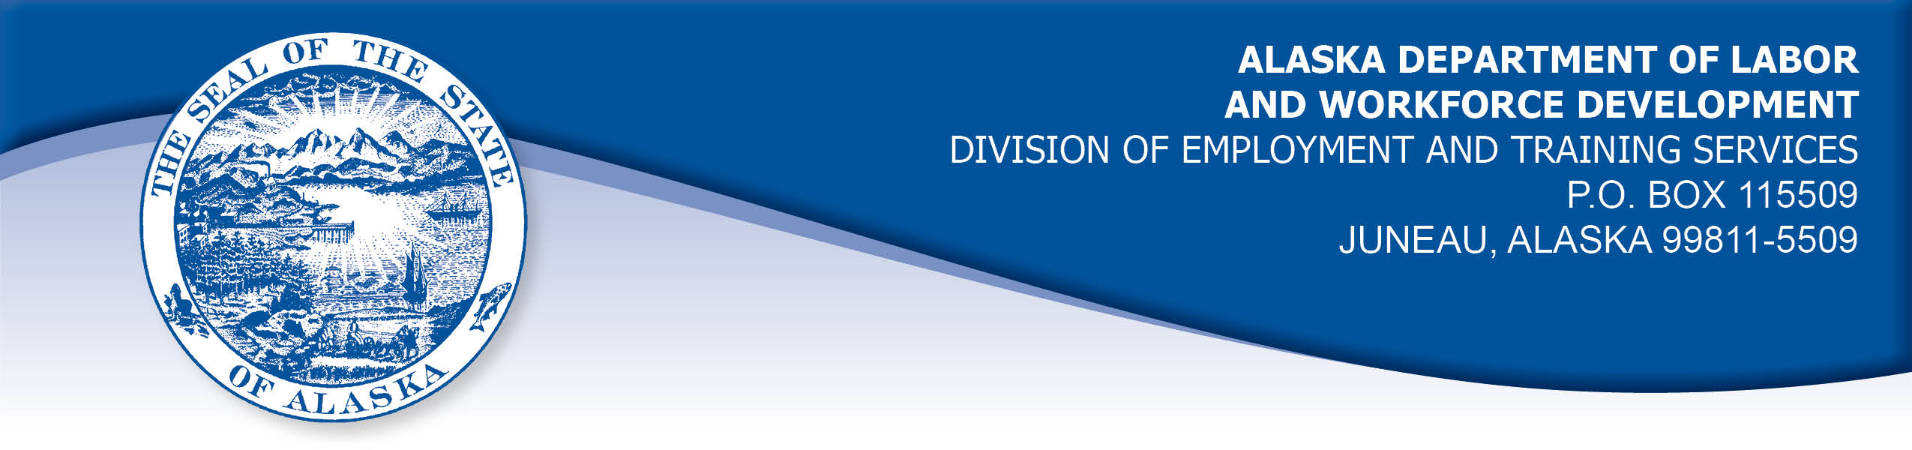

APPEAL TRIBUNAL DECISION

Docket number: 21 0050 Hearing date: June 14, 2021

CLAIMANT: EMPLOYER:

CORINNE CONLON STATE OF ALASKA
DEPARTMENT OF LABOR &
WORKFORCE DEVELOPMENT

CLAIMANT APPEARANCES: EMPLOYER APPEARANCES:

Corrine Conlon None

CASE HISTORY

The claimant timely appealed a December 20, 2020 determination which denied benefits under Alaska Statute 23.20.379. The issue before the Appeal Tribunal is whether the claimant voluntarily quit suitable work without good cause.

FINDINGS OF FACT

The claimant began work for the employer on October 11, 2018. She last worked on June 5, 2020. At that time, she worked full time as an employment security analyst.
The claimant had worked from home for a period due to the COVID-19 pandemic. At the end of May 2020, the claimant was advised that she was expected to return to working in the office on June 1, 2020. The return date was extended as the employer was coming up with a plan for COVID-19 safety in the office. The claimant was provided with a copy of the employer’s plan on June 5, 2020 and was expected to return to the office on June 8, 2020. The employer’s plan for COVID-19 safety required workers to sanitize common areas, encouraged hand washing, did not allow sick workers in the office, encouraged social distancing and made it optional to wear face masks.
The claimant was concerned the plan was not sufficient for her considering advice from the CDC and Alaska’s chief medical officer. The claimant has medical conditions that make her at high risk for complications of the COVID-19 virus. The claimant’s doctor advised the claimant to work from home as she was at risk for severe COVID-19 complications. The claimant was concerned that in her open cubicle she could not be guaranteed to be six feet away from other workers who would not be required to wear masks, and she would be breathing air circulated from other offices in the building as well.
The claimant requested to continue working from home. She also requested that workers in her office be required to wear a face mask in the office. The claimant’s requests were denied in a virtual meeting between the claimant, her supervisor and a human resources representative late in the day on June 5, 2020. The claimant was advised her only option was to report for work in the office at 8:00 am on Monday, June 8, 2020.
The claimant had called her union representative when the employer first advised that workers would be required to return to the office. She did not consider calling the union on June 5, 2020 because she did not feel she had time to do so after the Friday late afternoon meeting. The claimant considered calling out on Monday, but she feared she could be terminated if she did not go to work. The claimant was concerned that she could be terminated because it seemed to her that the employer was not willing to work with her. The claimant requested her doctor write her a letter detailing her risk from the virus, but she did not get the letter from the doctor before she resigned, so it was not given to the employer.
The claimant decided she would not risk her health by returning to work in the office while many facets of the virus transmission were still unknown. She submitted a letter of resignation effective immediately on June 7, 2020.

PROVISIONS OF LAW

AS 23.20.379 provides in part:

(a) An insured worker is disqualified for waiting-week credit or benefits for the first week in which the insured worker is unemployed and for the next five weeks of unemployment following that week if the insured worker...
- left the insured worker's last suitable work voluntarily without good cause....

8 AAC 85.095 provides in part:

(c) To determine the existence of good cause under AS 23.20.379(a)(1) for voluntarily leaving work determined to be suitable under
AS 23.20.385, the department will consider only the following factors:

(1) leaving work due to a disability or illness of the claimant that makes it impossible for the claimant to perform the duties required by the work, if the claimant has no other reasonable alternative but to leave work;
(2) leaving work to care for an immediate family member who has a disability or illness;
(3) leaving work due to safety or other working conditions or an employment agreement related directly to the work, if the claimant has no other reasonable alternative but to leave work;
(4) leaving work to accompany or join a spouse at a change of location, if commuting from the new location to the claimant’s work is impractical; for purposes of this paragraph, the change of location must be as a result of the spouse’s
(A) discharge from military service; or
(B) employment;
(5) leaving unskilled work to attend a vocational training or retraining course approved by the director under AS 23.20.382, only if the claimant enters the course immediately upon separating from work;
(6) leaving work in order to protect the claimant or the claimant’s immediate family members from harassment or violence;
(7) leaving work to accept a bonafide offer of work that offers better wages, benefits, hours, or other working conditions; if the new work does not materialize, the reasons for the work not materializing must not be due to the fault of the worker;
(8) other factors listed in AS 23.20.385(b).

AS 23.20.385(b) provides, in part:

(b) In determining whether work is suitable for a claimant and in determining the existence of good cause for leaving or refusing work, the department shall, in addition to determining the existence of any of the conditions specified in (a) of this section, consider the degree of risk to the claimant's health, safety, and morals, the claimant's physical fitness for the work, the claimant's prior training, experience, and earnings, the length of the claimant's unemployment, the prospects for obtaining work at the claimant's highest skill, the distance of the available work from the claimant's residence, the prospects for obtaining local work, and
other factors that influence a reasonably prudent person in the claimant's circumstances.

CONCLUSION

The claimant in this case voluntarily left work because she has several medical risk factors for severe illness or death from the COVID-19 virus. The claimant requested to continue working from home and requested that coworkers be required to wear masks in the office, but her requests were denied.

The Division’s Benefit Policy Manual, at VL 5-2 holds:

C. Suitable Work

There is no disqualification if a worker leaves unsuitable work. A worker needs good cause only to quit suitable work.

Suitable work is defined as work in the worker's usual occupation or an occupation for which the worker is reasonably fitted by training, experience, and physical condition.

If the worker has accepted the conditions of employment, by remaining on the job a significant period of time, and not attempting to change the objectionable circumstance, the work is suitable. However, in cases where the work is detrimental to the claimant’s health, even though the claimant is capable of performing a particular job, the work may be deemed unsuitable.

The claimant in this case left work because of a possible detriment to her health. The claimant’s concerns were reasonable in light of the COVID-19 pandemic guidelines and her medical risk factors. The Tribunal concludes the work was not suitable for the claimant at the time she left. Claimants are required to show good cause only when voluntarily leaving suitable work. The penalties of AS 23.20.379 are not appropriate in this case.

DECISION

The determination issued on December 20, 2020 is REVERSED. Benefits are ALLOWED for the weeks ending June 13, 2020 through July 18, 2020, if otherwise eligible. The three weeks are restored to the claimant’s maximum benefits. The determination will not interfere with the claimant’s eligibility for extended benefits under AS 23.20.406-409.

APPEAL RIGHTS

This decision is final unless an appeal is filed in writing to the Commissioner of Labor and Workforce Development within 30 days after the decision is mailed

to each party. The appeal period may be extended only if the appeal is delayed for circumstances beyond the party’s control. A statement of rights and procedures is enclosed.

Dated and mailed on June 18, 2021.

Rhonda Buness, Appeals Officer

