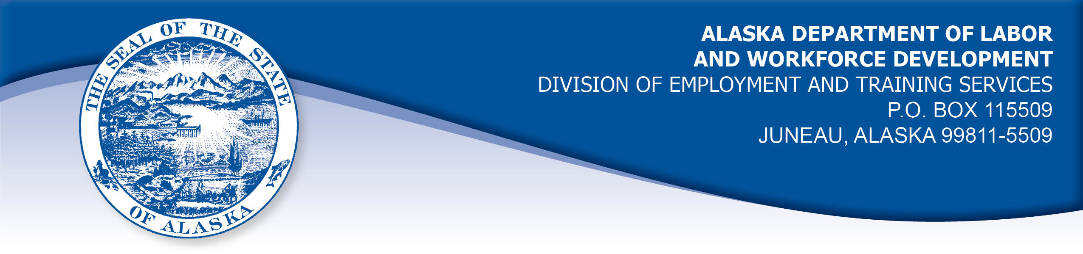

APPEAL TRIBUNAL DECISION

Docket number: 21 0487 Hearing date: August 24, 2021

CLAIMANT:

DEBRA KILDAY

CLAIMANT APPEARANCES: DETS APPEARANCES:

Debra Kilday None

CASE HISTORY

The claimant timely appealed two determinations issued March 1, 2021 and March 8, 2021, both of which denied benefits under AS 23.20.375. The issue before the Appeal Tribunal is whether the claimant met the Division’s filing requirements.

FINDINGS OF FACT

The claimant established a claim for unemployment insurance benefits effective March 15, 2020. The claimant filed weekly certifications to claim benefits for weeks of unemployment and partial unemployment using the Division’s website claim form.

On February 17, 2021, the claimant reviewed her benefit filing history and realized she had not filed a certification to claim benefits for the week ending December 19, 2020. The claimant was aware that she was required to file a certification each week to claim benefits, and she believed she just forgot to file a certification for that week. She called the Division that day and her certification for that week was taken by phone. The claimant’s benefits were denied on a holding that the certification was filed late.

On March 8, 2020, the claimant contacted the Division and requested to file a certification for the week ending February 27, 2021. She had forgotten to file until just before the deadline on March 6, 2021 and she could not get the certification filed in time. The claimant’s certification was taken March 8, 2021 by a claim center representative. The claimant’s benefits for that week were denied on a holding that the certification was filed late.

PROVISIONS OF LAW

AS 23.20.375. Filing requirements
(a) An insured worker is entitled to receive waiting-week credit or benefits for a week of unemployment for which the insured worker has not been disqualified under AS 23.20.360, 23.20.362, 23.20.378 - 23.20.387, or 23.20.505 if, in accordance with regulations adopted by the department, the insured worker has
(1) made an initial claim for benefits; and
(2) for that week, certified for waiting-week credit or made a claim for benefits.

8 AAC 85.102 Intrastate filing: continued claims

(a) An intrastate claimant located in this state is eligible for waiting week credit or benefits for a week if the claimant
(1) files a continued claim for the week as required in this section; and
(2) meets all requirements of AS 23.20 and this chapter.
(b) A claimant shall file a continued claim with an unemployment insurance claim center of the division by
(1) an electronic means designated by the director;
(2) telephone; or
(3) mail, with the prior approval of the director.
(c) A continued claim for a week is filed when an unemployment insurance claim center of the division receives a certification for a continued claim.
(d) The filing date of a continued claim filed by mail is the postmark date of the mailing of the completed claim form.
(e) The date of filing of a continued claim filed by telephone is the date that the claimant accesses the telephone filing system and provides claim information for the week using the claimant's personal identification number.
(f) For each week claimed, the claimant shall answer specific eligibility questions and shall certify to the truthfulness and completeness of the answers.
(g) A continued claim for a week may not be filed before the end of the week claimed. A continued claim may not be filed later than seven calendar days after the end of the week claimed, except that
(1) if the director authorizes the filing of bi-weekly claims, the claim may not be filed later than seven days after the end of the bi-weekly period authorized by the director;
(2) a claim for benefits for a week of partial unemployment may not be filed later than seven days after the claimant receives wages for that week.
(h) The director shall extend the time allowed in (g) of this section for filing a continued claim if the claimant has good cause for filing a late claim and the claimant files the claim as soon as possible under the circumstances.
(i) For the purposes of (h) of this section, "good cause" means circumstances beyond a claimant's control that the division determines leave the claimant with no reasonable choice but to delay filing the claim; "good cause" includes illness or disability of the claimant, processing delays within the division, or failure of the division to provide sufficient or correct information to the claimant in order to file a continued claim.

CONCLUSION

Alaska Statute 23.20.375 holds that a claimant must file a certification in accordance with regulations of the Department to claim benefits for a week of unemployment. Regulation 8 AAC 85.102(g)holds that a claim must be filed within seven days of the end of the week, or within seven days of the end of the bi-weekly period if the Director allows bi-weekly filing, or within seven days of the date the claimant receives wages for a week.

The claimant’s certification for the week ending December 19, 2021 was not filed timely, it was filed some two months later on February 17, 2021. Regulation 8 AAC 85.102(h) holds that the Director will extend the time allowed to file a certification if the claimant has good cause and files as soon as possible. The claimant has not established that she had good cause for her failure to file the certification timely. The circumstances were within her control to remember to file each week. The Tribunal cannot find that the claimant’s certification for the week ending December 19, 2020 was filed timely.

The Director does allow bi-weekly filing. The claimant requested to file a certification for the weeks ending February 27, 2021 and March 6, 2021 on March 8, 2021. The certifications for both weeks were timely filed. The Tribunal finds the claimant’s benefits for that week were improperly denied.

DECISION

The determination issued on March 1, 2020 is AFFIRMED. Benefits remain DENIED for the week ending December 19, 2020.

The determination issued March 8, 2021 is REVERSED. Benefits are ALLOWED for the week ending February 27, 2021, if the claimant is otherwise eligible.

APPEAL RIGHTS

This decision is final unless an appeal is filed in writing to the Commissioner of Labor and Workforce Development within 30 days after the decision is mailed
to each party. The appeal period may be extended only if the appeal is delayed for circumstances beyond the party’s control. A statement of rights and procedures is enclosed.

Dated and mailed on August 30, 2021.

Rhonda Buness, Appeals Officer

