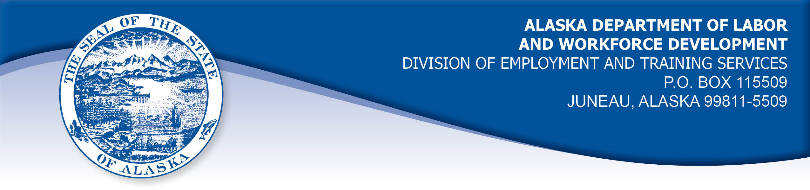

APPEAL TRIBUNAL DECISION

Docket number: 21 0577 Hearing date: September 21, 2021

CLAIMANT:

NICHOLAS BUTRYN

CLAIMANT APPEARANCES: DETS APPEARANCES:

Nicholas Butryn None

CASE HISTORY

The claimant timely appealed a March 24, 2021 determination which denied benefits under AS 23.20.375. The issue before the Appeal Tribunal is whether the claimant met the Division’s filing requirements.

FINDINGS OF FACT

The claimant established a claim for unemployment insurance benefits effective March 15, 2020. The claimant claimed benefits by filing weekly certifications on the Division’s website form set up for that purpose. The claimant was receiving Pandemic Emergency Unemployment Compensation (PEUC) during the period under review.

The claimant was in a period of continuous filing when he attempted to file a certification for the week ending January 16, 2021. The Division’s website did not allow the claimant to file his certification for that week, although he attempted to file it timely between January 17, 2021 and January 23, 2021. The claimant immediately tried to contact the Division by phone to find out why he could not file a certification. The claimant could not get through to the Division’s claim center because the Division’s phone lines were very busy and the claimant was disconnected. The claimant continued to try to file certifications online and continued to try to contact the Division by phone without success. The claimant noted there were messages on the Division’s website advising claimants to be patient because there were technical issues and not to call the claim center because of the high volume of calls.
The claimant continued trying to call the Division and reached a representative on February 22, 2021. His certification for the weeks ending January 23, 2021 through February 20, 2021 were taken by phone that day. The claimant’s benefits for those weeks were denied because the certifications were filed more than seven days after the end of the weeks filed. A certification for the week ending January 16, 2021 was not included in the documents in the record.

PROVISIONS OF LAW

AS 23.20.375. Filing requirements
(a) An insured worker is entitled to receive waiting-week credit or benefits for a week of unemployment for which the insured worker has not been disqualified under AS 23.20.360, 23.20.362, 23.20.378 - 23.20.387, or 23.20.505 if, in accordance with regulations adopted by the department, the insured worker has
(1) made an initial claim for benefits; and
(2) for that week, certified for waiting-week credit or made a claim for benefits.

8 AAC 85.102 Intrastate filing: continued claims

(a) An intrastate claimant located in this state is eligible for waiting week credit or benefits for a week if the claimant
(1) files a continued claim for the week as required in this section; and
(2) meets all requirements of AS 23.20 and this chapter.
(b) A claimant shall file a continued claim with an unemployment insurance claim center of the division by
(1) an electronic means designated by the director;
(2) telephone; or
(3) mail, with the prior approval of the director.
(c) A continued claim for a week is filed when an unemployment insurance claim center of the division receives a certification for a continued claim.
(d) The filing date of a continued claim filed by mail is the postmark date of the mailing of the completed claim form.
(e) The date of filing of a continued claim filed by telephone is the date that the claimant accesses the telephone filing system and provides claim information for the week using the claimant's personal identification number.
(f) For each week claimed, the claimant shall answer specific eligibility questions and shall certify to the truthfulness and completeness of the answers.
(g) A continued claim for a week may not be filed before the end of the week claimed. A continued claim may not be filed later than seven calendar days after the end of the week claimed, except that
(1) if the director authorizes the filing of bi-weekly claims, the claim may not be filed later than seven days after the end of the bi-weekly period authorized by the director;
(2) a claim for benefits for a week of partial unemployment may not be filed later than seven days after the claimant receives wages for that week.
(h) The director shall extend the time allowed in (g) of this section for filing a continued claim if the claimant has good cause for filing a late claim and the claimant files the claim as soon as possible under the circumstances.
(i) For the purposes of (h) of this section, "good cause" means circumstances beyond a claimant's control that the division determines leave the claimant with no reasonable choice but to delay filing the claim; "good cause" includes illness or disability of the claimant, processing delays within the division, or failure of the division to provide sufficient or correct information to the claimant in order to file a continued claim.

CONCLUSION

Alaska Statute 23.20.375 holds that in order to be eligible for benefits for a week of unemployment, a claimant must have an initial claim in place and must file a certification for that week. Regulation 8 AAC 85.102 holds that certifications must be filed within seven days of the last day of the week being claimed, or within seven days of the last day of the bi-weekly filing period. The regulation holds that additional time will be allowed to file certifications if the claimant has good cause to file the certifications late and does so as soon as possible.

The claimant in this case unable to file because the Division’s computer system prevented his access for some reason. The claimant was unable to reach the Division by phone because of a large volume of calls. These processing delays of the Division were outside the claimant’s control. The claimant filed the certifications as soon as he could get through to the Division by phone. The Tribunal finds the claimant has good cause to file late certifications for weeks ending January 23, 2021 through February 6, 2021 under 8 AAC 85.102(i).

The Tribunal finds that certifications for the weeks ending February 13, 2021 and February 20, 2021 were not late when filed on February 22, 2021.

It appears to be Division error that a certification for the week ending January 16, 2021 was not taken on February 22, 2021.

DECISION

The determination issued on March 24, 2021 is REVERSED. Benefits are ALLOWED for the weeks ending January 23, 2021 through February 20, 2021, if the claimant is otherwise eligible.

The issue of the claimant’s eligibility for benefits in the week ending January 16, 2021 is REMANDED to the Division. A certification for the week ending January 16, 2021 is to be taken and entered as timely filed.

APPEAL RIGHTS

This decision is final unless an appeal is filed in writing to the Commissioner of Labor and Workforce Development within 30 days after the decision is mailed to each party. The appeal period may be extended only if the appeal is delayed for circumstances beyond the party’s control. A statement of rights and procedures is enclosed.

Dated and mailed on September 27, 2021.

Rhonda Buness, Appeals Officer

