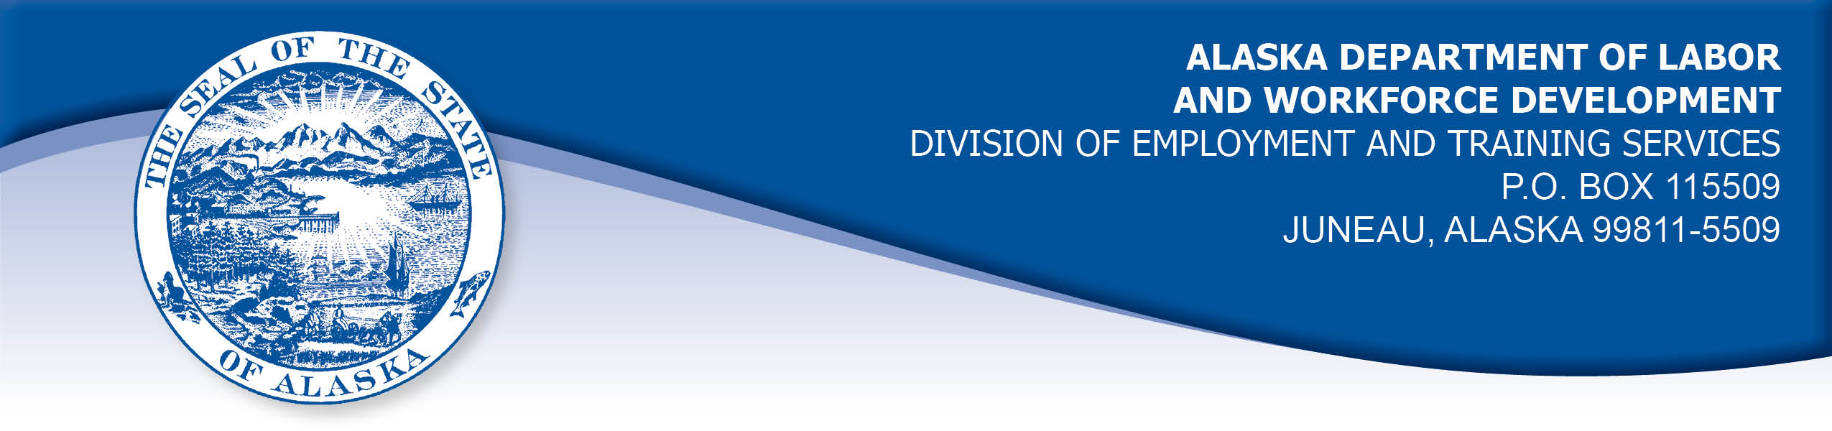

APPEAL TRIBUNAL DECISION

Docket number: 21 0723 Hearing date: September 22, 2021

CLAIMANT: EMPLOYER:

SETH COX ACE HOLDINGS LLC

CLAIMANT APPEARANCES: EMPLOYER APPEARANCES:

Seth Cox None

CASE HISTORY

The claimant timely appealed a March 5, 2021 determination which denied benefits under Alaska Statute 23.20.379. The issue before the Appeal Tribunal is whether the claimant was discharged for misconduct connected with the work.
FINDINGS OF FACT

The claimant began work for the employer in July 2017. He last worked on October 23, 2020. At that time, he worked full time tending plants.
On the claimant’s last day of work, he was advised by the owner and manager that he was being let go because it wasn’t working out. The claimant speculated that he was discharged because did not get along with the new manager that had started a couple months earlier.

Documents in the record indicate the employer told the Division that the claimant was discharged for drinking on the job after warning. The claimant denied that he had ever been warned for such behavior and held that the owner brought beer in for employees to celebrate harvest and drinking on the clock was accepted behavior. The claimant denied that he had consumed alcohol on his last day of employment.

PROVISIONS OF LAW

AS 23.20.379 provides in part:

(a) An insured worker is disqualified for waiting-week credit or benefits for the first week in which the insured worker is unemployed and for the next five weeks of unemployment following that week if the insured worker...
(2) was discharged for misconduct connected with the insured worker's last work.

8 AAC 85.095 provides in part:

(d) "Misconduct connected with the insured worker's work" as used in
AS 23.20.379(a)(2) means
(1) a claimant's conduct on the job, if the conduct shows a willful and wanton disregard of the employer's interest, as a claimant might show, for example, through gross or repeated negligence, willful violation of reasonable work rules, or deliberate violation or disregard of standards of behavior that the employer has the right to expect of an employee; willful and wanton disregard of the employer's interest does not arise solely from inefficiency, unsatisfactory performance as the result of inability or incapacity, inadvertence, ordinary negligence in isolated instances, or good faith errors in judgment or discretion....

CONCLUSION

The claimant in this case was told he was being let go because it was not working out. The employer told the Division the claimant was discharged for consuming alcohol at work after warning.

Misconduct cannot be established on the basis of unproven allegations. Cole, Com. Dec. 85HUI006, January 22, 1985.

When a worker has been discharged, the burden of persuasion rests upon the employer to establish that the worker was discharged for misconduct in connection with the work. In order to bear out that burden, it is necessary that the employer bring forth evidence of a sufficient quantity and quality to establish that misconduct was involved. Rednal, Com. Dec. 86H-UI-213, August 25, 1986.

The decision in this matter turns on the weight of the evidence. In Weaver, Com. Dec. 96 2687, February 13, 1997. The commissioner has held in part:

Uncorroborated hearsay evidence must normally be given less weight than that of the sworn testimony of eyewitnesses to an event. Only if first-hand testimony is clearly not credible, should hearsay statements be considered more reliable.

In Douglas, Com. Dec. 85H-UI-069, April 26, 1985, paraphrasing AS 44.62.460(d), the commissioner held in part:

“Hearsay evidence may be used to supplement or explain direct evidence but is, by itself, insufficient to support a finding unless that evidence would be admissible over objection in a civil action”.

The employer did not appear at the hearing to provide sworn testimony, standing on the hearsay documents in the record. The claimant provided credible sworn testimony that he was not warned for drinking alcohol at work and did not drink alcohol during work hours on his last day. The employer’s hearsay evidence did not establish that the claimant’s actions rose to the level of misconduct as described in Regulation 8 AAC 85.095(d), above.

The Tribunal does not question an employer’s right to discharge a claimant that does not meet its standards, but such a discharge is not always for misconduct. The Tribunal finds the claimant in this case was discharged for reasons other than misconduct and thus the penalties of AS 23.20.379 are not appropriate.

DECISION

The determination issued on March 5, 2021 is REVERSED. Benefits are ALLOWED for the weeks ending October 24, 2020 through November 28, 2020, if otherwise eligible. The three weeks are restored to the claimant’s maximum benefits. The determination will not interfere with the claimant’s eligibility for extended benefits under AS 23.20.406-409.

APPEAL RIGHTS

This decision is final unless an appeal is filed in writing to the Commissioner of Labor and Workforce Development within 30 days after the decision is mailed to each party. The appeal period may be extended only if the appeal is delayed for circumstances beyond the party’s control. A statement of rights and procedures is enclosed.

Dated and mailed on September 27, 2021.

Rhonda Buness, Appeals Officer

