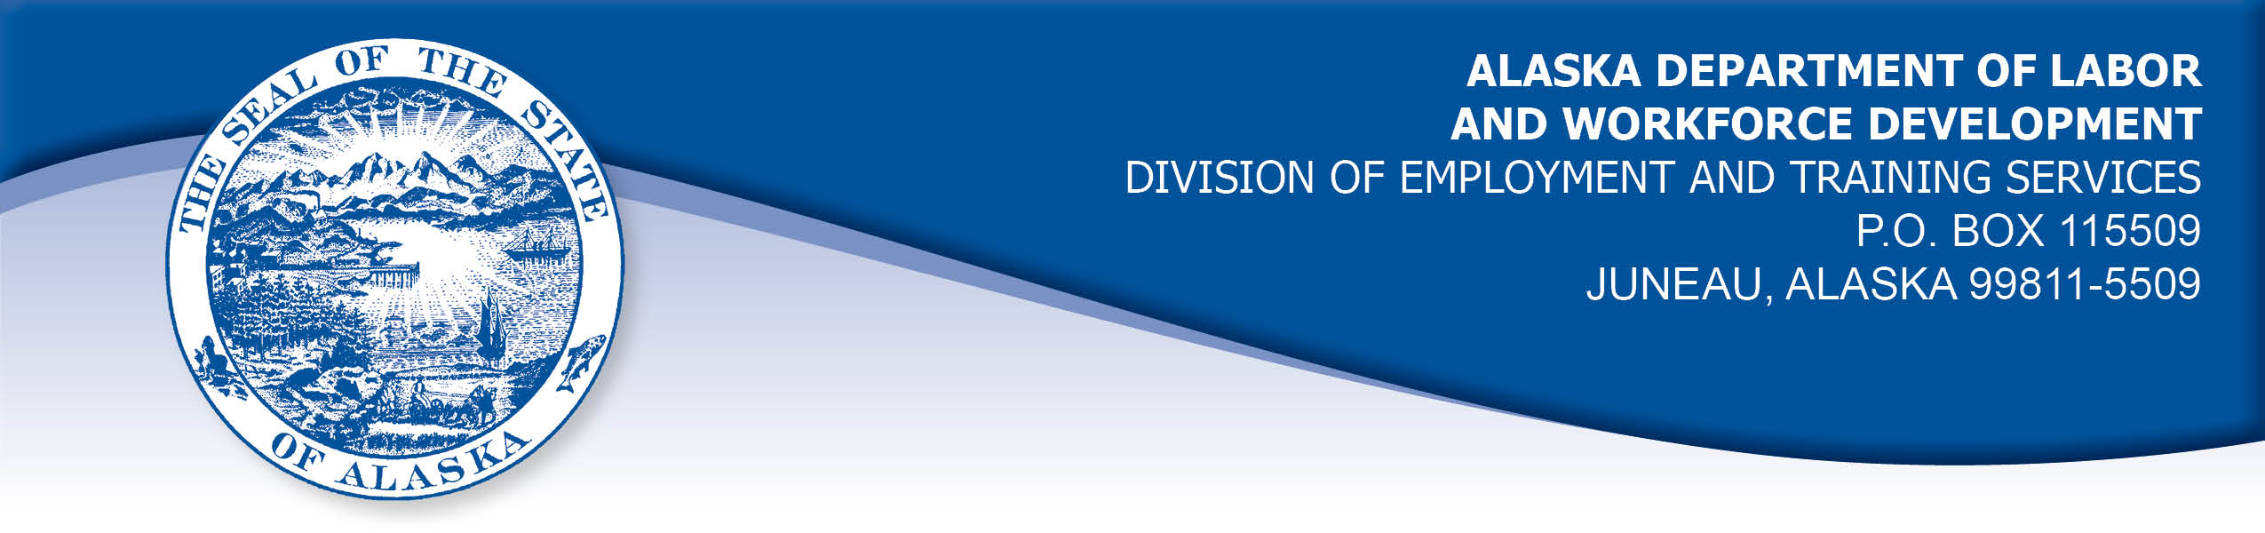

APPEAL TRIBUNAL DECISION

Docket number: 21 0778 Hearing date: October 5, 2021

October 12, 2021

CLAIMANT: EMPLOYER:

JONI YOUNG WAL-MART ASSOCIATES INC

CLAIMANT APPEARANCES: EMPLOYER APPEARANCES:

None Mike Morris
Matt Lolley

CASE HISTORY

The employer timely appealed a March 10, 2021 determination which allowed the claimant’s benefits with no penalty under Alaska Statute 23.20.379. The issue before the Appeal Tribunal is whether the claimant was discharged for misconduct connected with the work.
FINDINGS OF FACT

The claimant began work for the employer on October 8, 2020. She last worked on November 17, 2020. At that time, she worked full time as an online grocery pickup clerk.
On the claimant’s last day of work, a manager was called to assist another manager observing the claimant at work. The manager observed the claimant swaying while standing place, missing a handheld device entirely while attempting to push buttons on the device, leaning on displays while swaying, and driving her grocery pickup cart into displays. The claimant was taken into an office by the managers where she stated she was on allergy medication. The managers suspected the claimant was under the influence of alcohol because she slurred words and briefly fell asleep during the conversation. One manager took the calamint for alcohol testing at a nearby facility and returned to get the claimant’s coat and took her home.

The store manager received test results that showed the claimant’s blood alcohol level was over .04%, the amount listed in the employer’s drug and alcohol policy as being considered “under the influence.”

The employer provided a copy of their drug and alcohol policy. The policy does not include a statement of what substances would be tested for, the right of a worker to have a confirmatory test reviewed by a licensed physician or doctor of osteopathy after an initial positive test, a worker’s right to get a copy of the test results, a worker’s right to explain positive results in a confidential setting before any disciplinary action is taken, and a statement of the employer’s policy regarding the confidentiality of the test results. The employer’s practices may follow some of the intentions of the statute, and other policies hold that management’s doors are always open to discuss any issues a worker may have. The claimant was not subject to any mandatory drug or alcohol testing program such as that required by the Department of Transportation.

The store manager tried to contact the claimant for several weeks to discuss the test results, but the claimant did not answer or return his calls. The employer removed the claimant from the payroll system on December 11, 2020.

PROVISIONS OF LAW

AS 23.20.379 provides in part:
(a) An insured worker is disqualified for waiting-week credit or benefits for the first week in which the insured worker is unemployed and for the next five weeks of unemployment following that week if the insured worker...
- was discharged for misconduct connected with the insured worker's last work.
(f) “misconduct” includes conduct in violation of an employer’s policy concerning drugs or alcohol, but only if the policy is consistent with AS 23.10.620…

AS 23.10.620. Employer Policy
(a) Under AS 23.10.600 - AS 23.10.699 an employer may only carry out the testing or retesting for the presence or evidence of use of drugs or alcohol after adopting a written policy for the testing and retesting and informing employees of the policy. The employer may inform employees by distributing a copy of the policy to each employee subject to testing or making the policy available to employees in the same manner as the employer informs its employees of other personnel practices, including inclusion in a personnel handbook or manual or posting in a place accessible to employees. The employer shall inform prospective employees that they must undergo drug testing.
(b) The written policy on drug and alcohol testing must include, at a minimum,
(1) a statement of the employer's policy respecting drug and alcohol use by employees;
(2) a description of those employees or prospective employees who are subject to testing;
(3) the circumstances under which testing may be required;
(4) the substances as to which testing may be required;
(5) a description of the testing methods and collection procedures to be used, including an employee's right to a confirmatory drug test to be reviewed by a licensed physician or doctor of osteopathy after an initial positive drug test result in accordance with AS 23.10.640 (d);
(6) the consequences of a refusal to participate in the testing;
(7) any adverse personnel action that may be taken based on the testing procedure or results;
(8) the right of an employee, on the employee's request, to obtain the written test results and the obligation of the employer to provide written test results to the employee within five working days after a written request to do so, so long as the written request is made within six months after the date of the test;
(9) the right of an employee, on the employee's request, to explain in a confidential setting, a positive test result; if the employee requests in writing an opportunity to explain the positive test result within 10 working days after the employee is notified of the test result, the employer must provide an opportunity, in a confidential setting, within 72 hours after receiving the employee's written notice, or before taking adverse employment action;
(10) a statement of the employer's policy regarding the confidentiality of the test results.

8 AAC 85.095 provides in part:
(d) "Misconduct connected with the insured worker's work" as used in
AS 23.20.379(a)(2) means
(1) a claimant's conduct on the job, if the conduct shows a willful and wanton disregard of the employer's interest, as a claimant might show, for example, through gross or repeated negligence, willful violation of reasonable work rules, or deliberate violation or disregard of standards of behavior that the employer has the right to expect of an employee; willful and wanton disregard of the employer's interest does not arise solely from inefficiency, unsatisfactory performance as the result of inability or incapacity, inadvertence, ordinary negligence in isolated instances, or good faith errors in judgment or discretion....
CONCLUSION

The claimant in this case was discharged following a positive alcohol test.

A claimant, who is discharged for violation of a drug policy, is not discharged for misconduct connected with the work if the employer’s drug policy does not meet the standards set forth in AS 23.20.379(f). Smith, Com. Dec. 00 2523, June 21, 2001.

If the test was mandated by DOT and the drug testing facility used is approved by HHS, we direct the Tribunal to hold the claimant was discharged for misconduct connected with the work. If those two requirements were not met, then the misconduct provisions of 23.20.379(f) do not apply. Boll, Com. Dec. 03 0356, May 5, 2003.

The claimant’s position was not covered under federal requirements for drug testing. Therefore, the decision must be based on whether the employer’s drug testing policy meets the standards set forth in AS 23.20.379 and AS 23.10.620.

The Tribunal does not dispute the right of an employer to terminate a worker who violates its drug and alcohol policy. However, as stated in Smith above, in order for the violation to constitute misconduct, the employer’s drug and alcohol policy must meet all ten points of AS 23.10.620. It has not been established that the employer’s policy meets the provisions AS 23.10.620(b)(4), (5), (8), (9), and (10). Therefore, the Tribunal must conclude the claimant was discharged for reasons other than misconduct connected with the work.

DECISION

The determination issued on March 10, 2021 is AFFIRMED. Benefits remain ALLOWED for the weeks ending December 19, 2020 through January 23, 2021, if otherwise eligible. The three weeks are not reduced from the claimant’s maximum benefits. The determination will not interfere with the claimant’s eligibility for extended benefits under AS 23.20.406-409.

APPEAL RIGHTS

This decision is final unless an appeal is filed in writing to the Commissioner of Labor and Workforce Development within 30 days after the decision is mailed to each party. The appeal period may be extended only if the appeal is delayed for circumstances beyond the party’s control. A statement of rights and procedures is enclosed.

Dated and mailed on October 12, 2021.

Rhonda Buness, Appeals Officer

