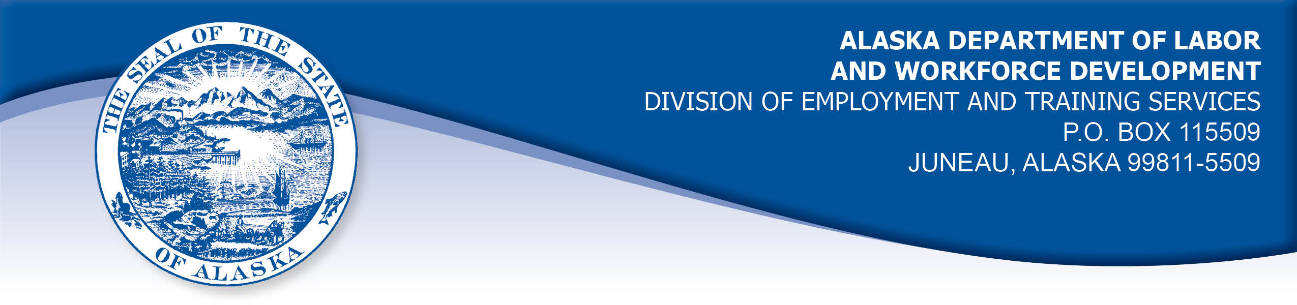

APPEAL TRIBUNAL DECISION

Docket number: 21 1149 Hearing date: December 8, 2021

CLAIMANT:

RICHARD ENGEBRETH

CLAIMANT APPEARANCES: DETS APPEARANCES:

Richard Engbreth None

CASE HISTORY

The claimant timely appealed a June 15, 2021 determination which denied benefits under Alaska Statute 23.20.350(f) and 8 AAC 85.075. The issue before the Appeal Tribunal is whether the claimant is eligible for an allowance for a dependent.

FINDINGS OF FACT

The claimant established a claim for unemployment insurance benefits effective January 24, 2021, using the Division’s website application designed for that purpose. The claimant was found to be eligible for a weekly benefit of $86 for sixteen weeks.
The claimant’s daughter was under the age of 18 and residing with the cklaimant at the time he established his claim. The claimant recalled that when he established his claim, he was requested to provide his daughter’s social security number in order to claim her as a dependent for the purpose of receiving a dependent’s allowance, which at the time the claim was established was $75 per week per dependent. The claimant was working on getting his daughter’s social security number at that time, and that process was delayed. The claimant recalled being told that he would not be able to add his daughter to the claim until he could provide her social security number. The child’s social security number was issued mid-May 2021.
The claimant exhausted his regular unemployment insurance benefits when he filed a certification to claim benefits for the week ending May 15, 2021 on May 16, 2021. The claimant contacted the Division on Monday, May 17, 2021 and completed an application for federal Pandemic Emergency Unemployment Compensation (PEUC). Also on that date, the claimant requested to add his daughter to his claim as a dependent. A copy pf the Division’s online application for a dependent’s allowance is included in the record. The form does not have a place to request or record a social security number for a dependent. The forms requests the child’s full name, relationship to the applicant, whether the child lives with the applicant, and the child’s date of birth.

PROVISIONS OF LAW

AS 23.20.350 Amount of benefits
. . .
(f) An individual who establishes a benefit year is eligible for an allowance for dependents in addition to the individual’s weekly benefit amount. The department may require an individual claiming or receiving an allowance for dependents to produce income tax returns, birth certificates, notices of adoption or custody, social security account number of spouse, verification of support documents, or other information necessary to verify that the allowance is payable to the individual. The allowance for dependents
(1) is $24 per week for each dependent, except that the total allowance for dependents paid to an individual may not exceed $72 for each week of unemployment;
(2) is payable beginning with the week during the benefit year in which the individual claims an allowance for the dependent and is payable for the remainder of the individual’s eligibility for regular, extended, or supplemental payments during the benefit year;
(3) may not be claimed for a new dependent after the end of the benefit year or after the exhaustion of regular benefits in the benefit year;
(g) In this section,
(1) dependent means an individual’s
(A) unmarried child, stepchild, legally adopted child, or legal ward under 18 years of age who is
(i) lawfully in the individual’s physical custody at the time the individual claims the allowance for dependents; or
(ii) dependent on the individual for more than 50 percent of support;
(B) unmarried child, stepchild, legally adopted child, or legal ward of any age who is dependent on the individual for more than 50 percent of support and who is prevented by infirmity from engaging in a gainful occupation;

8 AAC 85.075 Monetary determinations
. . .
(d) The following standards will be used to determine the allowance for dependents payable to an individual:
(1) Repealed 4/28/95;
(2) Repealed 4/11/90;
(3) Repealed 4/28/95;
(4) An additional allowance for a dependent acquired by birth or adoption during the benefit year will be paid beginning with the week in which an individual claims the additional dependent, if the total allowance for dependents does not exceed $72 for each week of unemployment;
(5) If an individual claims a dependent who is not lawfully in the individual's physical custody, the director may require the individual to provide a notarized statement from the custodial parent or legal guardian or other evidence that clearly demonstrates that the individual claiming the allowance provides or, for the 12 months before the request for the dependent's allowance or since the loss of custody, whichever is less, has provided more than 50 percent of the support of that dependent;
(6) A child is "lawfully in an individual's physical custody" if (A) the child is residing with the individual when the claim for the dependent's allowance is filed; and (B) the individual has either sole or joint legal custody of the child;
(7) As used in AS 23.20.350(g)(1), "legal ward" means a dependent who has been placed in the custody of an individual by court order.

Enrolled HB 308: Relating to unemployment benefits during a period of state or national emergency resulting from a novel coronavirus disease (COVID-19) outbreak; and providing for an effective date.
. . .
Sec. 2. The uncodified law of the State of Alaska is amended by adding a new section to read:
UNEMPLOYMENT INSURANCE: DEPENDENT ALLOWANCE DURING NOVEL CORONAVIRUS DISEASE OUTBREAK. Notwithstanding AS 23.20.350(f) and to the extent consistent with federal law, for the duration of a state or national emergency for an outbreak of novel coronavirus disease (COVID-19), the allowance for dependents of an insured worker under AS 23.20 (Alaska Employment Security Act) who establishes a benefit year under AS 23.20.350 is $75 per week for each dependent. The Department of Labor and Workforce Development may not limit the total allowances for dependents paid to the insured worker for each week of unemployment. In this section, "dependent" has the meaning given in AS 23.20.350(g).
Sec. 3. This Act is repealed April 1, 2021.

CONCLUSION

Alaska Statute 23.20.350 sets out the requirements to claim a dependent allowance. The claimant’s daughter was under the age of 18 and resided with the claimant at the time he established his claim. The statute sets out that the weekly amount for a dependent is $24, however temporary changes included in House Bill 308, above, raised the weekly amount to $75 per dependent and removed the cap of three dependents per claim. The temporary provision did not alter other aspects of the statute.
The statute holds that “an allowance for dependents may not be claimed after the end of the benefit year or after exhaustion of regular benefits in the benefit year.” The claimant argued that he had attempted to add his daughter to his claim before exhausting benefits, but the record does not reflect this. The claimant said that he was told he could not add his daughter to his claim at the time he established it, however he completed his claim application on the Division’s website and would have been prompted to provide information about his daughter on the Division’s application form. The Division’s form does not have a place to request or record a social security number for a dependent.
The claimant held that he contacted the Division May 17, 2021, after the child’s social security number was issued. At that point, the claimant had exhausted regular benefits on his claim.

This Appeal Tribunal does not have any jurisdiction to hold contrary to the clear wordage of the law. Scott, Com. Dec. 87H-EB-162, June 18, 1987.

While it is unfortunate that the claimant misunderstood the requirement to add a dependent to his claim, he has not established that his misunderstanding was due to circumstances beyond his control such as incorrect information provided by the Division. The claimant’s dependent’s allowance was properly denied by the Division.

DECISION

The determination issued on June 15, 2021 is AFFIRMED. The claimant is not eligible for a dependent’s allowance on the benefit year beginning January 24, 2021

APPEAL RIGHTS

This decision is final unless an appeal is filed in writing to the Commissioner of Labor and Workforce Development within 30 days after the decision is mailed to each party. The appeal period may be extended only if the appeal is delayed for circumstances beyond the party’s control. A statement of rights and procedures is enclosed.

Dated and mailed on December 16, 2021.

Rhonda Buness, Appeals Officer

