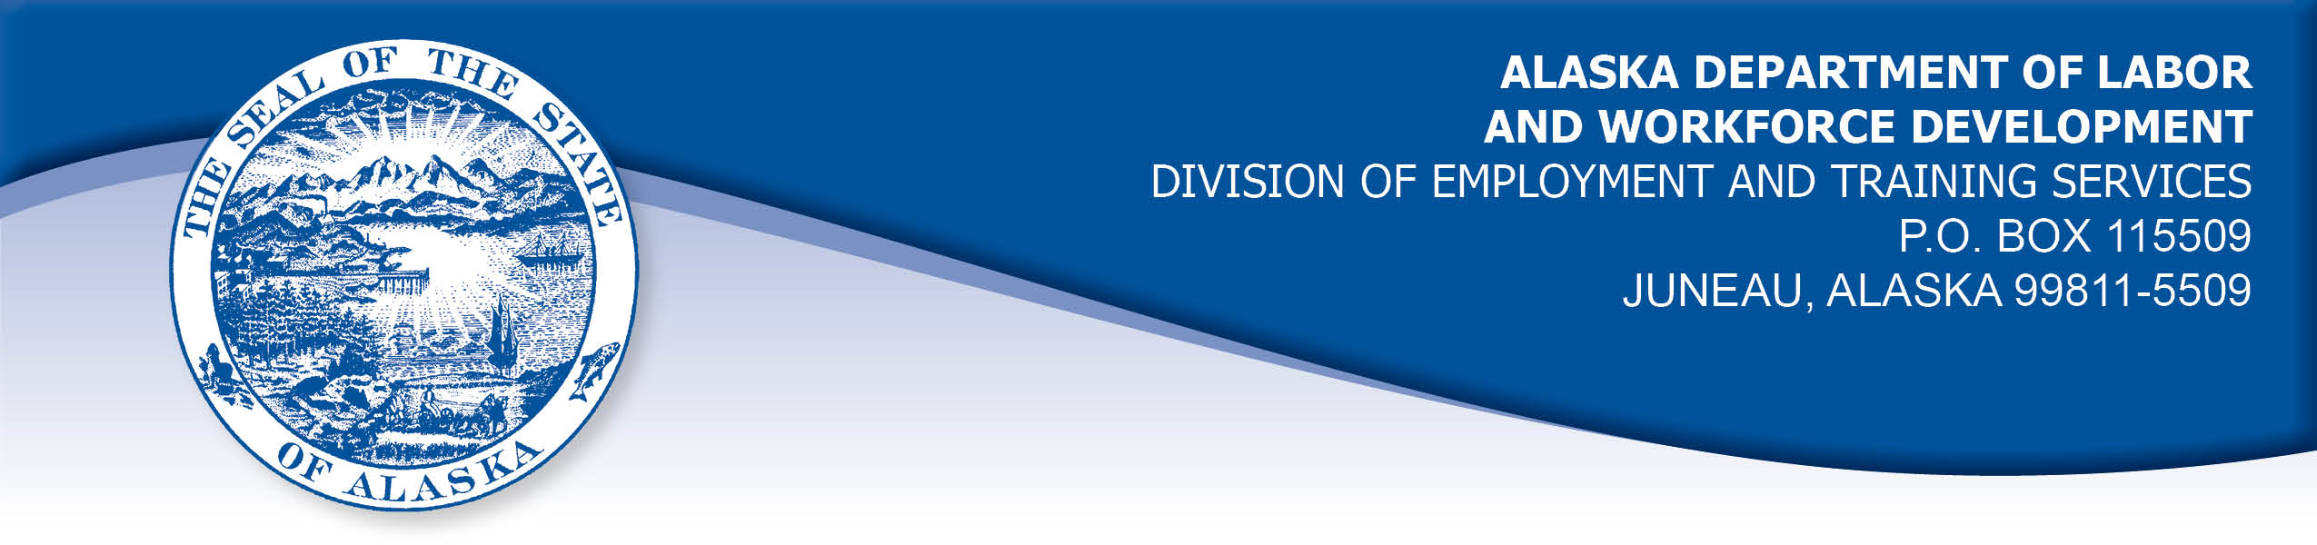

APPEAL TRIBUNAL DECISION

Docket number: 21 1219 Hearing date: December 14, 2021

CLAIMANT:

KIRSTEN GILES

CLAIMANT APPEARANCES: DETS APPEARANCES:

Kirsten Giles None

CASE HISTORY

The claimant timely appealed a May 26, 2021 determination which denied benefits under AS 23.20.375. The issue before the Appeal Tribunal is whether the claimant met the filing requirements.

FINDINGS OF FACT

The claimant contacted the Division in August 2020 to apply for unemployment benefits. A claim for federal Pandemic Emergency Assistance (PUA) benefits was established on August 31, 2020. PUA benefits are required to be made effective the date a claimant’s employment was affected by the COVIDF-19 pandemic. The claimant’s PUA claim was made effective April 5, 2020, despite the claimant’s intent to file after her work was affected when a job offer was withdrawn or delayed due to the pandemic at the end of August 2020.

The claimant began filing weekly certifications to claim benefits. She was alternately told that she was eligible for PUA benefits and then that she was not eligible. The Division ultimately determined the claimant was eligible for benefits from that program for weeks ending September 5, 2020 through November 28, 2020 and benefits for those weeks were paid to the claimant. The claimant recalled receiving a back-payment, although it was not clear to her what she had been paid for.

The claimant continued to file certifications to claim benefits through the week ending April 24, 2021. Throughout this period, the claimant received conflicting notices of eligibility and changing information from Division representatives about her eligibility for benefits. The claimant attempted to call the Division’s PUA and regular UI office frequently and when she could get through to a representative, she received conflicting information and instructions, with as many as four different instructions from four different representatives in one day. Her ability to contact the Division was hampered by the volume of call the Division received and the claimant tried for days without getting through at some points.

In March 2021, the Division determined the claimant was monetarily eligible for a regular unemployment claim effective April 5, 2020. On April 4, 2021, the Division established a claim for a federal extended benefit program, Pandemic Emergency Unemployment Compensation (PEUC) for the claimant. The claimant had not received any benefit payments other than the one time back-payment. On May 13, 2021, the claimant was advised to file certifications for regular unemployment benefits for weeks ending September 5, 2020 through January 23, 2021. The claimant had a period of work after that and she did not want claim benefits while working. She requested to file certifications for weeks ending March 13, 2021 through April 24, 2021 at which point she had again returned to work.

The Division denied the claimant’s benefits for those periods on a holding that she did not file timely certifications to claim benefits.

PROVISIONS OF LAW

AS 23.20.375. Filing requirements
(a) An insured worker is entitled to receive waiting-week credit or benefits for a week of unemployment for which the insured worker has not been disqualified under AS 23.20.360, 23.20.362, 23.20.378 - 23.20.387, or 23.20.505 if, in accordance with regulations adopted by the department, the insured worker has
(1) made an initial claim for benefits; and
(2) for that week, certified for waiting-week credit or made a claim for benefits.
8 AAC 85.102 Intrastate filing: continued claims

(a) An intrastate claimant located in this state is eligible for waiting week credit or benefits for a week if the claimant
(1) files a continued claim for the week as required in this section; and
(2) meets all requirements of AS 23.20 and this chapter.
(b) A claimant shall file a continued claim with an unemployment insurance claim center of the division by
(1) an electronic means designated by the director;
(2) telephone; or
(3) mail, with the prior approval of the director.
(c) A continued claim for a week is filed when an unemployment insurance claim center of the division receives a certification for a continued claim.
(d) The filing date of a continued claim filed by mail is the postmark date of the mailing of the completed claim form.
(e) The date of filing of a continued claim filed by telephone is the date that the claimant accesses the telephone filing system and provides claim information for the week using the claimant's personal identification number.
(f) For each week claimed, the claimant shall answer specific eligibility questions and shall certify to the truthfulness and completeness of the answers.
(g) A continued claim for a week may not be filed before the end of the week claimed. A continued claim may not be filed later than seven calendar days after the end of the week claimed, except that
(1) if the director authorizes the filing of bi-weekly claims, the claim may not be filed later than seven days after the end of the bi-weekly period authorized by the director;
(2) a claim for benefits for a week of partial unemployment may not be filed later than seven days after the claimant receives wages for that week.
(h) The director shall extend the time allowed in (g) of this section for filing a continued claim if the claimant has good cause for filing a late claim and the claimant files the claim as soon as possible under the circumstances.
(i) For the purposes of (h) of this section, "good cause" means circumstances beyond a claimant's control that the division determines leave the claimant with no reasonable choice but to delay filing the claim; "good cause" includes illness or disability of the claimant, processing delays within the division, or failure of the division to provide sufficient or correct information to the claimant in order to file a continued claim.

CONCLUSION

Alaska Statute 23.20.375 holds that in order to be eligible for benefits for a week, the claimant must have an initial claim in place and must file a certification for that week.

Regulation 8 AAC 85.102 holds that certifications must be filed within seven days of the end of the week being claimed, or seven days of the end of a bi-weekly claim period. The claimant in this case filed certifications each week, however, she was filing the certifications with the wrong unemployment program, due to conflicting information received from Division representatives and difficulty getting through to representatives by phone. The regulation holds that a claimant may have good cause to file late certifications if the Division has not provided sufficient or correct information to the claimant in order to file the claim. The documents in the record do not establish that the claimant was advised she was required to file her certifications through the Division’s regular UI system instead of the PUA system. The claimant did not recall being told she was not filing correctly until May 13, 2021.

We find no material errors in the Tribunal's findings. However, we have previously ruled in Murphy, Com. Decision 87H-UI-283, Sept. 29, 1997, and other cases, that a claimant may rely on the instructions received from an authorized representative of the Employment Security Division. Such instructions may supersede instructions given in written form, such as claimant information handbooks or determinations depending on the circumstances. Vassar, Com. Dec. 96 0614, May 15, 1996.

The Tribunal finds the claimant’s certifications for the period under review were filed timely.

The matter of whether the claimant is eligible for PUA benefits for the weeks ending September 5, 2020 through November 8, 2020 is not before the Tribunal. A basic eligibility requirement of the federal PUA program is that a claimant must not be eligible for a regular UI benefit. That matter will be remanded to the Division for consideration.

DECISION

The determination issued on May 26, 2021 is REVERSED. Benefits are ALLOWED under 8 AAC 85.102(i) for the weeks ending September 5, 2020 through January 23, 2021 and March 13, 2021 through April 24, 2021, if the claimant is otherwise eligible.

The matter of the claimant’s eligibility for PUA benefits under Public Law 116-136 Sec. 2101 Pandemic Unemployment Assistance for weeks ending September 5, 2020 through November 28, 2020 is REMANDED to the Division for consideration in light of the claimant’s eligibility for regular unemployment benefits effective April 5, 2020.

APPEAL RIGHTS

This decision is final unless an appeal is filed in writing to the Commissioner of Labor and Workforce Development within 30 days after the decision is mailed

to each party. The appeal period may be extended only if the appeal is delayed for circumstances beyond the party’s control. A statement of rights and procedures is enclosed.

Dated and mailed on December 22, 2021.

Rhonda Buness, Appeals Officer

