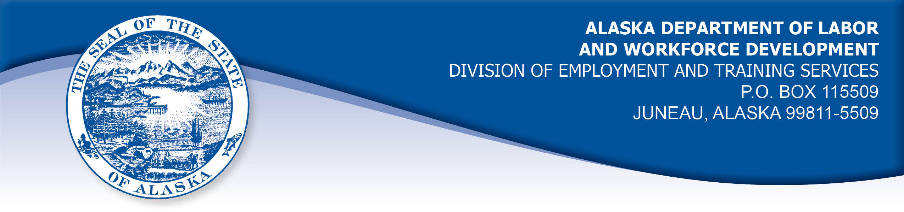

APPEAL TRIBUNAL DECISION

Docket number: 21 1572 Hearing date: January 27, 2022

CLAIMANT:

ROBERT HERNDON

CLAIMANT APPEARANCES: DETS APPEARANCES:

Robert Herndon None

CASE HISTORY

The claimant timely appealed a July 29, 2021 determination which denied benefits under Alaska Statute 23.20.378. The issue before the Appeal Tribunal is whether the claimant was able to work and available for suitable work.
FINDINGS OF FACT

The claimant established a claim for unemployment insurance benefits effective May 9, 2021.
The claimant works as a ventilator nurse providing in-home care to a seriously ill patient 30 hours a week. The claimant was on his way to work on April 30, 2021, when he was contacted by his employer and told not to go to work because his patient’s family has tested positive for the COVID-19 virus. The claimant was advised he had been exposed to the virus on his last work day, before the family knew of the positive test. The claimant was advised to get tested for the virus and told that he was required to quarantine for 14 days. The claimant was not paid for shifts missed while he was required to quarantine.
The claimant quarantined through May 14, 2021 as required and returned to work on his next scheduled shift on May 18, 2021.
PROVISIONS OF LAW

AS 23.20.378 provides:

(a) An insured worker is entitled to receive waiting-week credit or benefits for a week of unemployment if for that week the insured worker is able to work and available for suitable work. An insured worker is not considered available for work unless registered for work in accordance with regulations adopted by the department. An insured worker may not be disqualified for failure to comply with this subsection if
(1) the insured worker is not available for work because the insured worker
(A) is ill or disabled;
(B) is traveling to obtain medical services that are not available in the area in which the insured worker resides, or, if a physician determines it is necessary, the insured worker is accompanying a spouse or dependent who is traveling to obtain medical services;
(C) resides in the state and is non-commercially hunting or fishing for personal survival or the survival of dependents;
(D) is serving as a prospective or impaneled juror in a court; or
(E) is attending the funeral of an immediate family member for a period of no longer than seven days; and
(2) a condition described in (1) of this subsection occurs during an uninterrupted period of unemployment immediately following a week for which the insured worker has filed a compensable claim, and work has not been offered that would have been suitable for the insured worker before the illness, disability, hunting, fishing, medical travel, jury service, or funeral attendance.
(b) A waiver of disqualification for an illness or disability under (a)(1) of this section may not exceed six consecutive weeks.

8 AAC 85.350:

(a) A claimant is considered able to work if the claimant is physically and mentally capable of performing work under the usual conditions of employment in the claimant's principal occupation or other occupations for which the claimant is reasonably fitted by training and experience.
(b) A claimant is considered available for suitable work for a week if the claimant
(1) registers for work as required under 8 AAC 85.351;
(2) makes independent efforts to find work as directed under 8 AAC 85.352 and 8 AAC 85.355;
(3) meets the requirements of 8 AAC 85.353 during periods of travel;
(4) meets the requirements of 8 AAC 85.356 while in training;
(5) is willing to accept and perform suitable work which the claimant does not have good cause to refuse;
(6) is available, for at least five working days in the week, to respond promptly to an offer of suitable work; and
(7) is available for a substantial amount of full-time employment.

HB 308 UNEMPLOYMENT INSURANCE: BENEFIT QUALIFICATION AND WAITING WEEK DURING NOVEL CORONAVIRUS DISEASE OUTBREAK.
(a) To the extent consistent with federal law, an insured worker who is otherwise qualified to receive a benefit under AS 23.20 (Alaska Employment Security Act) may not be disqualified for failure to comply with AS 23.20.378(a) because of conduct by the insured worker or the employer of the insured worker related to an outbreak of novel coronavirus disease (COVID-19), including conduct involving:
(1) providing care, including medical care, to one or more persons
(2) preventing or limiting the spread of COVID-19; or
(3) preventing or limiting economic loss or harm.
(b) The protection of an insured worker under (a) of this section applies for a period of 120 days beginning on the effective date of this section or the date the insured worker applies for a benefit under AS 23.20, whichever is later.
This Act is repealed April 1, 2021

CONCLUSION
The claimant in this case was required by his employer to quarantine after exposure to the COVID-19 virus. He could not work for his patient for other patients. The claimant was not paid for shifts he missed while quarantined.
Alaska Statute 23.20.378 holds that a claimant must be available for work and able to work in order to be eligible for benefits. The statute holds that individuals may not be disqualified for failure to comply with the requirement to be available for work if the claimant is not available because of certain circumstances, including being ill or disabled, traveling to receive medical care, jury service and attending the funeral of an immediate family member. The period of unavailability for work must occur in an uninterrupted period of unemployment immediately following a week for which a claimant has filed a compensable claim as defined in regulation 8 AAC 85.101, above. The claimant’s circumstances do not make him eligible for a waiver of the requirement to be available for work.

The Alaska Legislature passed HB308 and it was signed into law in March 2020. The provision waived claimants from the requirement to be available for work if the circumstances making them unavailable for work was directly caused by the COVID-19 virus. The claimant’s circumstances would meet the requirements of this provision, however that the provision ended effective April 1, 2021, before the period under review in this matter.

Regulation 8 AAC 85.350 holds that a claimant must be available for five days working days in the week to promptly accept an offer of work. The claimant was available for work for five days in the week ending May 1, 2021, however he had not established his claim for benefits before that week ended, so allowing his eligibility based on his availability for work will not result in benefits being paid for that week.

The Tribunal finds the claimant was not available for work for five days in the weeks ending May 8, 2021 and May 15, 2021. Benefits for those weeks were properly denied.

DECISION

The determination issued on July 29, 2021 is MODIFIED. Benefits are ALLOWED under AS 23.20.378 for the week ending May 1, 2021, if the claimant is otherwise eligible. Benefits remain DENIED for the weeks ending May 8, 2021 and May 15, 2021.

APPEAL RIGHTS

This decision is final unless an appeal is filed in writing to the Commissioner of Labor and Workforce Development within 30 days after the decision is mailed to each party. The appeal period may be extended only if the appeal is delayed for circumstances beyond the party’s control. A statement of rights and procedures is enclosed.

Dated and mailed on February 2, 2022

Rhonda Buness, Appeals Officer

