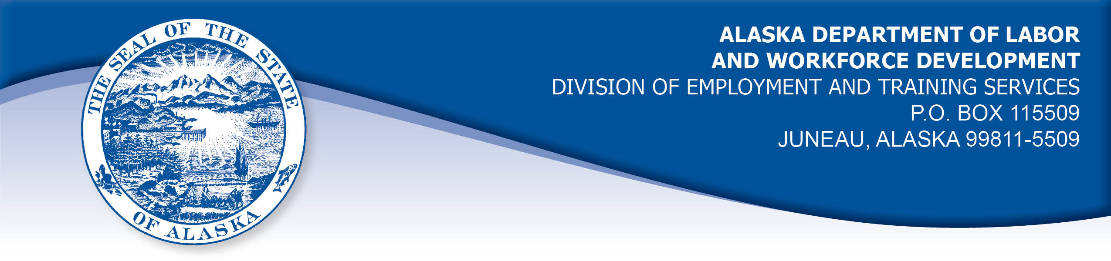

APPEAL TRIBUNAL DECISION

Docket number: 21 1846 Hearing date: April 19, 2022

CLAIMANT: EMPLOYER:

CHRISTIAN HARPEL O'REILLY AUTO ENTERPRISES LLC

CLAIMANT APPEARANCES: EMPLOYER APPEARANCES:

None Jennifer Alexander
Chynna Jones

CASE HISTORY

The employer timely appealed a September 9, 2021 determination which allowed the claimant’s benefits without penalty under Alaska Statute 23.20.379. The issue before the Appeal Tribunal is whether the claimant was discharged for misconduct connected with the work.
A hearing in this matter was held on April 19, 2022 without the claimant’s participation, due to circumstances outside his control. When the error was noted, the hearing was scheduled to be continued on May 9, 2022 to give the claimant the opportunity to participate. Both parties were present on that date, however neither party had received an audio recording of the April 19, 2022 hearing as ordered by the hearing officer, so no hearing was held that day. The hearing was continued to June 6, 2022 and both parties were provided with audio recordings and with advance notice by mail. The claimant did not answer his phone at the scheduled time or respond within 15 minutes, so the record was closed.

FINDINGS OF FACT

The claimant began work for the employer on September 1, 2020. He last worked on May 25, 2021. At that time, he worked full-time as a team lead.
On the claimant’s last day of work, he was physically assaulted at work by a co-worker. The police were called but the employer is not aware that any charges were filed. The claimant was injured and was seen by a doctor. On May 26, 2021, the claimant brought a note from his doctor to the employer. The note did not state that the claimant should be off work, but the claimant said he was hurting and would not return to work at that time. The employer asked the claimant to provide a note from his doctor when he was fit for duty.
The claimant’s supervisor called the claimant and advised him that the employer’s policy required he be tested for illegal drugs because he was involved in an incident. The supervisor recalled that she told the claimant at least twice more in the week after the assault, and at least once told him his job was in jeopardy if he did not get tested. The supervisor recalled that the claimant told her that he was not required to be tested because he was the victim in the incident and that he was now taking pain medication.
The claimant was advised by the district manager on June 18, 2021 that he was discharged for refusing to take a drug test in accordance with the employer’s policy.
The Division examined the employer’s drug testing policy and noted it did not meet one of the minimum requirements of AS 23.10.620(b) because it does not provide for the right of an employee to explain a positive test result in a confidential setting if they request the opportunity within ten days after being notified of the result, and the employer’s responsibility to provide such an opportunity within 72 hours or before taking adverse employment action.

PROVISIONS OF LAW

AS 23.20.379 provides in part:
(a) An insured worker is disqualified for waiting-week credit or benefits for the first week in which the insured worker is unemployed and for the next five weeks of unemployment following that week if the insured worker...
- was discharged for misconduct connected with the insured worker's last work.
(f) “misconduct” includes conduct in violation of an employer’s policy concerning drugs or alcohol, but only if the policy is consistent with AS 23.10.620…

AS 23.10.620. Employer Policy
(a) Under AS 23.10.600 - AS 23.10.699 an employer may only carry out the testing or retesting for the presence or evidence of use of drugs or alcohol after adopting a written policy for the testing and retesting and informing employees of the policy. The employer may inform employees by distributing a copy of the policy to each employee subject to testing or making the policy available to employees in the same manner as the employer informs its employees of other personnel practices, including inclusion in a personnel handbook or manual or posting in a place accessible to employees. The employer shall inform prospective employees that they must undergo drug testing.
(b) The written policy on drug and alcohol testing must include, at a minimum,
(1) a statement of the employer's policy respecting drug and alcohol use by employees;
(2) a description of those employees or prospective employees who are subject to testing;
(3) the circumstances under which testing may be required;
(4) the substances as to which testing may be required;
(5) a description of the testing methods and collection procedures to be used, including an employee's right to a confirmatory drug test to be reviewed by a licensed physician or doctor of osteopathy after an initial positive drug test result in accordance with AS 23.10.640 (d);
(6) the consequences of a refusal to participate in the testing;
(7) any adverse personnel action that may be taken based on the testing procedure or results;
(8) the right of an employee, on the employee's request, to obtain the written test results and the obligation of the employer to provide written test results to the employee within five working days after a written request to do so, so long as the written request is made within six months after the date of the test;
(9) the right of an employee, on the employee's request, to explain in a confidential setting, a positive test result; if the employee requests in writing an opportunity to explain the positive test result within 10 working days after the employee is notified of the test result, the employer must provide an opportunity, in a confidential setting, within 72 hours after receiving the employee's written notice, or before taking adverse employment action;
(10) a statement of the employer's policy regarding the confidentiality of the test results.
8 AAC 85.095 provides in part:
(d) "Misconduct connected with the insured worker's work" as used in
AS 23.20.379(a)(2) means
(1) a claimant's conduct on the job, if the conduct shows a willful and wanton disregard of the employer's interest, as a claimant might show, for example, through gross or repeated negligence, willful violation of reasonable work rules, or deliberate violation or disregard of standards of behavior that the employer has the right to expect of an employee; willful and wanton disregard of the employer's interest does not arise solely from inefficiency, unsatisfactory performance as the result of inability or incapacity, inadvertence, ordinary negligence in isolated instances, or good faith errors in judgment or discretion....

CONCLUSION

The claimant in this case was discharged because he refused to take a drug test after being involved in an incident at work, which is required by the employer’s drug testing policy.

A claimant, who is discharged for violation of a drug policy, is not discharged for misconduct connected with the work if the employer’s drug policy does not meet the standards set forth in AS 23.20.379(f). Smith, Com. Dec. 00 2523, June 21, 2001.

If the test was mandated by DOT and the drug testing facility used is approved by HHS, we direct the Tribunal to hold the claimant was discharged for misconduct connected with the work. If those two requirements were not met, then the misconduct provisions of 23.20.379(f) do not apply. Boll, Com. Dec. 03 0356, May 5, 2003.

It was not established that the claimant’s position was covered under DOT or any other Federal requirements for drug testing. Therefore, the decision must be based on whether the employer’s drug testing policy meets the standards set forth in AS 23.20.379 and AS 23.10.620.

The Tribunal does not dispute the right of an employer to terminate a worker who violates its policies. However, as stated in Smith above, in order for the violation to constitute misconduct, the employer’s drug and alcohol testing policy must meet all ten points of AS 23.10.620. It has not been established that the employer’s policy meets the provisions. Therefore, the Tribunal must conclude the claimant was discharged for reasons other than misconduct connected with the work.

DECISION

The determination issued on September 9, 2021 is AFFIRMED. Benefits remain ALLOWED for the weeks ending June 19, 2021 through July 24, 2021, if otherwise eligible. The three weeks are not reduced from the claimant’s maximum benefits. The determination will not interfere with the claimant’s eligibility for extended benefits under AS 23.20.406-409.

APPEAL RIGHTS

This decision is final unless an appeal is filed in writing to the Commissioner of Labor and Workforce Development within 30 days after the decision is mailed to each party. The appeal period may be extended only if the appeal is delayed for circumstances beyond the party’s control. A statement of rights and procedures is enclosed.

Dated and mailed on June 8, 2022.

Rhonda Buness, Appeals Officer

