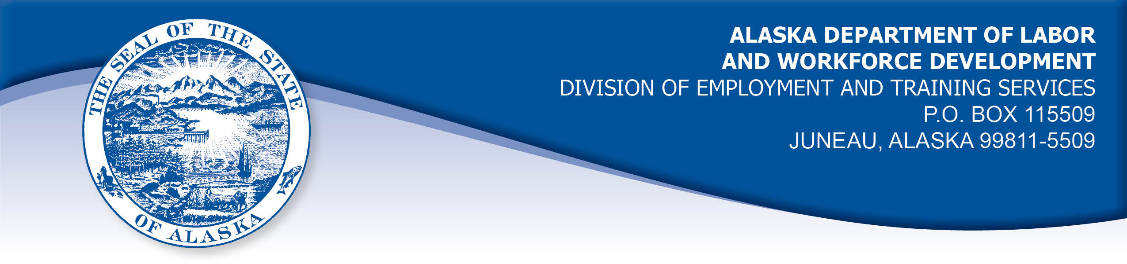

APPEAL TRIBUNAL DECISION

Docket number: 21 1974 Hearing date: April 15, 2021

CLAIMANT:

NICOLE DAVIS

CLAIMANT APPEARANCES: DETS APPEARANCES:

Nicole Davis None

CASE HISTORY

The claimant timely appealed two October 6, 2021 determinations which denied benefits under AS 23.20.375. The issue before the Appeal Tribunal is whether the claimant met the Division’s filing requirements.

FINDINGS OF FACT

The claimant established a claim for unemployment insurance benefits effective November 8, 2020. The claimant filed weekly certifications to claim benefits using the Division’s website form designed for that purpose.

The claimant had a period of work that ended August 10, 2021. On that date she accessed the Division’s website and filled out an application to re-open her claim effective Sunday, August 8, 2021. The claimant believed that she had claimed the week ending August 8, 2021 when she took that action, so she did not access the Division’s website between August 15 and 21, 2021 and file a certification to claim benefits for the week ending August 14, 2021. The claimant resumed filing certifications weekly with the following week.

In the week ending September 25, 2021, the claimant had a working interview at a dentist’s office. She was unsure how to report the interview and payment. The claimant was concerned that if she reported incorrectly, it could be considered fraud, because of warning on the Division’s website. The claimant started work on Monday, September 27, 2021 and her worksite was in an area with poor cellphone reception. The claimant tried to call the Division during her lunch breaks, but she was unable to maintain a phone connection long enough to get assistance from a representative.

On October 5, 2021, the claimant reached a Division representative to ask about her benefits. Certifications for the weeks ending August 14, 2021 and September 25, 2021 were taken on that day. Benefits for both weeks were denied on a holding that the claimant filed the certifications late.

PROVISIONS OF LAW

AS 23.20.375. Filing requirements
(a) An insured worker is entitled to receive waiting-week credit or benefits for a week of unemployment for which the insured worker has not been disqualified under AS 23.20.360, 23.20.362, 23.20.378 - 23.20.387, or 23.20.505 if, in accordance with regulations adopted by the department, the insured worker has
(1) made an initial claim for benefits; and
(2) for that week, certified for waiting-week credit or made a claim for benefits.

8 AAC 85.102 Intrastate filing: continued claims

(a) An intrastate claimant located in this state is eligible for waiting week credit or benefits for a week if the claimant
(1) files a continued claim for the week as required in this section; and
(2) meets all requirements of AS 23.20 and this chapter.
(b) A claimant shall file a continued claim with an unemployment insurance claim center of the division by
(1) an electronic means designated by the director;
(2) telephone; or
(3) mail, with the prior approval of the director.
(c) A continued claim for a week is filed when an unemployment insurance claim center of the division receives a certification for a continued claim.
(d) The filing date of a continued claim filed by mail is the postmark date of the mailing of the completed claim form.
(e) The date of filing of a continued claim filed by telephone is the date that the claimant accesses the telephone filing system and provides claim information for the week using the claimant's personal identification number.
(f) For each week claimed, the claimant shall answer specific eligibility questions and shall certify to the truthfulness and completeness of the answers.
(g) A continued claim for a week may not be filed before the end of the week claimed. A continued claim may not be filed later than seven calendar days after the end of the week claimed, except that
(1) if the director authorizes the filing of bi-weekly claims, the claim may not be filed later than seven days after the end of the bi-weekly period authorized by the director;
(2) a claim for benefits for a week of partial unemployment may not be filed later than seven days after the claimant receives wages for that week.
(h) The director shall extend the time allowed in (g) of this section for filing a continued claim if the claimant has good cause for filing a late claim and the claimant files the claim as soon as possible under the circumstances.
(i) For the purposes of (h) of this section, "good cause" means circumstances beyond a claimant's control that the division determines leave the claimant with no reasonable choice but to delay filing the claim; "good cause" includes illness or disability of the claimant, processing delays within the division, or failure of the division to provide sufficient or correct information to the claimant in order to file a continued claim.

CONCLUSION

Alaska Statute 23.20.375 holds that in order to be eligible for waiting week credit or benefits for a week of unemployment a claimant must, in accordance with regulation adopted by the department, establish an initial claim and must filed a certification for the week. Regulation 8 AAC 85.102 holds that a certification must be filed within seven days of the week or bi-weekly period being claimed. The claimant did not file a certification for the week ending August 14, 2021 within the time allowed.

The regulation holds that the time for filing a certification may be extended, if circumstances beyond her control gives the claimant no choice but to delay filing the claim. Good cause includes illness or disability of the claimant, processing delays within the division, or failure of the division to provide sufficient or correct information to the claimant in order to file a continued claim. The claimant did not file her certification because she thought she had filed for that week when she re-opened her claim on August 10, 2021. However, the Division’s application for re-opening a claim did not ask the claimant to report her eligibility for the week ending August 14, 2021, as the certification form does. The week ending August 14, 2021 had not yet ended at the time the claimant was filling out her application to re-open the claim, so she could not have reported facts about that week yet. The Division provides claimant’s with a handbook detailing reporting requirements and makes the handbook available on it’s website, which the claimant used to file her certifications.

The Tribunal cannot conclude that the claimant’s delay in filing a certification was due to circumstances beyond her control which left her with no choice but delay filing her certification for the week ending August 14, 2021.

The claimant filed a certification for the week ending September 25, 2021 on October 5, 2021. This was within seven days a bi-weekly period including weeks ending September 25, 2021 and October 2, 2021. The Tribunal finds the week ending September 25, 2021 was not filed late.

In Scott, Com. Dec. 87H-EB-162, June 18, 1987, the Commissioner held in part:

Neither the Appeal Tribunal nor I have any jurisdiction to hold contrary to the clear wordage of the law.

The Tribunal finds the claimant’s benefits for the week ending August 14, 2021 were properly denied. The claimant filed a timely certification for the week ending September 25, 2021.

DECISION

The determinations issued on October 6, 2021 are AFFIRMED in part and REVERSED in part.

Benefits remain DENIED for the week ending August 14, 2021.

Benefits are ALLOWED for the week ending September 25, 2021, if the claimant is otherwise eligible.

APPEAL RIGHTS

This decision is final unless an appeal is filed in writing to the Commissioner of Labor and Workforce Development within 30 days after the decision is mailed to each party. The appeal period may be extended only if the appeal is delayed for circumstances beyond the party’s control. A statement of rights and procedures is enclosed.

Dated and mailed on April 22, 2022.

Rhonda Buness, Appeals Officer

