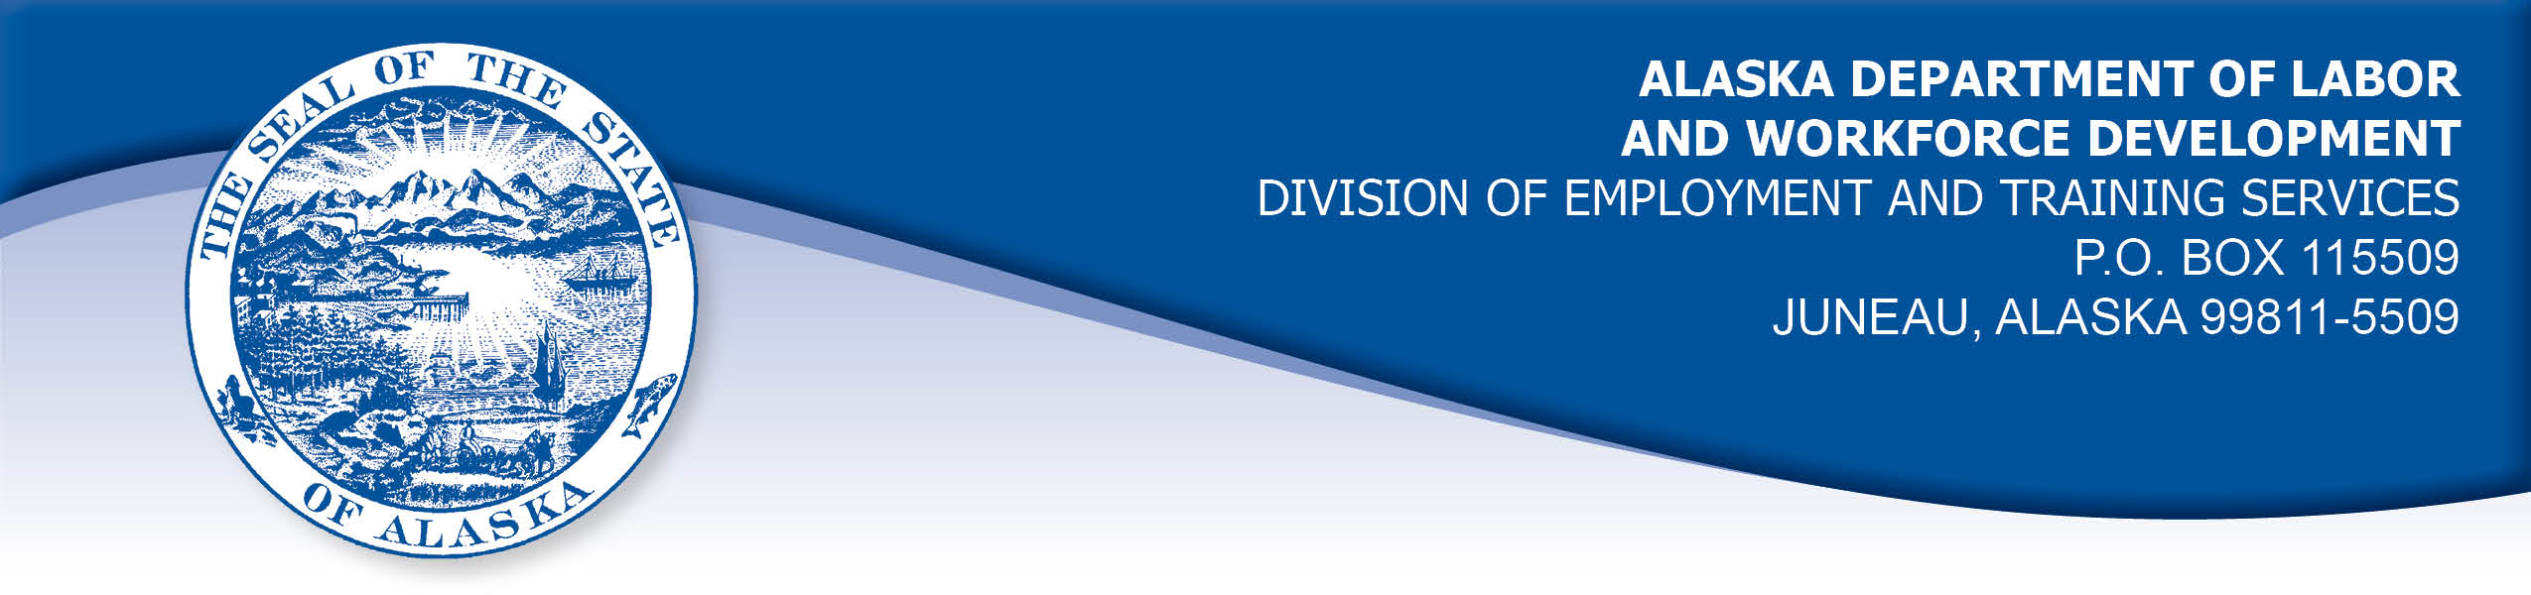

APPEAL TRIBUNAL DECISION

Docket number: 21 2035 Hearing date: April 7, 2022

CLAIMANT: EMPLOYER:

NINZAMMAEL MARSHALL VICTORIA'S SECRET STORES LLC

CLAIMANT APPEARANCES: EMPLOYER APPEARANCES:

Ninzammael Marshall Dena Shelton
Charity Garrido

CASE HISTORY

The employer timely appealed a September 16, 2021 determination which allowed the claimant’s benefits without penalty under Alaska Statute 23.20.379. The issue before the Appeal Tribunal is whether the claimant was discharged for misconduct connected with the work.
FINDINGS OF FACT

The claimant worked for the employer November 2018 through May 2021. She was re-hired July 20, 2021. She last worked on August 19, 2021. At that time, she worked full time as a supervisor in the employer’s retail store.
The employer received a report from an automated program on August 9, 2021 that the claimant had recently used a gift card purchased with an employee discount to purchase items that were marked down to clearance prices. The employer’s policy specifically prohibits using discounted gift cards to purchase discounted products. The claimant was advised of the employer’s policies on hire in 2018 and again when re-hired on July 20, 2021. The claimant recalled that she did flip through the policies, but she did not read them and she did not recall the policy regarding double discounts.
In January 2021, the manager had learned that a supervisor was advising some workers to purchase gift cards with their employee discount and use them to buy sale merchandise to get a great deal. In February 2021, the claimant’s manager advised all employees, including the claimant, that the double discounts were specifically prohibited by the employer’s policies. The claimant did not recall being advised about double discounts by the manager.
On August 18, 2021, the claimant was asked about the purchases she had made with a gift card. The claimant was not aware she had violated a policy until that day. The claimant recalled that two managers checked her out when she made the purchases of sale items with her gift card. The managers did not alert the claimant to the policy or ask if her gift card had been purchased with an employee discount. The claimant offered to return the items she had purchased with the gift card which still had tags on, but the employer refused the returns. The claimant agreed to reimburse the employer $42.98 for the additional discounts she had received by using her discounted gift card.

The employer decided to discharge the claimant because she violated the policy against using discounted gift cards to purchase discounted items. The claimant had not been warned for any performance failures during her tenure with the employer. The claimant was advised she was discharged on August 18, 2021.

PROVISIONS OF LAW

AS 23.20.379 provides in part:

(a) An insured worker is disqualified for waiting-week credit or benefits for the first week in which the insured worker is unemployed and for the next five weeks of unemployment following that week if the insured worker...
(2) was discharged for misconduct connected with the insured worker's last work.

8 AAC 85.095 provides in part:

(d) "Misconduct connected with the insured worker's work" as used in
AS 23.20.379(a)(2) means
(1) a claimant's conduct on the job, if the conduct shows a willful and wanton disregard of the employer's interest, as a claimant might show, for example, through gross or repeated negligence, willful violation of reasonable work rules, or deliberate violation or disregard of standards of behavior that the employer has the right to expect of an employee; willful and wanton disregard of the employer's interest does not arise solely from inefficiency, unsatisfactory performance as the result of inability or incapacity, inadvertence, ordinary negligence in isolated instances, or good faith errors in judgment or discretion....

CONCLUSION

The claimant in this case was discharged after the employer learned she had purchased sale items with a gift card purchased with her employee discount, which is prohibited in the employer’s policies. The issue is whether the claimant’s actions meet the definition of misconduct as laid out in regulation 8 AAC 85.095(d), above.

The meaning of the term misconduct is limited to conduct evincing such willful disregard of an employer's interests as is found in deliberate violations or disregard of standards of behavior which the employer has a right to expect of his employee, or in carelessness or negligence of such degree or recurrence as to manifest equal culpability, wrongful intent or evil design, or to show an intentional and substantial disregard of the employer's interests or of the employee's duties and obligations to his employer. On the other hand mere inefficiency, unsatisfactory conduct, failure in good performance as the result of inability or incapacity, inadvertencies or ordinary negligence in isolated instances, or good faith errors in judgment or discretion are not to be deemed "misconduct" within the meaning of the statute. Boynton Cab Co. v. Neubeck, 237 Wis. 249, 296 N.W. 636 (1041) from Lynch, Com. Rev. No. 82H-UI-051, March 31, 1982.

The claimant did make a purchase of sale items with a gift card she had purchased using her employee discount, contrary to the employer’s policy. The employer held the claimant was made aware of the policy on hire in 2018 and again in July 2021 when she was rehired. The manager recalled telling all employees about the discount policy in January 2021 after a supervisor and other employees were found to be unaware of the policy and actively promoting the practice.

The claimant held that two managers rang her up when she made the purchases with her gift card and they did not bring up the policy when she made the purchases or ask if her gift card was discounted. The claimant questioned whether the managers were aware of the policy.

A Hearing Officer must base his decision on a "preponderance of evidence." See e.g. Patterson, Com. Dec. 86H-UI-233, 1C Unemp. Ins. Rptr. (CCH), AK ¶8121.28, 10/16/86. "Preponderance of evidence" has been defined as "that evidence which, when fairly considered, produces the stronger impression, and has the greater weight, and is more convincing as to its truth when weighed against the evidence in opposition thereto." Adelman, Com. Dec. 86H-UI-041, 1C Unemp. Ins. Rptr. (CCH), AK ¶8121.25, 5/10/86, citing S. Yamamoto v. Puget Sound Lumber Co., 146 P. 861, 863 (WA).
This claimant in this case denied that she intentionally violated the employer’s policy because she was not aware of it. The employer held the policy, which is clear and is reasonable, was presented to the claimant in writing twice during her employment and she was verbally reminded of the policy once. Employees including a supervisor were not aware of the policy in January 2021 and there is a question of whether the managers who rang up the claimant’s purchases in July 2021 were aware of the policy. The employer has not shown with a preponderance of evidence that the policy was properly made known to employees. The Tribunal finds the claimant’s violation of policy regarding double discounts was inadvertent and does not rise to the level of misconduct as described in regulation 8 AAC 85.095(d) and Boynton Cab Co, above.

The Tribunal does not dispute an employer’s right to discharge a worker that does not meet its standards, but not all such discharges are for misconduct. The Tribunal finds the claimant was discharged for reasons other than misconduct and the penalties of AS 23.20.379 are not appropriate.

DECISION

The determination issued on September 16, 2021 is AFFIRMED. Benefits remain ALLOWED for the weeks ending August 28, 2021 through October 2, 2021, if otherwise eligible. The three weeks are not reduced from the claimant’s maximum benefits. The determination will not interfere with the claimant’s eligibility for extended benefits under AS 23.20.406-409.

APPEAL RIGHTS

This decision is final unless an appeal is filed in writing to the Commissioner of Labor and Workforce Development within 30 days after the decision is mailed to each party. The appeal period may be extended only if the appeal is delayed for circumstances beyond the party’s control. A statement of rights and procedures is enclosed.

Dated and mailed on April 13, 2022.

Rhonda Buness, Appeals Officer

