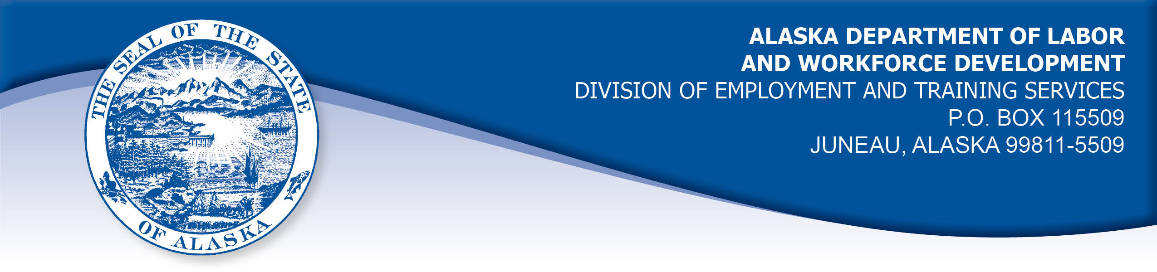

APPEAL TRIBUNAL DECISION

Docket number: 21 2042 Hearing date: April 8, 2022

CLAIMANT: EMPLOYER:

TRENT KRUGER ARMY AIRFORCE EXCHANGE

CLAIMANT APPEARANCES: EMPLOYER APPEARANCES:

None Torry Lundberg
Brian Littlejohn

CASE HISTORY

The employer timely appealed a September 24, 2021 determination which allowed the claimant’s benefits without penalty under Alaska Statute 23.20.379. The issue before the Appeal Tribunal is whether the claimant was discharged for misconduct connected with the work.
FINDINGS OF FACT

The claimant began his most recent period of work for the employer on January 6, 2021. He last worked on August 15, 2021. At that time, he worked part-time as a customer associate.
On about July 27, 2021, the employer determined that the claimant had violated an employer policy when he touched the hips of a worker of another business that shared workspace with the employer, causing the worker to scream. The employer also cited previous behavior of the claimant that the employer determined to be unprofessional, such asking employees of the other employer for their phone numbers and making numerous calls. The employer held the claimant had attempted to follow other employees into the bathroom. Documents in the record show the claimant advised the Division he had attempted to return to the bathroom on one occasion to get his phone, not to follow another worker.
The employer determined the claimant’s actions in touching another worker violated the employer’s sexual harassment policy prohibiting unwanted touch. The employer held the claimant had received sexual harassment training on February 15, 2021. As a disciplinary measure, the employer suspended the claimant without pay for two weeks, August 16 through 29, 2021. The claimant returned to work on August 30, 2021.

PROVISIONS OF LAW

AS 23.20.379 provides in part:

(a) An insured worker is disqualified for waiting-week credit or benefits for the first week in which the insured worker is unemployed and for the next five weeks of unemployment following that week if the insured worker...
(2) was discharged for misconduct connected with the insured worker's last work.

8 AAC 85.095 provides in part:

(d) "Misconduct connected with the insured worker's work" as used in
AS 23.20.379(a)(2) means
(1) a claimant's conduct on the job, if the conduct shows a willful and wanton disregard of the employer's interest, as a claimant might show, for example, through gross or repeated negligence, willful violation of reasonable work rules, or deliberate violation or disregard of standards of behavior that the employer has the right to expect of an employee; willful and wanton disregard of the employer's interest does not arise solely from inefficiency, unsatisfactory performance as the result of inability or incapacity, inadvertence, ordinary negligence in isolated instances, or good faith errors in judgment or discretion....

CONCLUSION

When a claimant makes a claim for unemployment benefits, the Division is required to examine the reason the claimant is unemployed at that time, and determine if penalties apply.

A discharge is “a separation from work in which the employer takes the action which results in the separation, and the worker does not have the choice of remaining in employment." 8 AAC 85.010(20). Voluntary leaving means a separation from work in which the worker takes the action which results in the separation, and the worker does have the choice of remaining in employment. Swarm, Com. Dec. 87H-UI-265, September 29, 1987. Alden, Com. Dec. 85H-UI-320, January 17, 1986.

The employer in this case took the action that resulted in the claimant being unemployed in the week ending August 21, 2021 when it suspended the claimant without pay. The separation is a discharge. The Tribunal will consider if the discharge was for work related misconduct.

The meaning of the term misconduct is limited to conduct evincing such willful disregard of an employer's interests as is found in deliberate violations or disregard of standards of behavior which the employer has a right to expect of his employee, or in carelessness or negligence of such degree or recurrence as to manifest equal culpability, wrongful intent or evil design, or to show an intentional and substantial disregard of the employer's interests or of the employee's duties and obligations to his employer. On the other hand mere inefficiency, unsatisfactory conduct, failure in good performance as the result of inability or incapacity, inadvertencies or ordinary negligence in isolated instances, or good faith errors in judgment or discretion are not to be deemed "misconduct" within the meaning of the statute. Boynton Cab Co. v. Neubeck, 237 Wis. 249, 296 N.W. 636 (1041) from Lynch, Com. Rev. No. 82H-UI-051, March 31, 1982.

The claimant in this case was suspended for touching another worker in a manner that was considered to be unwanted touching and a violation of the employer’s policy regarding sexual harassment. The record does not establish that the claimant had previously been warned for similar violations. The employer did not establish that the claimant’s actions were so egregious as to be considered a willful disregard of the employer’s interests without prior warning. This is supported by the fact that the employer suspended the claimant and did not discharge him.

The Tribunal does not dispute an employer’s right to discipline a worker who does not meet its standards, however, the Tribunal concludes that the claimant in this matter was unemployed in the week ending August 21, 2021 for reasons other than work-related misconduct as described in Boynton, above. The penalties of AS 23.20.379 are not appropriate.

The potential disqualification period is adjusted to demonstrate that the claimant became unemployed in the week ending August 21, 2021.

DECISION

The determination issued on September 24, 2021 is AFFIRMED and MODIFIED. Benefits are ALLOWED for the weeks ending August 21, 2021 through September 25, 2021, if otherwise eligible. The three weeks are not reduced from the claimant’s maximum benefits. The determination will not interfere with the claimant’s eligibility for extended benefits under AS 23.20.406-409.

APPEAL RIGHTS

This decision is final unless an appeal is filed in writing to the Commissioner of Labor and Workforce Development within 30 days after the decision is mailed to each party. The appeal period may be extended only if the appeal is delayed for circumstances beyond the party’s control. A statement of rights and procedures is enclosed.

Dated and mailed on April 15, 2021.

Rhonda Buness, Appeals Officer

