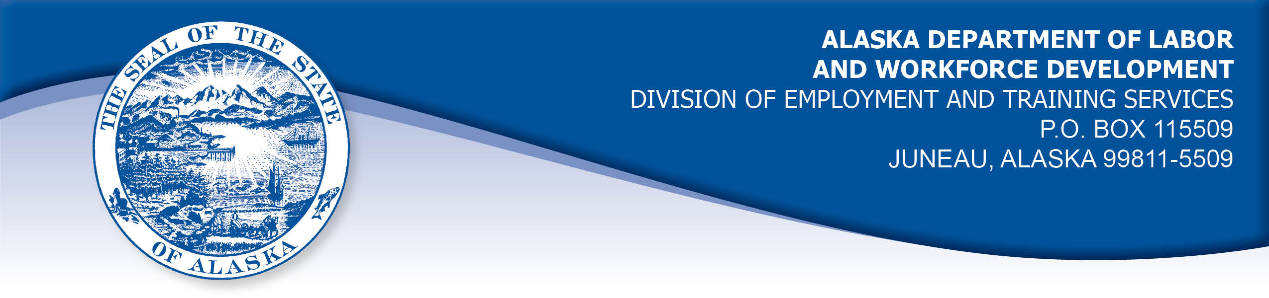

APPEAL TRIBUNAL DECISION

Docket number: 21 2085 Hearing date: April 12, 2022

CLAIMANT: EMPLOYER:

TRAVIS ATUALEVAO LOWE'S HOME CENTERS LLC

CLAIMANT APPEARANCES: EMPLOYER APPEARANCES:

Travis Atualevao Sam Miller

CASE HISTORY

The employer timely appealed a September 17, 2021 determination which denied benefits under Alaska Statute 23.20.379. The issue before the Appeal Tribunal is whether the claimant was discharged for misconduct connected with the work.
FINDINGS OF FACT

The claimant began work for the employer on November 12, 2018. He last worked on August 6, 2021. At that time, he worked full-time as a receiver/stocker.
On July 17, 2021, the employer received a report that an employee’s personal Bluetooth speaker had been stolen from the worksite when left there after a shift in early July. The employer’s asset protections manager reviewed security camera video of the area where the employee reported leaving the speaker. The manager saw the claimant take the speaker, place it in an empty trash bag and place the bag in a gear locker. The manager then noted the claimant returned to the locker the next day and retrieved the speaker in the bag and left the area with it. The claimant recalled that he asked his coworkers who the speaker belonged to, and no one knew, so he put the speaker in the gear locker. The claimant then became concerned that it could be stolen from the locker because it was not secured and items had gone missing from that area before, so he took the speaker home for safekeeping until he could locate the owner. The claimant recalled that he talked to a night shift manager and asked him to let the speaker’s owner know that the claimant had the speaker. The claimant did not often see the night manager, so he later left the manager a message about the speaker but he did not get a response.
On August 6, 2021, the claimant was called into a meeting with the asset protection manager. The claimant at first believed the meeting was about a candy bar he had eaten during his shift the previous day. The claimant had been very busy at work and he felt weak and dehydrated. The claimant took a candy bar from a display and ate it. He was on his way to pay for the candy when he was distracted by a customer requesting assistance. The claimant then forgot to pay for the candy bar. The manager told the claimant he was investigating a missing speaker. The claimant admitted he had taken the speaker home, but held that he did not intend to keep it, just to keep it safe until he found the owner. The manager told the claimant the speaker’s owner had asked all workers on the claimant’s shift about his missing speaker on July 7, 2021, including the claimant. The claimant did not recall anyone asking him about the speaker.
The claimant had no explanation for why he did not give the speaker to a manager on his shift for safekeeping instead of taking it home for almost a month. The claimant held that it was not a good decision on his part, but maintained that he did not intend to keep the speaker.
The employer notified the claimant on August 6, 2021 that he was discharged for dishonest acts.

PROVISIONS OF LAW

AS 23.20.379 provides in part:

(a) An insured worker is disqualified for waiting-week credit or benefits for the first week in which the insured worker is unemployed and for the next five weeks of unemployment following that week if the insured worker...
(2) was discharged for misconduct connected with the insured worker's last work.

8 AAC 85.095 provides in part:

(d) "Misconduct connected with the insured worker's work" as used in
AS 23.20.379(a)(2) means
(1) a claimant's conduct on the job, if the conduct shows a willful and wanton disregard of the employer's interest, as a claimant might show, for example, through gross or repeated negligence, willful violation of reasonable work rules, or deliberate violation or disregard of standards of behavior that the employer has the right to expect of an employee; willful and wanton disregard of the employer's interest does not arise solely from inefficiency, unsatisfactory performance as the result of inability or incapacity, inadvertence, ordinary negligence in isolated instances, or good faith errors in judgment or discretion....
CONCLUSION

The claimant in this case was discharged because the employer believed he had stolen a speaker from another worker.

The Division’s Benefit Policy Manual, Misconduct 140.3 addresses theft of a co-worker’s property:

C. Theft of Property Other Than the Employer’s

A worker who takes articles under the care of the employer that belong to fellow employees, customers, or other persons is discharged for misconduct in connection with the work. Likewise, the taking of property of others during working hours and during the course of the worker's employment is misconduct, even if the act takes place outside the premises of the employer.

Example: A claimant was discharged because she did not return to a customer $40 that he had dropped nor give it to a supervisor, in accordance with company policy. The employer had set up and videotaped the event because they had reason to doubt the claimant's honesty. In denying benefits, the Tribunal held that the claimant violated the standard of behavior that the employer had a right to expect. (98 0427, April 7, 1998)

The claimant in this case denied that he took the speaker with the intention of keeping it.

A Hearing Officer must base his decision on a "preponderance of evidence." See e.g. Patterson, Comm'r Dec. 86H-UI-233, 1C Unemp. Ins. Rptr. (CCH), AK ¶8121.28, 10/16/86. "Preponderance of evidence" has been defined as "that evidence which, when fairly considered, produces the stronger impression, and has the greater weight, and is more convincing as to its truth when weighed against the evidence in opposition thereto." Adelman, Comm'r. Dec. 86H-UI-041, 1C Unemp. Ins. Rptr. (CCH), AK ¶8121.25, 5/10/86, citing S. Yamamoto v. Puget Sound Lumber Co., 146 P. 861, 863 (WA).

The claimant took the speaker home for almost a month. He know he did not have permission to take a co-worker’s property and he admitted it had not been a good idea to take the speaker home. His explanation for doing so was not reasonable considering he could have given the speaker to a manager on his shift. When confronted by the manager, the claimant admitted to taking a candy bar without paying for it. The claimant’s explanation for eating the employer’s product without paying for it was also not reasonable considering how easy it would have been for the claimant to wait a few minutes to pay for item before consuming it. The Tribunal finds the preponderance of evidence show that the claimant was dishonest and his actions show a willful disregard of the employer’s interests.

The Tribunal concludes the claimant was discharged for work related misconduct. The penalties of AS 23.20.379 are appropriate.

DECISION

The determination issued on September 17, 2021 is REVERSED. Benefits are DENIED for the weeks ending August 14, 2021 through September 18, 2021. The three weeks are reduced from the claimant’s maximum benefits. The claimant may not be eligible for extended benefits under AS 23.20.406-409.

APPEAL RIGHTS

This decision is final unless an appeal is filed in writing to the Commissioner of Labor and Workforce Development within 30 days after the decision is mailed to each party. The appeal period may be extended only if the appeal is delayed for circumstances beyond the party’s control. A statement of rights and procedures is enclosed.

Dated and mailed on April 18, 2022.

Rhonda Buness, Appeals Officer

