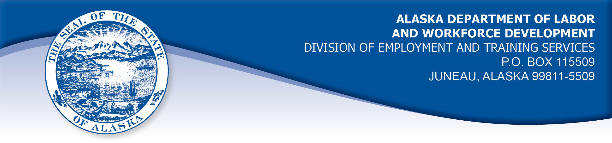

APPEAL TRIBUNAL DECISION

Docket number: 21 2331 Hearing date: August 4, 2022

CLAIMANT: EMPLOYER:

SALLY GANT CACHE MAINTENANCE

CLAIMANT APPEARANCES: EMPLOYER APPEARANCES:

Sally Gant None

CASE HISTORY

The claimant timely appealed a November 15, 2021 determination which denied benefits under Alaska Statute 23.20.379. The issue before the Appeal Tribunal is whether the claimant voluntarily quit suitable work without good cause.

FINDINGS OF FACT

The claimant began work for the employer in May 2021. She last worked on September 24, 2021. At that time, she worked full-time as a bookkeeper and scheduler.
The employer performed maintenance on rental properties and the claimant worked in the employer’s office. The office had no running water. The claimant was told on hire that there was a portable bathroom behind the office, but that it would be removed in the winter because no one used it during the cold months. The owner told the claimant employees went to other businesses to use the bathroom. The claimant told the owner she would require the portable bathroom to stay and she would use it during the winter. The claimant knew she could not work all day without a bathroom facility close by.
On her last day of work, the claimant went out to use the portable bathroom and found it had been removed. The claimant went to the nearest business, a mall located about a quarter mile away, but it was not open until 10:00 am. The claimant then went to a grocery store located about a half mile away, only to find the public bathroom closed. An employee let the claimant use an employee-only bathroom because she physically could not wait any longer. The claimant went back to the office and cleared out her desk. When the owner arrived, the claimant told him she was leaving the job because the portable bathroom had been removed and she could not work without a bathroom on the premises. The owner told her there were no hard feelings and the claimant left.

PROVISIONS OF LAW

AS 23.20.379 provides in part:

(a) An insured worker is disqualified for waiting-week credit or benefits for the first week in which the insured worker is unemployed and for the next five weeks of unemployment following that week if the insured worker...
- left the insured worker's last suitable work voluntarily without good cause....

8 AAC 85.095 provides in part:

(c) To determine the existence of good cause under AS 23.20.379(a)(1) for voluntarily leaving work determined to be suitable under
AS 23.20.385, the department will consider only the following factors:
(1) leaving work due to a disability or illness of the claimant that makes it impossible for the claimant to perform the duties required by the work, if the claimant has no other reasonable alternative but to leave work;
(2) leaving work to care for an immediate family member who has a disability or illness;
(3) leaving work due to safety or other working conditions or an employment agreement related directly to the work, if the claimant has no other reasonable alternative but to leave work;
(4) leaving work to accompany or join a spouse at a change of location, if commuting from the new location to the claimant’s work is impractical; for purposes of this paragraph, the change of location must be as a result of the spouse’s
(A) discharge from military service; or
(B) employment;
(5) leaving unskilled work to attend a vocational training or retraining course approved by the director under AS 23.20.382, only if the claimant enters the course immediately upon separating from work;
(6) leaving work in order to protect the claimant or the claimant’s immediate family members from harassment or violence;
(7) leaving work to accept a bonafide offer of work that offers better wages, benefits, hours, or other working conditions; if the new work does not materialize, the reasons for the work not materializing must not be due to the fault of the worker;
(8) other factors listed in AS 23.20.385(b).

AS 23.20.385(b) provides, in part:

(b) In determining whether work is suitable for a claimant and in determining the existence of good cause for leaving or refusing work, the department shall, in addition to determining the existence of any of the conditions specified in (a) of this section, consider the degree of risk to the claimant's health, safety, and morals, the claimant's physical fitness for the work, the claimant's prior training, experience, and earnings, the length of the claimant's unemployment, the prospects for obtaining work at the claimant's highest skill, the distance of the available work from the claimant's residence, the prospects for obtaining local work, and
other factors that influence a reasonably prudent person in the claimant's circumstances.

CONCLUSION

Regulation 8 AAC 85.095(c) provides seven reasons that the Department will consider when determining good cause for voluntarily leaving work. The claimant in this case voluntarily quit work when she discovered there was no longer any bathroom facility on the employer’s premises. The regulation holds a claimant may have good cause to leave due to safety or other working conditions or an employment agreement related directly to the work, if the claimant has no other reasonable alternative but to leave work.

The Division’s Benefit Policy Manual, Voluntary Leaving 515.05, holds the following regarding changed working conditions:

Change in Working Conditions

In most cases, when working conditions change a worker is expected to try the new conditions to determine whether or not they create an intolerable situation. The worker must also bring the condition to the notice of the employer if this would possibly be useful. However, if the worker knows from the outset that working under the change would be impossible, the worker has good cause to quit.

The claimant in this case knew that not having a bathroom facility on the premises would not be tolerable for her and she told the owner that on hire. The claimant found the situation intolerable on the first day the bathroom was removed and she told the owner so upon his arrival. The owner did not offer to get the portable bathroom back, he just told the claimant there were no hard feelings.

It was not unreasonable of the claimant to require access to a bathroom closer than a half mile away from her worksite during the winter months. The Tribunal finds the employer broke an employment agreement when the portable bathroom was removed after the claimant told the owner she required access to a bathroom on the premises. On her last day, the claimant told the employer whey she was leaving, and he had the opportunity to offer to correct the problem but made not attempt. The Tribunal finds the claimant had good cause to voluntarily leave work at the time she did. The penalties of AS 23.20.379 are not appropriate.

DECISION

The determination issued on November 15, 2021 is REVERSED. Benefits are ALLOWED for the weeks ending September 25, 2021 through October 30, 2021, if otherwise eligible. The three weeks are restored to the claimant’s maximum benefits. The determination will not interfere with the claimant’s eligibility for extended benefits under AS 23.20.406-409.

APPEAL RIGHTS

This decision is final unless an appeal is filed in writing to the Commissioner of Labor and Workforce Development within 30 days after the decision is mailed to each party. The appeal period may be extended only if the appeal is delayed for circumstances beyond the party’s control. A statement of rights and procedures is enclosed.

Dated and mailed on August 9, 2022.

Rhonda Buness, Appeals Officer

