ALASKA WORKERS' COMPENSATION BOARD
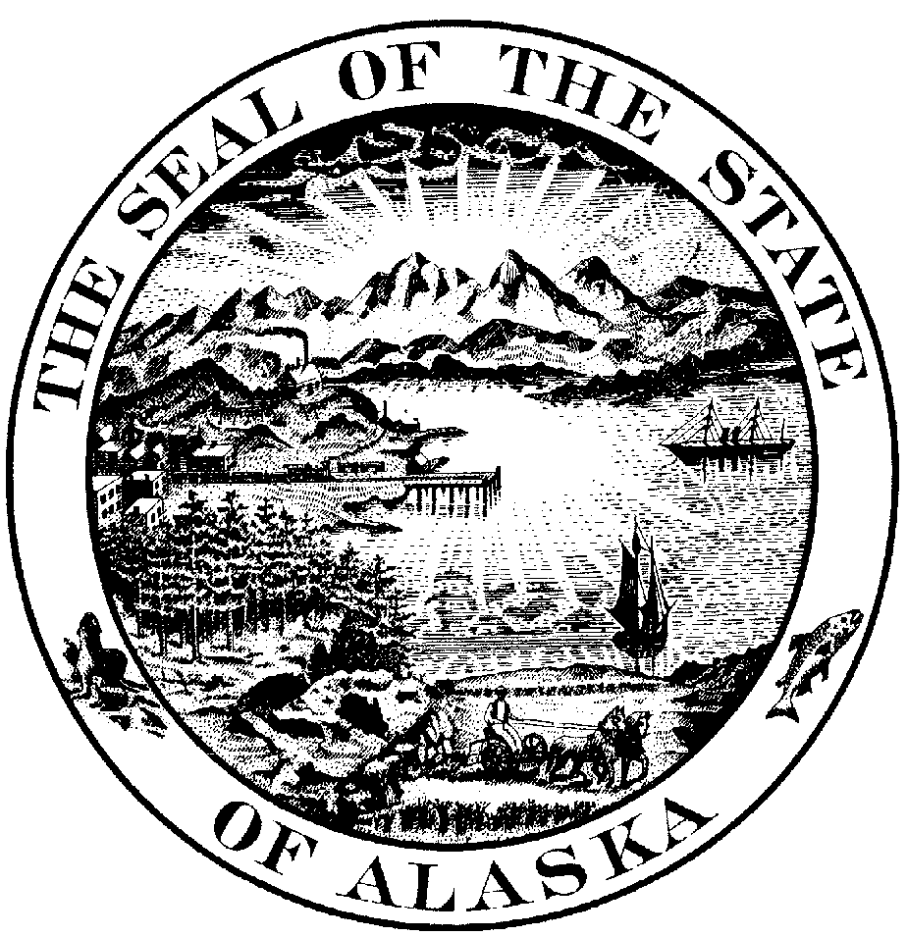

P.O. Box 25512 Juneau, Alaska 99802-5512

JAMES YOUNG, )
)
Employee, )
Petitioner, ) DECISION AND ORDER
)
v. ) AWCB CASE No. 8907991
)
TIP TOP CHEVROLET, ) AWCB Decision No. 95-0072
)
Employer, ) Filed with AWCB Fairbanks
) March 14, 1995
and )
)
ALASKA NATIONAL INS. CO., )
)
Insurer, )
Respondents. )
)

This request for discovery of surveillance material was heard at Fairbanks, Alaska on February 9, 1995. The employee was represented by attorney William Soule. Attorney Michael McConahy represented the respondents. The record closed at the end of the hearing.

DISCOVERY BACKGROUND
It is undisputed that on August 11, 1994 counsel for the employee wrote the respondents and stated the following:
Please provide me with a complete copy of any and all videotapes, audio tapes, still photographs, reports, notes, correspondence, and any other documents related to or memorializing surveillance by any and all detectives, investigators, private investigators, or other representative of you or your clients in Mr. Youngs' case. Please treat this request as an informal request for production of material as is required by the board, and please produce this material within 30 days of the date of this letter, plus 3 days for service by mail.

If you have any questions about what I am requesting, or feel you cannot comply with this request, please advise at your earliest possible opportunity but in no event later than 30 days. Thank you very much for your anticipated cooperation with this request.

The employee's counsel received no response, so on October 17, 1994, he filed a Petition seeking the following:
Applicant requested discovery of discoverable material on 8/11/94. To date, Applicant's counsel has heard neither an objection nor a response. Applicant petitions the board to compel Defendants to disgorge the requested material.

In response to the Petition, the employee's counsel received a letter stating:
The answer to the petition you filed regarding the informal request for surveillance material is enclosed. For the reasons set out therein, the employer believes that any such material is not discoverable, or at least is not discoverable until a decision is made to use it at a hearing, and then it has the right to re-depose the employee before such production.

As your office was kind enough to respond to my inquiries regarding the medical release sent to you in March, I also believe any differences regarding your request could have been either composed or narrowed by a similar inquiry from your office. Although the matter is before the board now on your petition, I nevertheless propose the same solution I expect we would have worked out or the board will suggest: I will re-depose the employee and then provide you with any surveillance material I intend to use at hearing.

I will be out of the state from December 7, 1994 through January 10, 1995. If this approach is agreeable to you, please let my office know and we will schedule the deposition. If not, we can proceed to litigate your petition (emphasis added).

In its Answer to the employee's Petition, the respondents stated:
Deny that the employee requested discoverable material and further deny the employee is entitled to any relief from the board to 'disgorge' such information. The employee informally requested surveillance material by letter, a copy of which is attached as Exhibit 1 and employer is required to produce such information only if it plans to rely upon that evidence at the hearing (citations omitted). If the employer is not going to rely on the evidence at a hearing, the employer is not required to produce it. (Citation omitted).

Even if an employer decides to rely upon surveillance material at a hearing, work product can be redacted. (Citation omitted). Additionally, an employer who plans on using surveillance at the hearing has the right to re-depose the employee and/or do more discovery prior to releasing the film to the employee. (Citation omitted).

In this case no decisions have been made regarding what, if any, may be adduced at any hearing that may be held in this case. Moreover, the use of a petition to resolve issues of this nature is the antithesis of informal discovery. The employee calls the request informal, yet makes no attempt to informally resolve any issue before filing the petition. . . .

No response or objection was due under Alaska Civil Rule 34 to an informal request. No informal attempt was made to compose any differences before filing the petition. The employer has, of even date, written to the employee, and suggesting an approach to the case short of litigation. . . . To the extent the matter is destined to be litigated, the employer objects to production of any such material for the reasons set forth herein.

Affirmative Defenses

1. This case cannot be heard completely at the first hearing because no decision has been made as to what, if any, material may be used at hearing.

2. The material sought, in whole or in part, is protected by the work-product doctrine and the attorney-client privilege and is not discoverable.

3. Material that will be used at hearing is discoverable only upon additional discovery and the redeposition of the employee (emphasis added).

To date, the respondents have not subpoenaed the employer for a redeposition.

FINDINGS OF FACT AND CONCLUSIONS OF LAW
AS 23.30.135(a) provides in pertinent part: "In making an investigation or inquiry or conducting a hearing, the board is not bound by common law or statutory rules of evidence or by technical or formal rules of procedure, except as provided by this chapter."
AS 23.30.115 provides in pertinent part: "[T]he testimony of a witness may be taken by depositions or interrogatories according to the rules of civil procedure."
8 AAC 45.110(e) provides in pertinent part: "Technical rules relating to evidence and witnesses do not apply in board proceedings, except as provided in this chapter. The rules of privilege apply to the same extent as in civil actions."
8 AAC 45.054 provides in pertinent part:
(a) The testimony of a material witness, including a party, may be taken by written or oral deposition in accordance with the Alaska Rules of Civil Procedure.

(b) Upon the petition of a party, the board will, in its discretion, order other means of discovery.

. . . .

(d) A party who refuses to release information after having been properly served with a request for discovery may not introduce at a hearing the evidence which is the subject of the discovery request.

"Other means of discovery, such as a request for production, may be used only with our approval." Bryant v. Gavora, Inc., AWCB No. 91-0315 (December 5, 1991). Before making a formal request for production to a party, informal means of discovery must be attempted and fail. Only then can a party petition the board for other means of discovery. We may deny a request to compel discovery where there is no evidence the party "attempted and failed to obtain the information informally." Bryant at 5.
For guidance, we have also relied on discovery rules found in the Alaska Rules of Civil Procedure. ARCP 26(b) states in part:
Scope of discovery. Unless otherwise limited by order of the court in accordance with these rules, the scope of discovery is as follows:

1) In General. Parties may obtain discovery regarding any matter, not privileged which is relevant to the subject matter involved in the pending action, whether it relates to the claim or defense of the parties seeking discovery or to the claim or defense of any other party, including the existence, description, nature, custody, condition and location of any books, documents, or other tangible things and the identify and location of persons having knowledge of any discoverable matter. It is not ground for objection that the information sought will be inadmissible at the trial if the information sought appears reasonably calculated to lead to the discovery of admissible evidence (emphasis added).

The frequency or extent of use of the discovery methods set forth in paragraph (a) shall be limited by the court if it determines that: (i) the discovery sought is unreasonably cumulative or duplicative, is obtainable from some other source that is more convenient, less burdensome, or less expensive; (ii) the party seeking discovery has had ample opportunity by discovery in the action to obtain the information sought; or (iii) discovery is unduly burdensome or expensive, taking into account the needs of the case, the amount in controversy, limitations on the parties' resources, and the important of the issues at stake in the litigation. The court may act upon its own initiative after reasonable notice or pursuant to a motion under paragraph (c).

ARCP 34 states in part:

(a) Scope. Any party may serve on any other party a request (1) to produce and permit the party making the request, or someone acting on the requestor's behalf, to inspect and copy, any designated documents (including writing, drawings, graphs, charts, photographs, phono-records and any other data compilation from which information can be obtained, translated, if necessary, by the Respondent through detection devices into reasonably usable form) or to inspect and copy, test, or sample any tangible things which constitute or contain matters within the scope of Rule 26(b) and which are in the possession, custody or control of the party upon whom the request is served . . . (emphasis added).

Consistently, we have relied on the reasoning in Hickman v. Taylor, 329 U.S. 495, 507 (1947) in which the United States Supreme Court discussed discovery in general and the need for broad disclosure of facts:
We agree, of course, that the deposition-discovery rules are to be accorded a broad and liberal treatment. No longer can the time-honored cry of 'fishing expedition' serve to preclude a party from inquiring into the facts underlying his opponents' case. Mutual knowledge of all the relevant facts gathered by both parties is relevant facts gathered by both parties is essential to proper litigation. To that end, either party may compel the other to disgorge whatever facts he has in his possession.

Buswell v. New Hope Ministry & Anchorage Rescue Mission, AWCB No. 93-0046 (February 26, 1993).

The respondents contend they are not required to produce the contested surveillance materials because they are protected by the "work-product" doctrine and the attorney-client privilege. The defendants are incorrect. To be considered "work product," material must 1) be a document or other tangible thing, 2) be prepared in anticipation of litigation, and 3) be prepared by the opposing attorney or his representative. "Representative has been deemed to mean "his attorney, consultant, surety, indemnitor, insurer or agent." Langdon v. Champion, 752 P.2d 999, 1005 (Alaska 1988). We find a private investigator is none of these things. Given the respondents' failure to respond to the employee's informal discovery request or to identify specific materials which they believe are protected by the work product or attorney-client privilege, we find they must be produced.
Additionally, the respondents contend they are not required to produce the materials unless they intend to rely upon them at hearing, as suggested by 8 AAC 45.054(d). We disagree.
In Clark v. Timber Fallers, Inc., AWCB No. 88-0318 (November 29, 1988) aff'd, 1JU-88-2038 CI (Alaska Super. Ct., September 25, 1989), we considered a similar situation. In Clark we noted that, with a few exceptions such as privilege, everything relevant is discoverable under the Alaska Workers' Compensation Act and that the work product doctrine is not a form of privilege. Although we also concluded we are not necessarily bound by Civil Rule 26(b)(3), which protects work product from discovery in civil litigation, we found "that sound policy considerations exist for 'protect[ing] against disclosure . . . the mental impressions, conclusions, opinions or legal theories of an attorney or other representative of a party . . . .'" Clark at 3. We ordered the defendants to release surveillance videotapes and any logs or reports of the investigator, but allowed the defendants to protect any part of the report which revealed the mental impressions, conclusions, opinions, or legal theories of the defendant's attorney or investigator. In Sulkosky v. Morrison-Knudsen, AWCB No. 91-0098 (April 11, 1991), we adopted the findings, reasoning and procedures set out in Clark, and stated them again in Dixon v. Olympic Constructors, AWCB No. 93-0106 (April 30, 1993). In each case we also permitted the defendants to take the employee's deposition prior to requiring release of the surveillance materials.
We conclude that regulation subsection .054(d) describes one of the penalties which may be imposed for failure to provide timely discovery. It is not a shield behind which a party may hide in an effort to avoid producing materials otherwise required by law. In this instance we find the respondents have 30 days to produce the requested materials. If they wish to redepose the employee in the meantime, concerning subjects not previously addressed in a prior 1991 deposition, they may do so. This provision should satisfy the respondents' contention they may redepose prior to releasing the surveillance materials, while setting a specific date at which the employee may expect release of the discoverable materials.
ORDER
The defendants shall release the contested surveillance materials within 30 days of this decision. A redeposition of the employee may be held during the interim period.
Dated at Fairbanks, Alaska this 14th day of March, 1995.

ALASKA WORKERS' COMPENSATION BOARD

/s/ Fred G. Brown
Fred G. Brown,
Designated Chairman

/s/ John Giuchici
John Giuchici, Member

/s/ Ray Kimberlin
Ray Kimberlin, Member

If compensation is payable under terms of this decision, it is due on the date of issue and penalty of 25 percent will accrue if not paid within 14 days of the due date unless an interlocutory order staying payment is obtained in Superior Court.

APPEAL PROCEDURES
A compensation order may be appealed through proceedings in Superior Court brought by a party in interest against the Board and all other parties to the proceedings before the Board, as provided in the Rules of Appellate Procedure of the State of Alaska.
A compensation order becomes effective when filed in the office of the Board, and unless proceedings to appeal it are instituted, it becomes final on the 31st day after it is filed.

CERTIFICATION
I hereby certify that the foregoing is a full, true and correct copy of the Decision and Order in the matter of James Young, employee / petitioner; v. Tip Top Chevrolet, employer; and Alaska National Ins. Co., insurer / respondents; Case No.8907991; dated and filed in the office of the Alaska Workers' Compensation Board in Fairbanks, Alaska, this 14th day of March, 1995.

_________________________________
Cathy D. Hill, Clerk
SNO

