ALASKA WORKERS' COMPENSATION BOARD
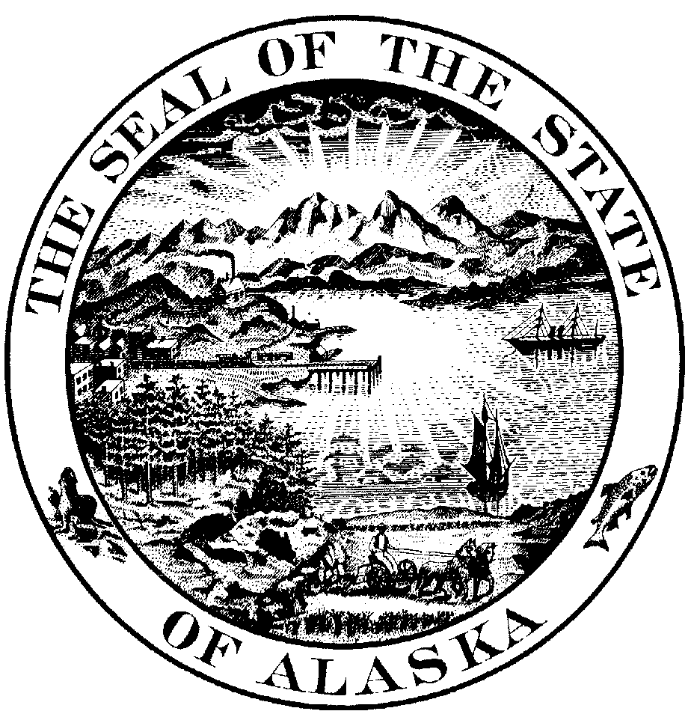

P.O. Box 25512 Juneau, Alaska 99802-5512

RICHARD J. OLIVER,  Employee,  Respondent,  v.  REEVE ALEUTIAN AIRWAYS, INC.,  Employer,  and  INSURANCE CO. OF STATE PA.,  Insurer,  Petitioners. | )  )  )  )  )  )  )  )  )  )  )  )  )  )  )  )  )  )  ) | FINAL  DECISION AND ORDER  AND SUPPLEMENTARY ORDER  OF DEFAULT.  AWCB Case No. 199910213  AWCB Decision No. 03-0204  Filed with AWCB Anchorage, Alaska  on August 27, 2003

We heard the employer’s petition for a supplementary order of default, and reimbursement of additional fees pursuant to AS 23.30.250 at Anchorage, Alaska on June 17, 2003. Attorney Robin Gabbert represented the employer. The employee, unrepresented, did not appear or otherwise participate. We found the employee had notice of the hearing and proceeded in his absence pursuant to 8 AAC 45.070(f)(1). We closed the record at the hearing’s conclusion.

ISSUES
- Whether to issue a supplementary order declaring the employee in default.
- Whether to award additional fees incurred in securing the order of default.
- Whether the employer remains liable for any additional workers’ compensation benefits.

SUMMARY OF THE EVIDENCE
We incorporate by reference the facts as detailed in our prior decisions, Oliver v. Reeve Aleutian Airways, AWCB Decision Nos. 02-0063 (April 10, 2002) (Oliver I), and 02-0153 (August 9, 2002) (Oliver II). The employee injured his back while working as a fueler in Cold Bay for the employer on June 9, 1999. The employer accepted the employee’s claim and paid substantial medical and timeloss benefits.
The employer became suspicious of the employee’s continuing claims for benefits and began an investigation. The employer obtained surveillance video of the employee far exceeding his abilities as described to physicians. After hearing the employer’s evidence at the April 9, 2002 hearing, we made several oral orders, including bifurcating the employer’s petition for finding of fraud, from the employee’s claims for additional benefits. We memorialized our oral orders in our decision in Oliver I. In Oliver II, we found the employee intentionally made false statements in order to obtain benefits. Under AS 23.30.250(b), we ordered reimbursement of benefits obtained totaling $62,838.62.
On March 11, 2003, attorney Gabbert filed an affidavit stating that the employee has not made any payments to the employer as ordered. On April 2, 2003 the employer filed a Petition for a Supplementary Order of Default. The affidavit also provides that since our decision in Olvier II, the employer and its carrier have incurred an additional $1,637.56 in costs and attorney’s fees. The employee did not appear for a prehearing held April 17, 2003, however a phone call to the employee’s number of record, verified that we have his correct address of record and the employee receives his mail at that address. In its Affidavit of Readiness for Hearing (ARH) filed on April 24, 2003 the employer requested an oral hearing on its petition for default, and the employee’s November 13, 2000 claim for additional benefits. In its attached “statement” to the ARH, the employer stated in pertinent part: “The employer requests a final determination of issues not resolved by the Board’s 08/09/02 Decision and Order.”
At the June 17, 2003 hearing, the employer reiterated these arguments. The employer argued the medical record reflects that the employee, at most, suffered a temporary aggravation of a pre-existing condition, and that no further timeloss or medical benefits are indicated. Specifically, in its hearing brief, the employer argued:
The employer and carrier have received no additional medical reports relating to the employee subsequent to the original hearing that was held in this case on April 10, 2002. All witnesses relevant to this matter were presented by the employer at the hearing on 4/10/02. Accordingly, the employer and carrier do not intend to present any further evidence in this case, unless there is a need for rebuttal witnesses. With regard to argument, this case was fully briefed at the time of the prior hearing and the employer incorporates all arguments made in its earlier brief into this current brief for the hearing scheduled for 6/17/03. For ease of reference, a copy of the employer’s hearing brief of 4/1/02 is hereby attached. For the many reasons set forth in that brief, the employer and carrier request that any and all outstanding claims of the employee be expressly denied.

FINDINGS OF FACT AND CONCLUSIONS OF LAW
AS 23.30.250(b) provides:
If the board, after a hearing, finds that a person has obtained compensation, medical treatment, or another benefit provided under this chapter by knowingly making a false or misleading statement or representation for the purpose of obtaining that benefit, the board shall order that person to make full reimbursement of the cost of all benefits obtained. Upon entry of an order authorized under this subsection, the board shall also order that person to pay all reasonable costs and attorney fees incurred by the employer and the employer's carrier in obtaining an order under this section and in defending any claim made for benefits under this chapter. If a person fails to comply with an order of the board requiring reimbursement of compensation and payment of costs and attorney fees, the employer may declare the person in default and proceed to collect any sum due as provided under AS 23.30.170(b) and (c).

We find, based on attorney Gabbert’s affidavit, the employee has not complied with the Board’s order to reimburse the employer for the compensation it paid the employee and the employer’s attorney’s fees and litigation costs. We find the employee was properly served with the employer’s Petition for Supplementary Order of Default. Based on our review of the record, we find the employee did not respond to the employer’s Petition.
We find the employee is in default. We find the total amount in default is $63,838.62. Accordingly, we conclude a Supplementary Order of Default will be issued.
Regarding the employer’s request for an award of additional litigation costs incurred after our decision in Oliver II, we decline to order payment of these fees. We find that since neither party appealed our decisions, the fees incurred executing the default order would be part and parcel of the employer’s civil recourses available in the Superior Court. We deny and dismiss the request for an award of additional fees and costs under the Workers’ Compensation. We query if we were to award additional fees, whether, assuming the employee ignored that order as well, in six months the employer would be seeking an additional order in its bid to have these fees ordered.
Likewise, we deny the employer’s request to enter a final order regarding the employee’s claims for additional benefits. We do so for several reasons. First, we find we bifurcated the issues the employee would be arguing, hearing the employer’s fraud petition first. We did not address the employee’s additional claims for benefits in Oliver II because the employee did not present any evidence or argument, pursuant to our instructions. Furthermore, the ARH requested an oral hearing, but the employer essentially argued the “written record.” Granted, the employee did not attend or participate in the oral hearing on June 17, 2003, however, had notice been provided to the employee that theis was to be heard on the written record, the employee may have filed responses, and/or evidence. Accordingly, we deny the employer’s request to enter final judgment at this time. Barring any modification, we note that the employer is not obligated to pay any claims until its reimbursement ordered in Oliver II is satisfied.

ORDER
The employee is in default of $63,838.62. Judgement may enter in accordance with law. The employer’s other requests are denied at this time.

Dated at Anchorage, Alaska this 27TH day of August, 2003.
ALASKA WORKERS' COMPENSATION BOARD

____________________________
Darryl Jacquot,
Designated Chairman

____________________________
Philip Ulmer, Member

No longer with Board.
____________________________
Curtis Hall, Member
APPEAL PROCEDURES
This compensation order is a final decision. It becomes effective when filed in the office of the Board unless proceedings to appeal it are instituted. Proceedings to appeal must be instituted in Superior Court within 30 days of the filing of this decision and be brought by a party in interest against the Board and all other parties to the proceedings before the Board, as provided in the Rules of Appellate Procedure of the State of Alaska.
RECONSIDERATION
A party may ask the Board to reconsider this decision by filing a petition for reconsideration under AS 44.62.540 and in accordance with 8 AAC 45.050. The petition requesting reconsideration must be filed with the Board within 15 days after delivery or mailing of this decision.
MODIFICATION
Within one year after the rejection of a claim or within one year after the last payment of benefits under AS 23.30.180, 23.30.185, 23.30.190, 23.30.200 or 23.30.215 a party may ask the Board to modify this decision under AS 23.30.130 by filing a petition in accordance with 8 AAC 45.150 and 8 AAC 45.050.
CERTIFICATION
I hereby certify that the foregoing is a full, true and correct copy of the Final Decision and Order and Supplementary Order of Default in the matter of RICHARD J. OLIVER employee / respondent; v. REEVE ALEUTIAN AIRWAYS INC., employer; INSURANCE CO. OF STATE PA., insurer / petitioners; Case No. 199910213; dated and filed in the office of the Alaska Workers' Compensation Board in Anchorage, Alaska, this 27TH day of August, 2003.
_________________________________
Robin Burns, Clerk

The Hearing Notice sent to him by certified return receipt requested mail to his address of record was returned, the Notice of Hearing sent regular mail was not returned.

